Robotics: Fundamentals (Online Course Notes)

* Inner Product=Dot Product
* Norm=Magnitude of/Absolute value of a vector
* Commutative: (**u•v**)=(**v•u**)
* Orthogonality: (**u•v**)=0

= |u||v| cos(θ)

i.e. θ=π/2

* 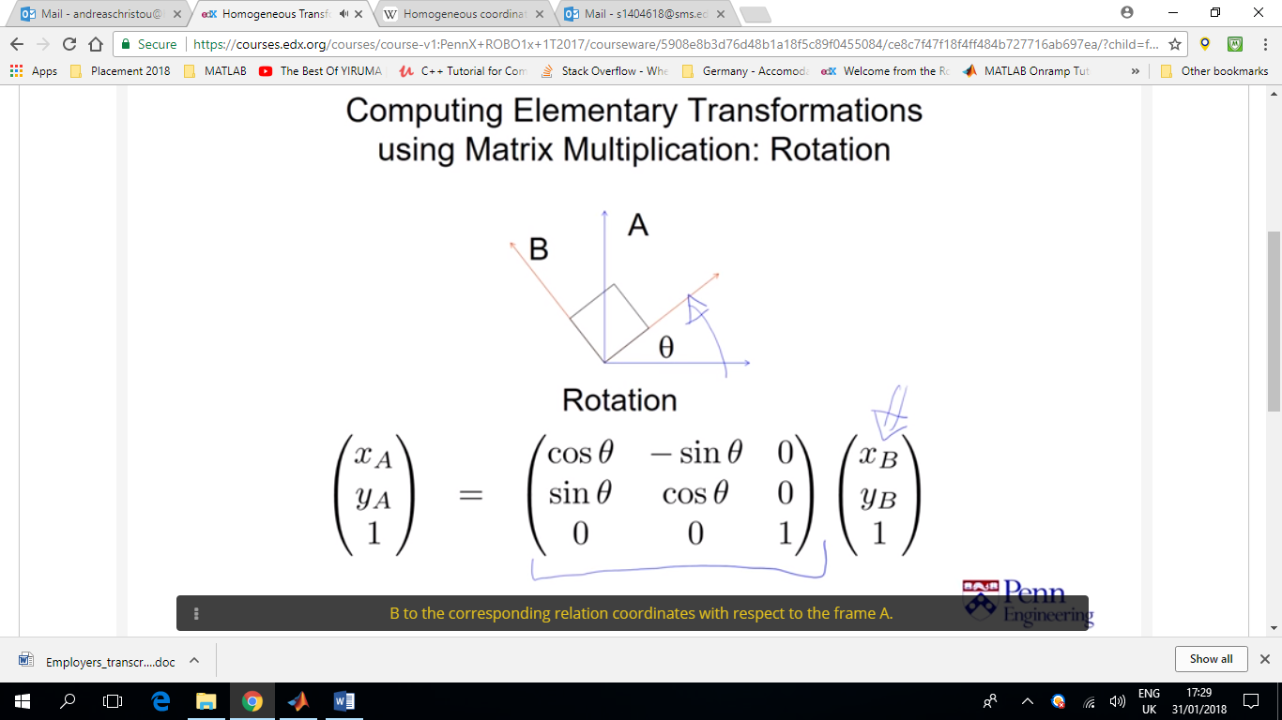[C]=[A][B] => [C]T=[B]T[A]T => ([A][B])T=[B]T[A]T

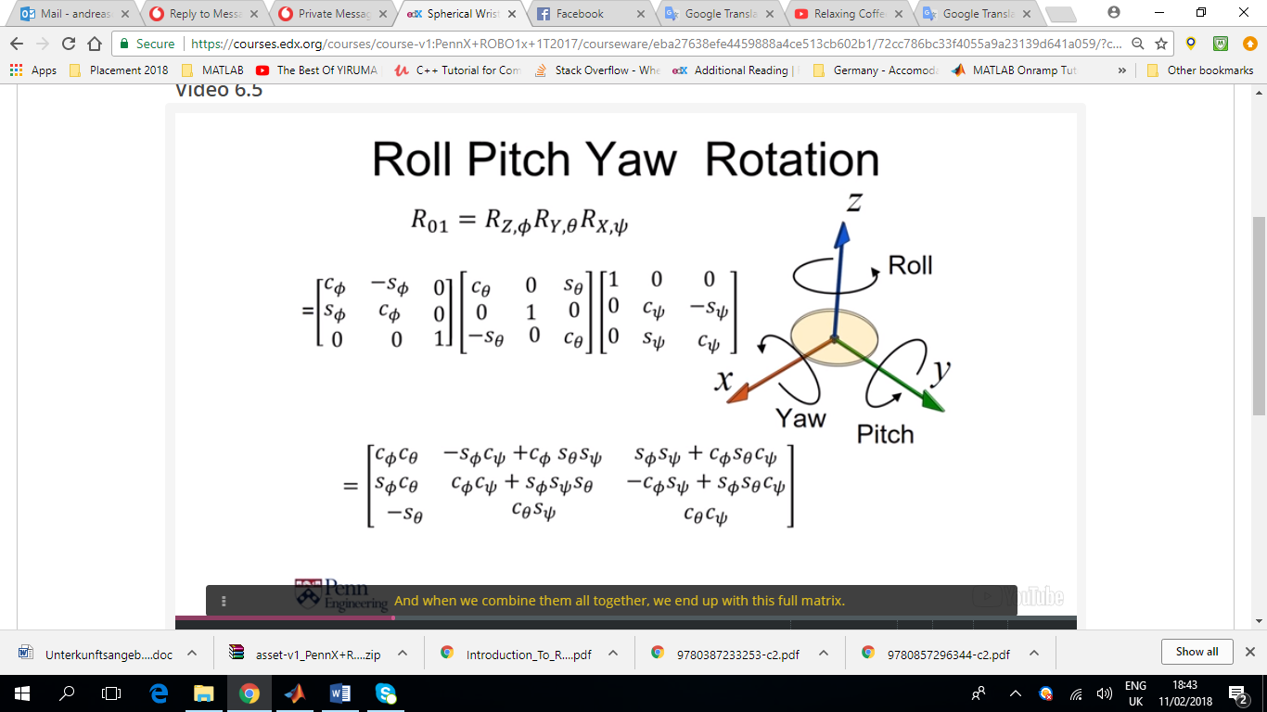

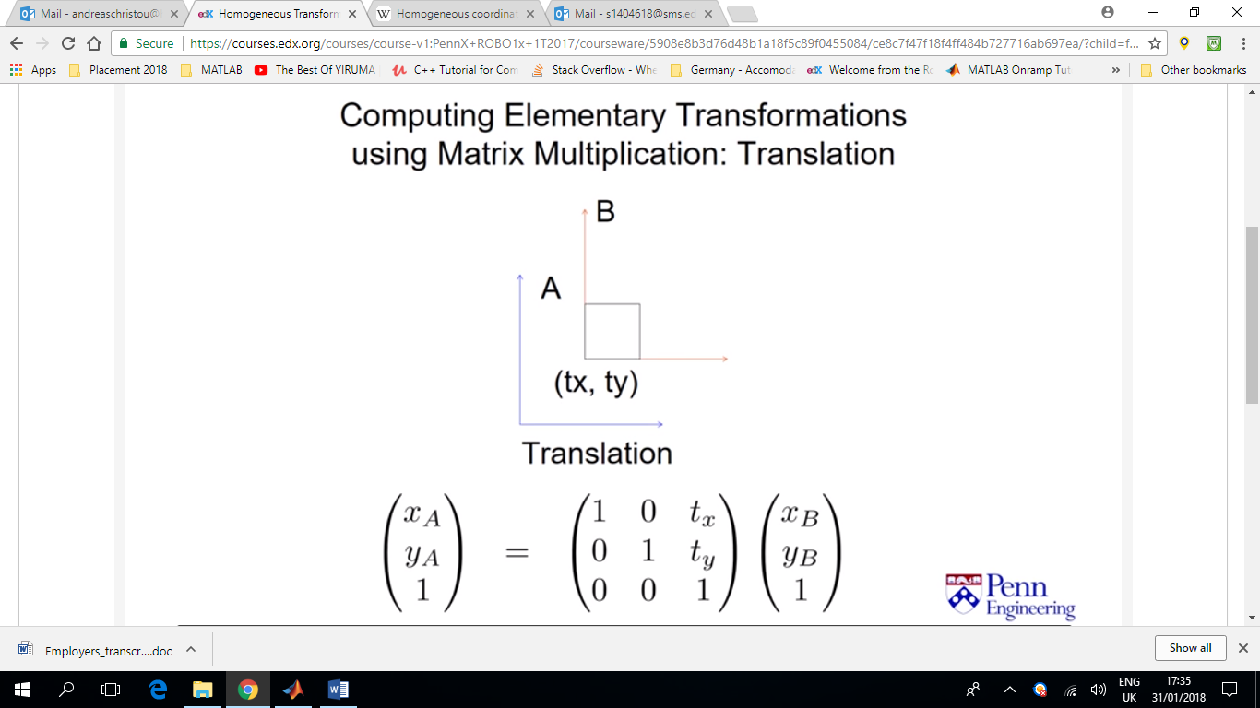

* **u** x **v** = |u||v| sin(θ)

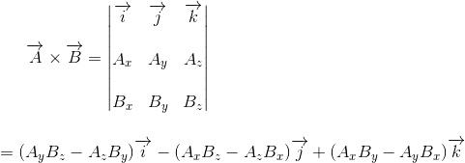

* 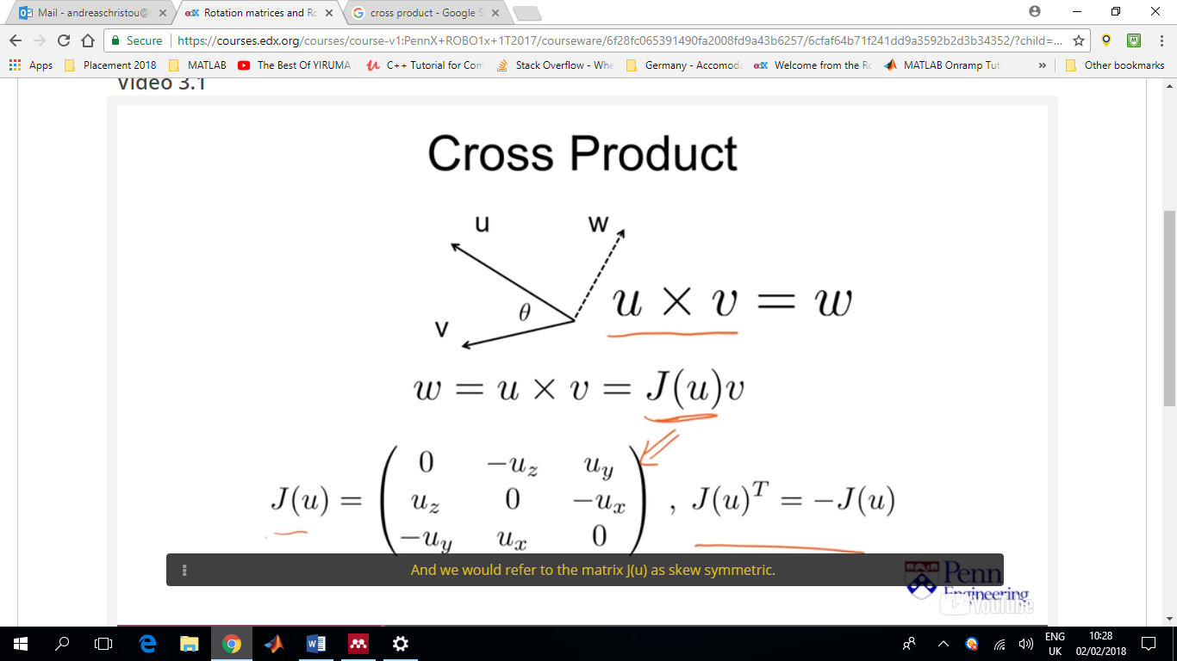
* 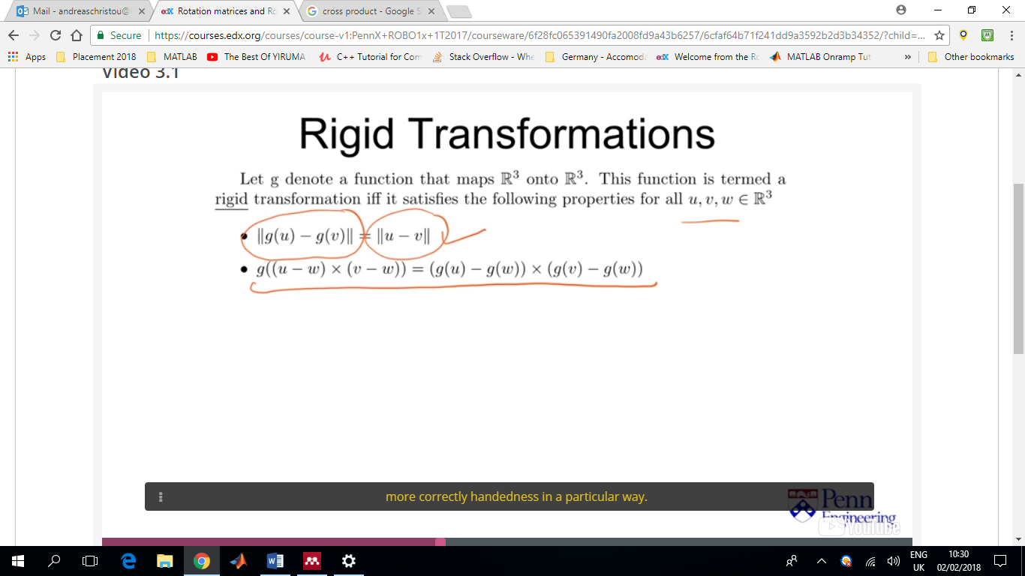

Maintaining distances and angles (or handedness). Second point rules out transformations like reflections around an axis

* 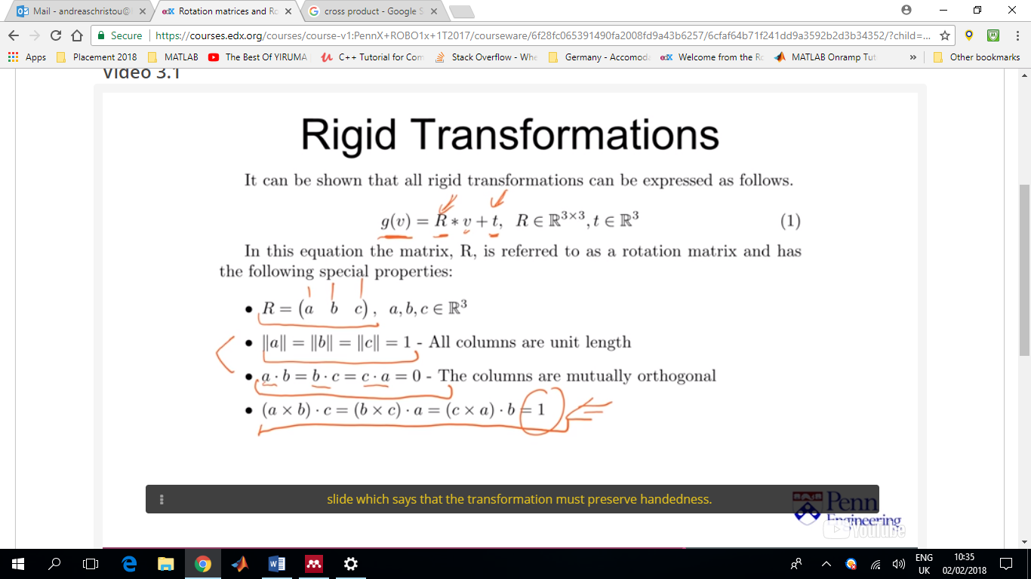

Orthonormal matrices

(without the last point)

Matrices like R that satisfy the last point too, preserve handedness = Rotation Matrix

t= translation factor

For R to be considered Rotation matrix

* + **R**T**R**= **I = [**1 0 0; 0 1 0; 0 0 1**]**
  + det**(R) =** (**a**x**b**)•**c =** 1

where a, b and c are vector in R3 and are the columns of which **R** is composed

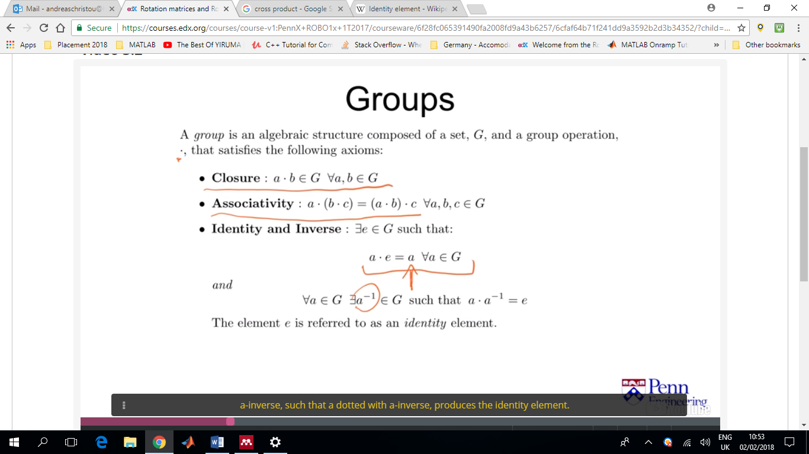In [mathematics](https://en.wikipedia.org/wiki/Mathematics), an **identity element** or **neutral element** is a special type of element of a [set](https://en.wikipedia.org/wiki/Set_(mathematics)) with respect to a [binary operation](https://en.wikipedia.org/wiki/Binary_operation) on that set, which leaves other elements unchanged when combined with them. This concept is used in [algebraic structures](https://en.wikipedia.org/wiki/Algebraic_structure) such as [groups](https://en.wikipedia.org/wiki/Group_(mathematics)) and [rings](https://en.wikipedia.org/wiki/Ring_(mathematics)). The term *identity element* is often shortened to *identity* (as will be done in this article) when there is no possibility of confusion, however, the identity implicitly depends on the binary operation it is coupled with.

Let (*S*, ∗) be a set *S* with a binary operation ∗ on it. Then an element *e* of *S* is called a [**left**](https://en.wikipedia.org/wiki/Left_and_right_(algebra))**identity** if *e* ∗ *a* = *a* for all *a* in *S*, and a [**right**](https://en.wikipedia.org/wiki/Left_and_right_(algebra)) **identity** if *a* ∗ *e* = *a* for all *a* in *S*. If *e* is both a left identity and a right identity, then it is called a **two-sided identity**, or simply an **identity**

Example of groups

* + Integers where * in this case is ‘+’ and e=0

Adding and integer produces another integer and the operation of addition is associative.

Adding e(=0) to any integer produces the same integer

Adding the inverse (-ve) of an integer to an integer produces e ( 1+(-1)=0 )

* + Real numbers (except zero) where * is multiplication and e=1

Multiplying two real numbers produces another real number

The operation of multiplication of real numbers is associative

Multiplying any real number with e(=1) gives back the real number

In this case rotation matrices are groups where * is matrix multiplication and e=**I** (it can be verified that **I** is also a rotation matrix)

* **RI=IR=R**
* 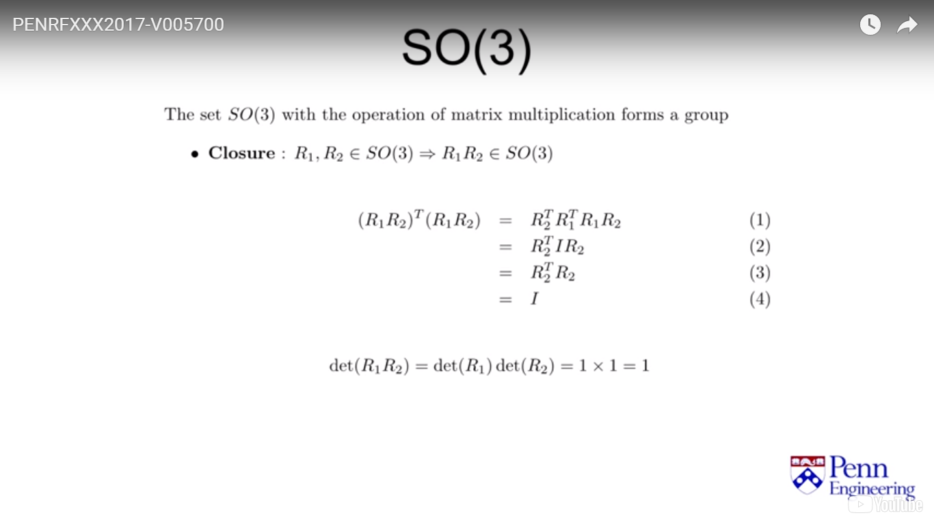
* 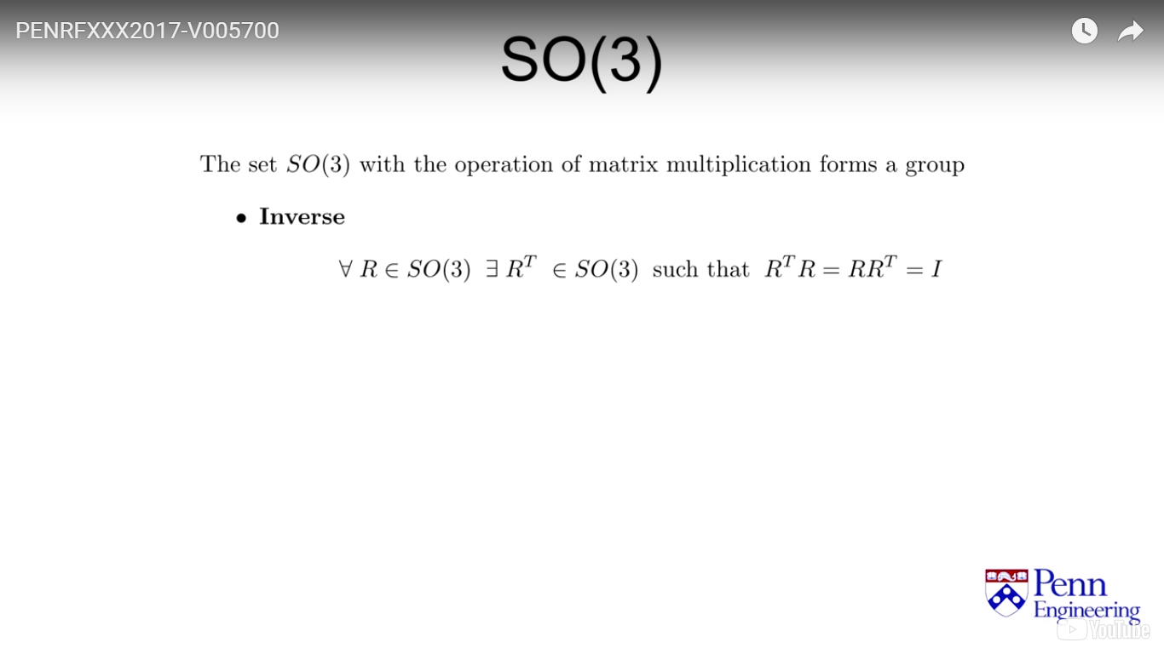For every element R we can find an element opposite to R for which we get the identity element
* Using group theory for rotation Matrices we can observe that:
  + The Identity element is unique
  + The Identity matrix is a two-sided identity.
* The instantaneous velocity **v** of a vector **P** that rotates with angular velocity **ω** can be expressed by:

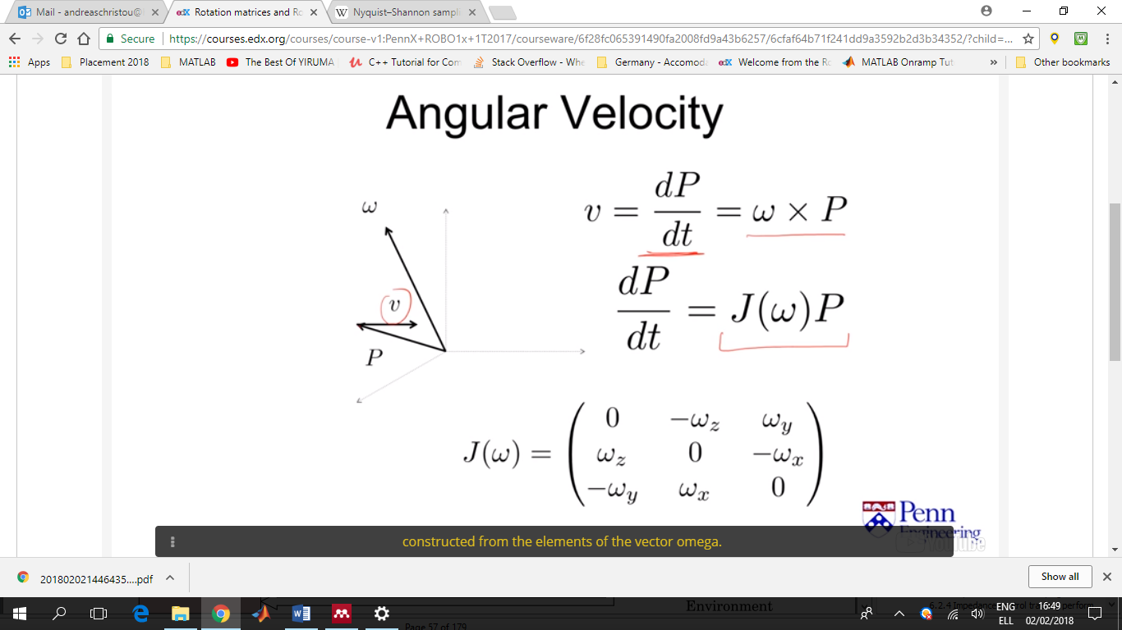

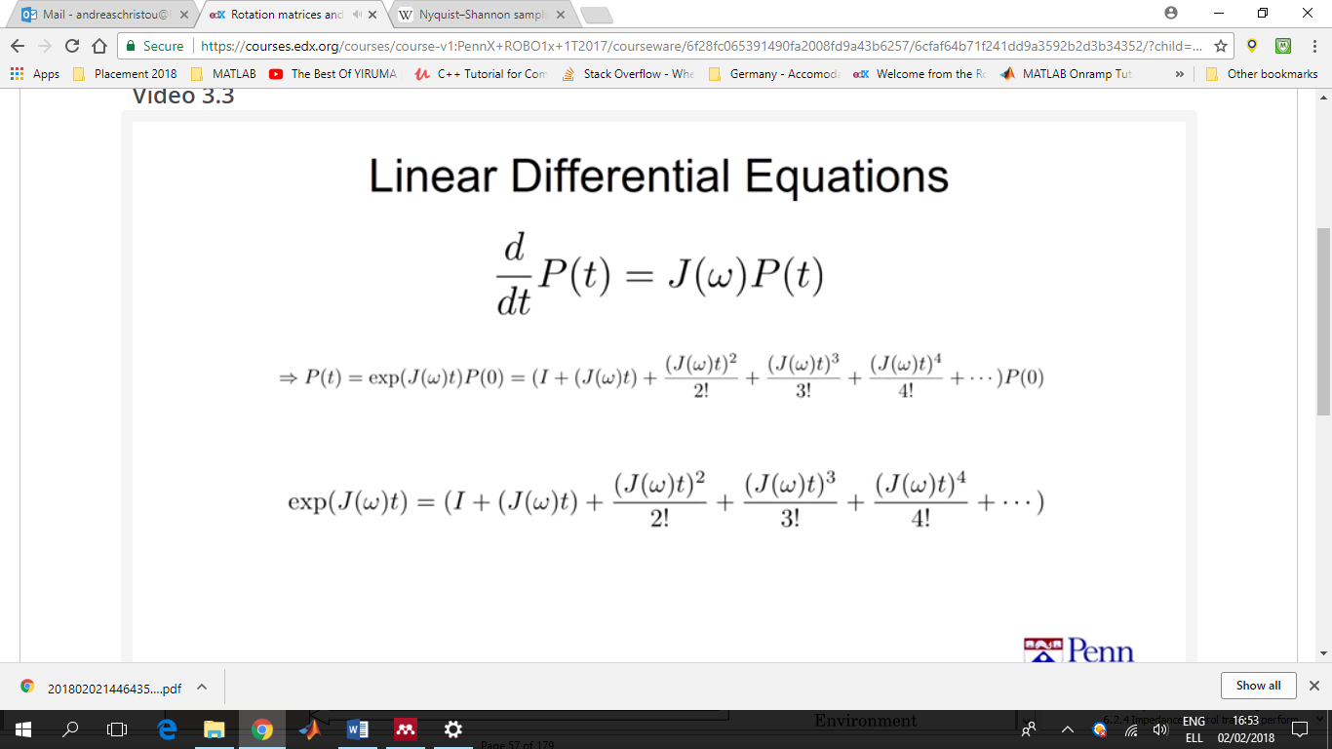Which can be seen/solved as a simple linear differential equation:

This allows us to express all rotations and rotation matrices as an infinite sum of some angular velocity of omega over a period of time.

* 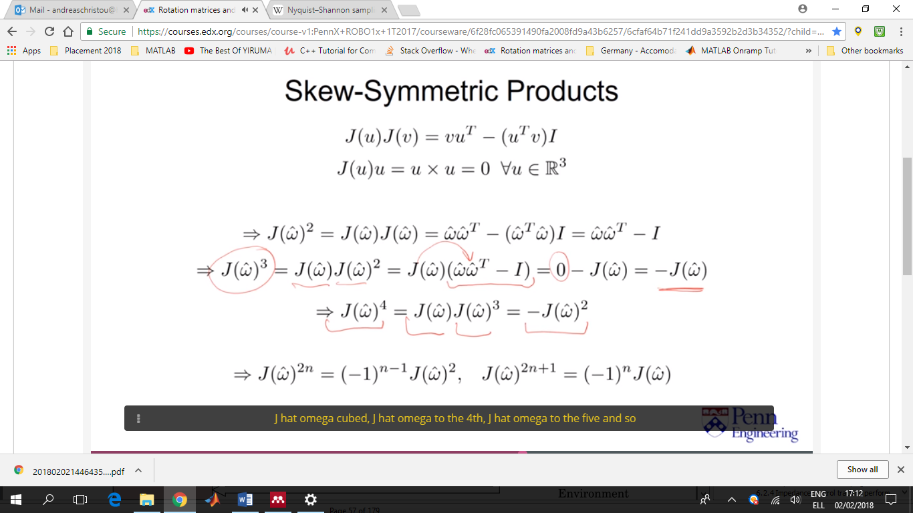

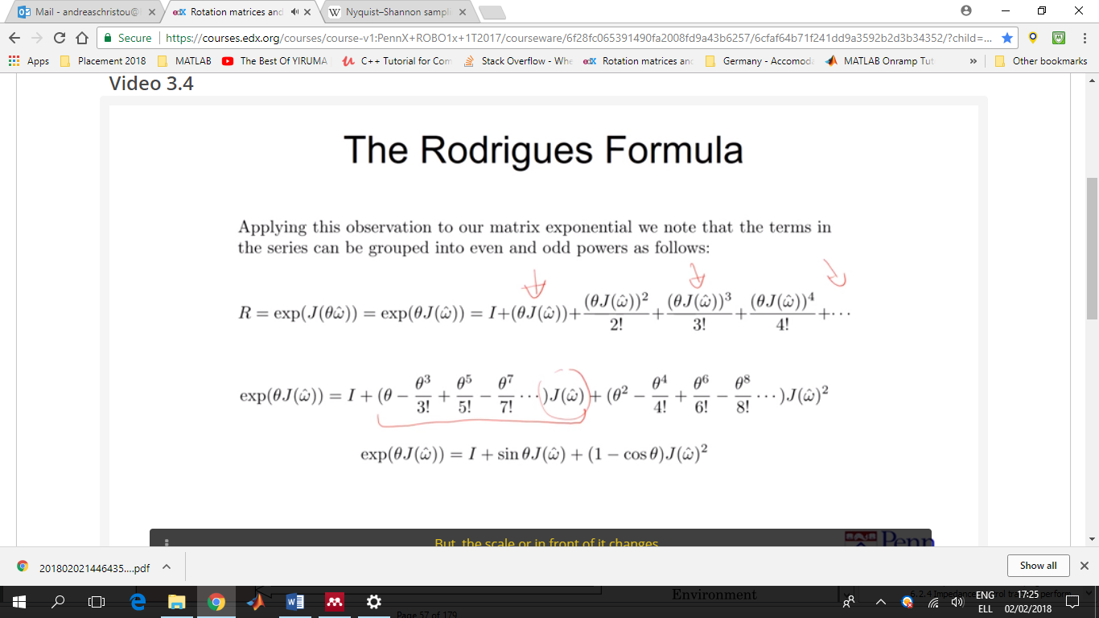

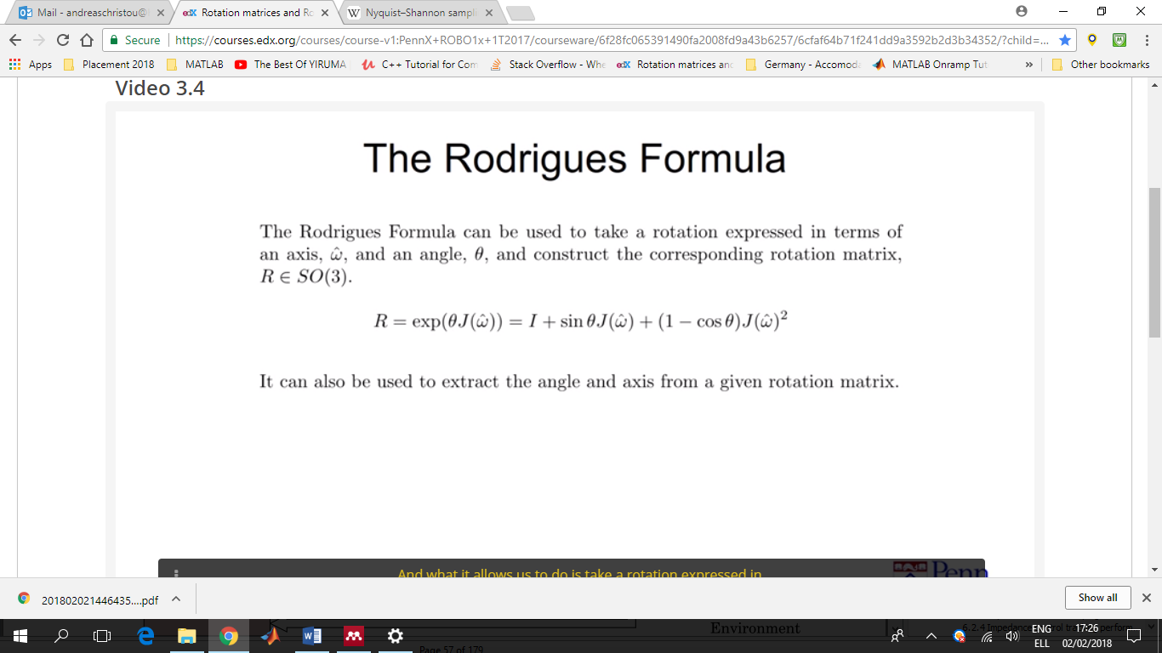

Where θ is simply the magnitude of the angular velocity ω, i.e. ω=θώ (ω hat)

* Quaternion = A tuple consisting of a scalar part and a vector part (it has a total of 4 terms)

q=(u,**u**)

=u**i**+u**j**+u**k**+u0

* Quaternion Multiplication

(w0,**w**)(y0,**y**)=[ w0y0-**w**T**y** , w0**y** + y0**w** + **w** x **y** ]

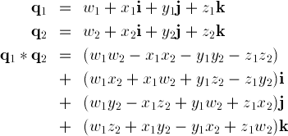

* Unit Quaternion

q02+q**i**2+q**j**2+q**k**2 = 1

* Unit quaternions with the operation of multiplication form a Group
* A rotation that is expressed by an angle θ and an axis **ω**^ can be expressed as a unit quaternion where:

(u0, **u**) = ( cos(θ/2) , sin(θ/2)**ω**^)

The opposite is also true. A 3x3 rotation matrix can be constructed given a **unit** quaternion expressed in the form above.

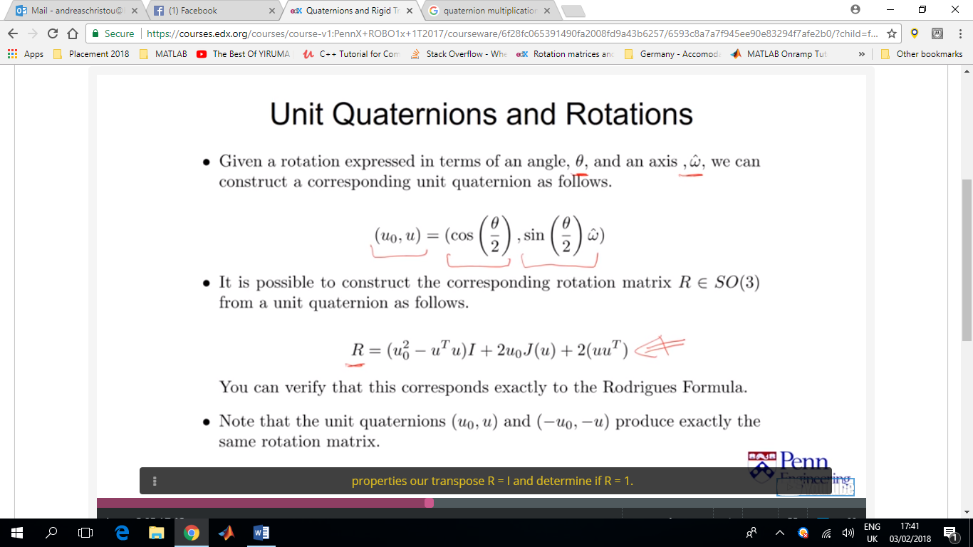

Which corresponds to the Rodrigues Formula.

Note: **q^=**(u0,**u**) and -**q**^=(-u0,**-u**) produces the same rotation matrix

* 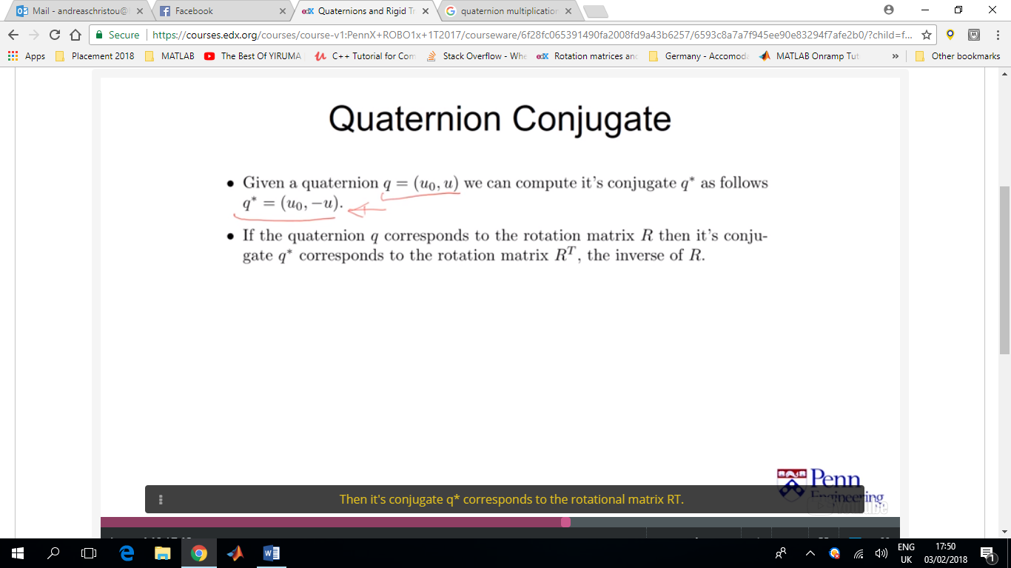**q\***=(u0,-**u**) is the quaternion conjugate of **q** (defined above)

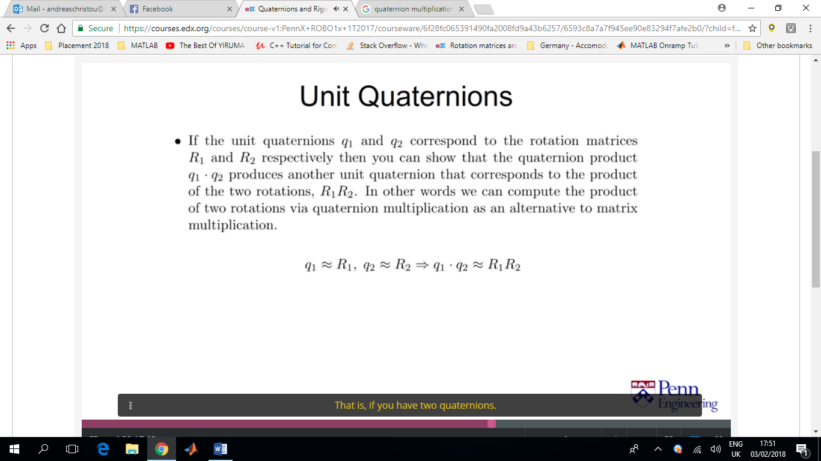

* The outcome of a quaternion multiplication on a computer can be easily renormalized by simply dividing through by the norm of those four numbers. Unlike in matrix multiplication of rotation matrices that when carried out on a computer loses accuracy in the long run and renormalisation is harder.
* Quaternion multiplication is also a more compact way of performing multiplication compared to matrix multiplication (4numbers vs 9numbers)
* This makes quaternion use preferable in robotics, computers vision and graphics to represent rotations.
* Now that we know how a rotation matrix is defined we can see how they can be used for a rigid body transformation

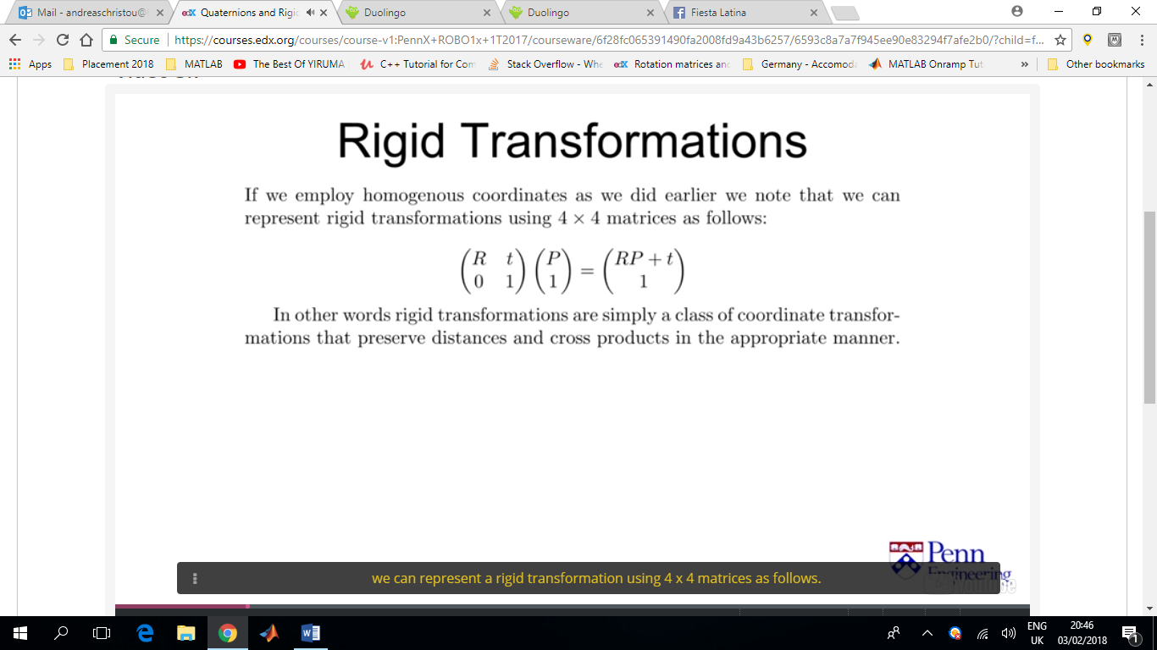

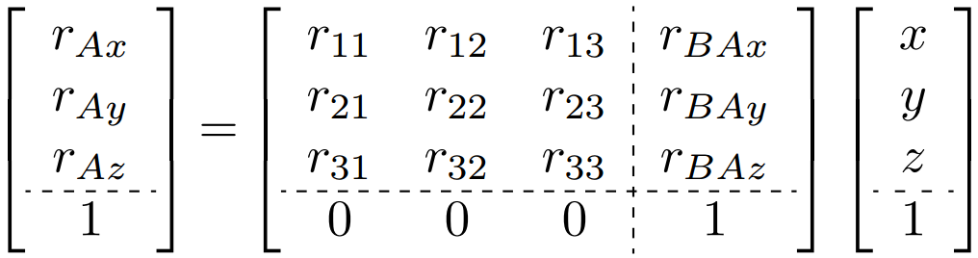

* Rigid body transformations can be composed as they form a group under the operation of multiplication, meaning that a rigid body transformation can be applied on another rigid body transformation to form the combined rigid body transformation.

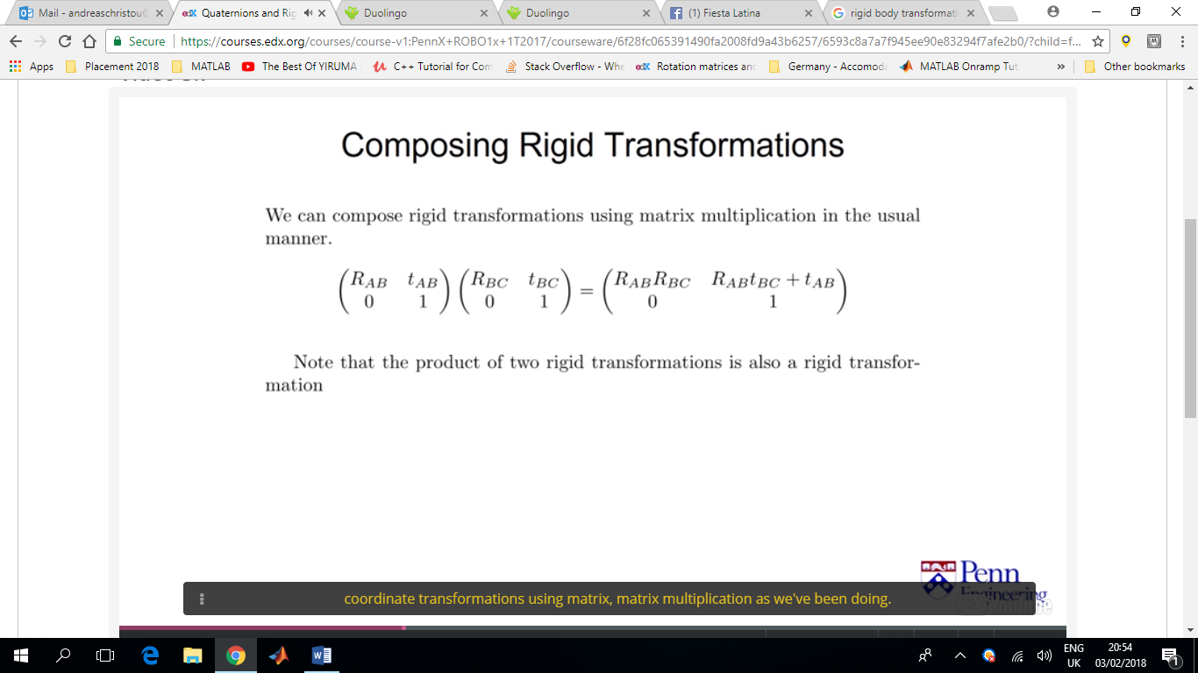

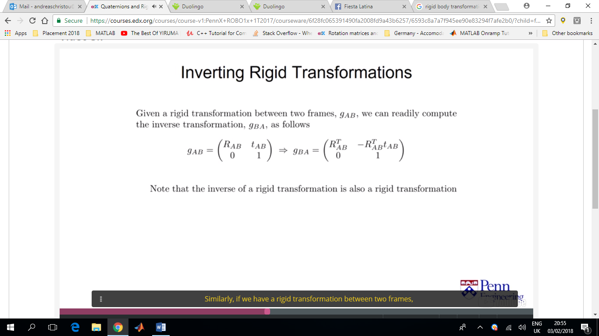

* 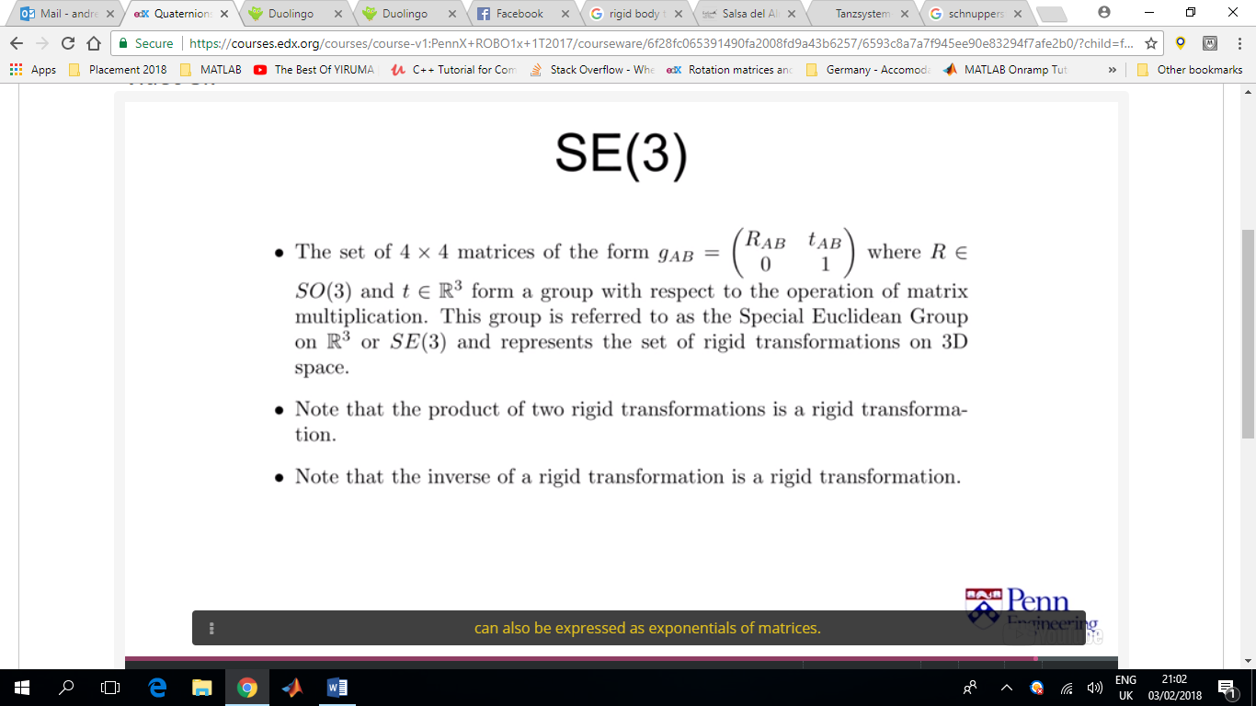
* 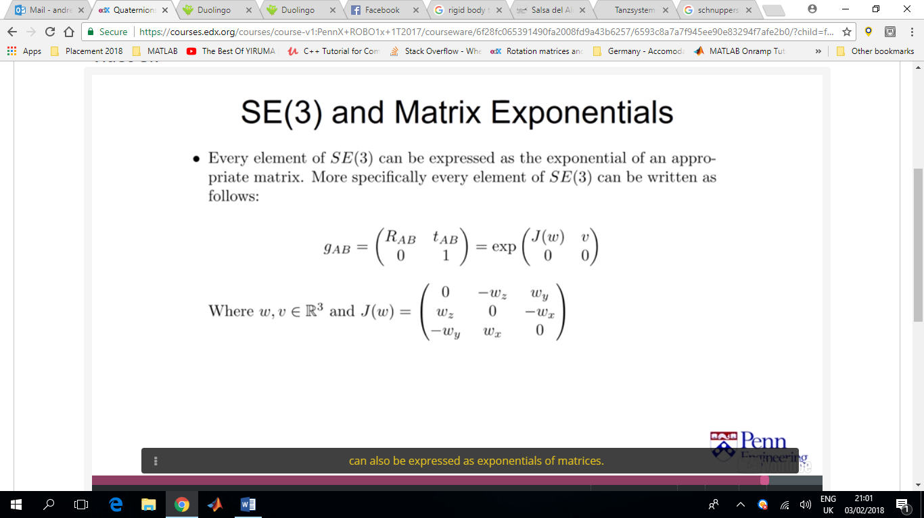

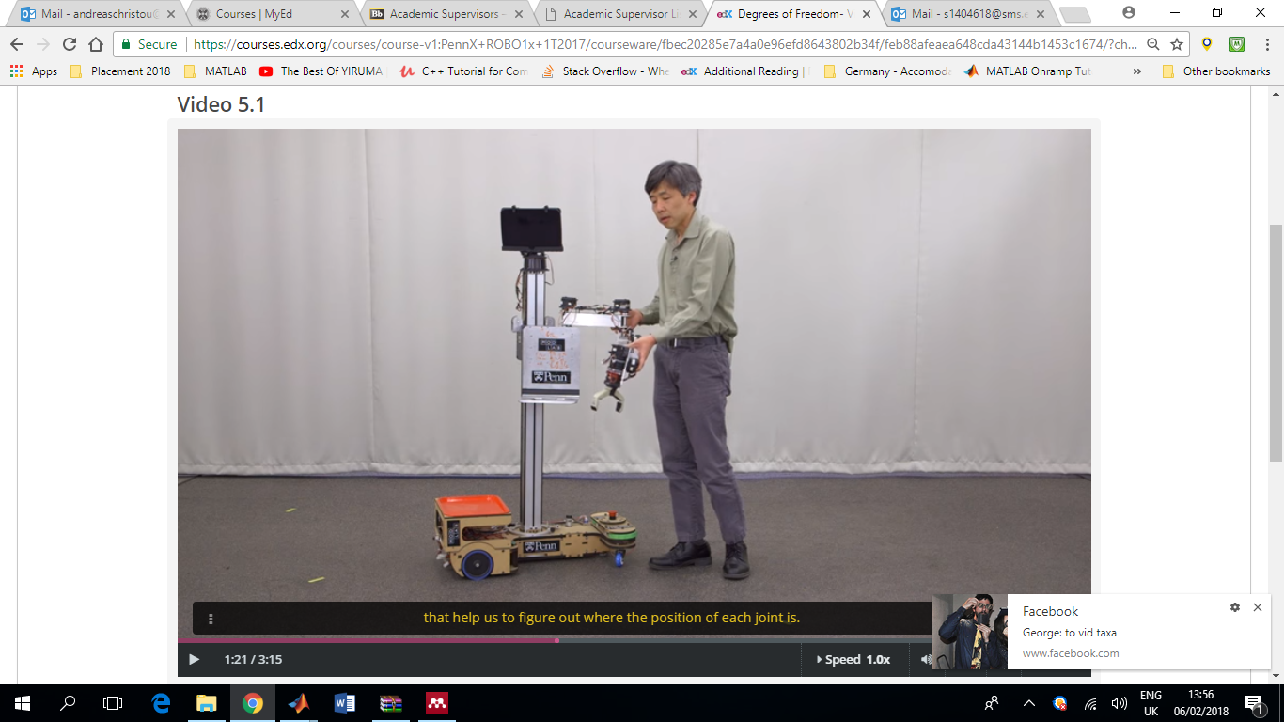

(Mobile) Manipulator

(Mobile) Base

Joint angle sensors to help us figure out where the position of each joint is.

In Kinematics we want to be able to figure out the position and orientation of the different parts.

Kinematics=The motion of rigid bodies (velocities and accelerations are also part of kinematics)

Prismatic Joint = Linear in motion

Revolute Joints = Joints that can bend like elbow

End effector = The end of a robotic arm (can be a gripper, torch for welding, a human arm, camera etc)

Degrees of Freedom = How many dimensions do we need to describe the motion of the rigid body (usually in free space we need xyz &’roll’’pitch’’yaw’ -for rotations- a total of 6 dofs)

Roll = rotation in x, Pitch = rotation in y, Yaw = rotation in z

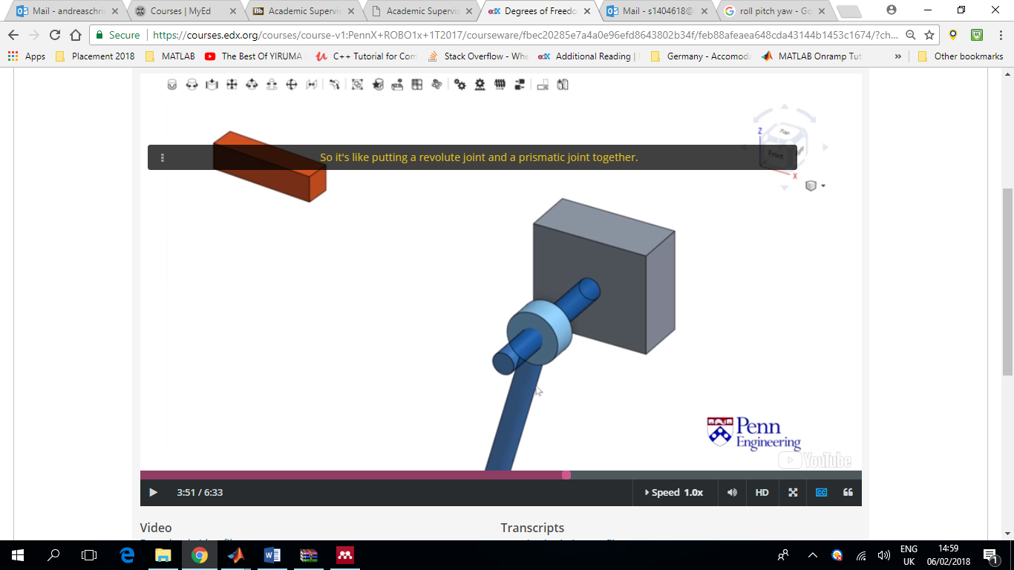Cylindrical Mate = Prismatic Joint + Revolute Joint

(spatial constraint, not planar)

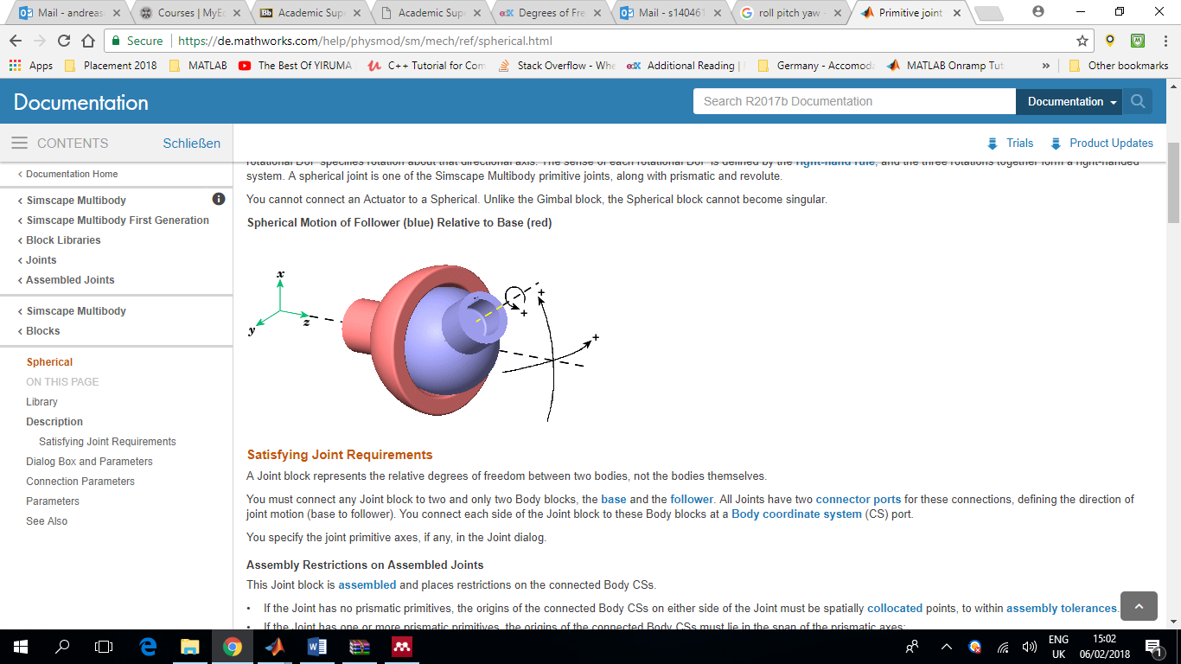

Spherical Joint/Ball Mate = 3 DoFs

Screw Mate = Just like the cylindrical joint but where the translation and the rotation are coupled. Which means that if the body rotates it must translate as well. Therefor there is only one degree of freedom that can be used to describe the position and orientation of the rigid body.

Universal Joint = Very common in robotics. Similar to the Spherical Joint where the third degree of freedom is constraint. (usually made up of more than one rigid body)

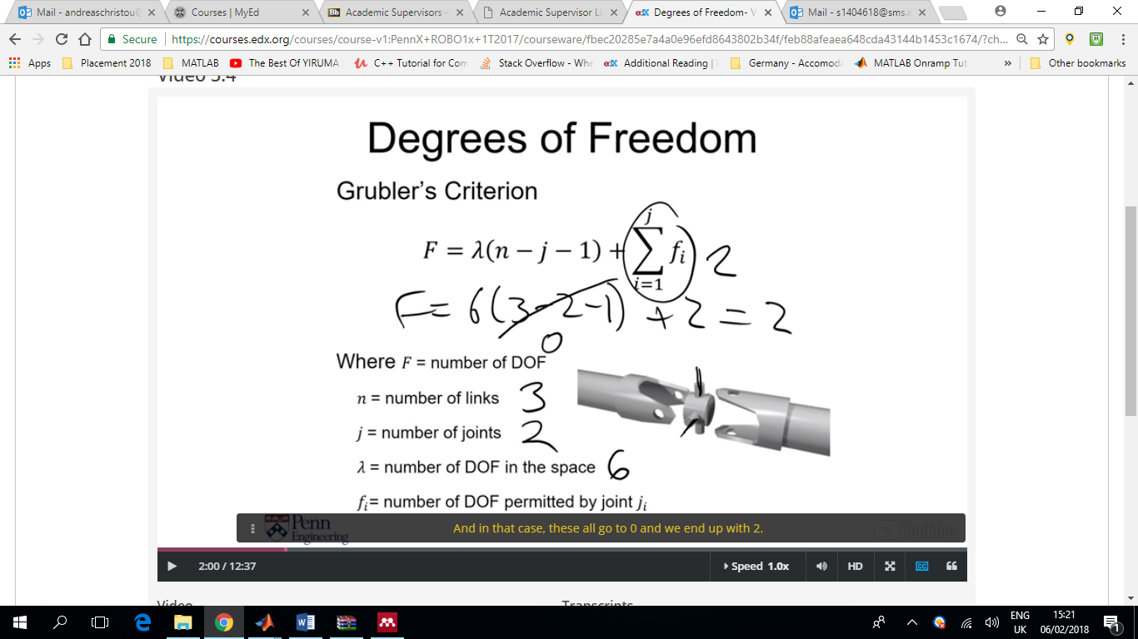

Figure Grubler's Criterion

n = number of links (rigid bodies)

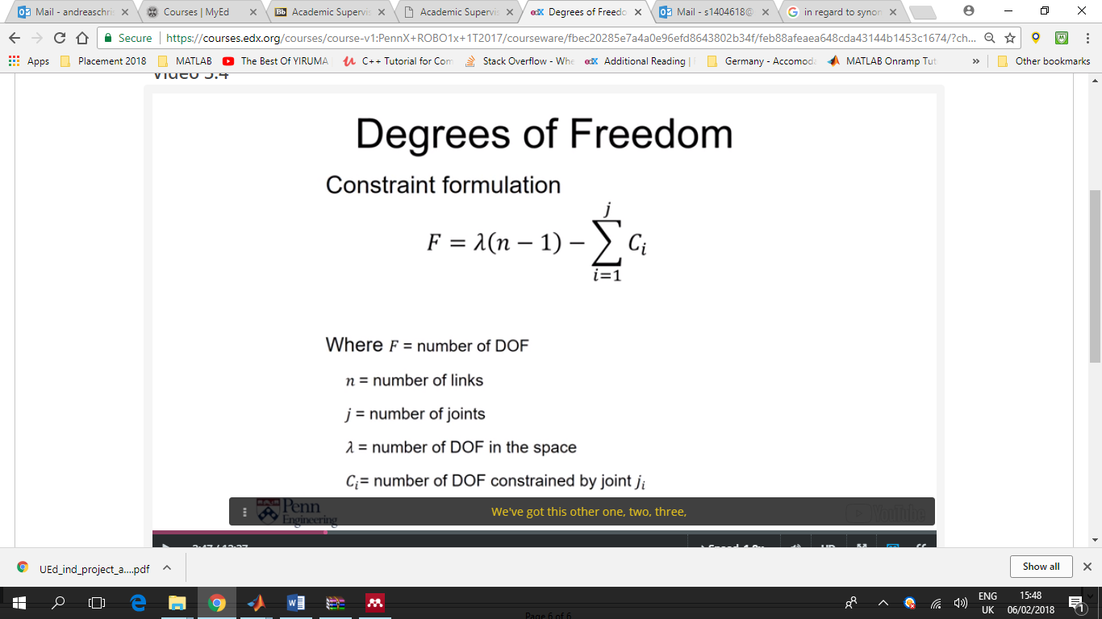Similarly another method to calculate the degrees of freedom is by using the constraints method.

In the example in figure 1 this would result in:

F = 6 ( 3 – 2 ) – 5 – 5

F = 2

For the example in figure 2 this would be:

F = 6 ( 7 – 1 ) – (5 + 5 + 5 + 5 + 5 + 5)

F = 6

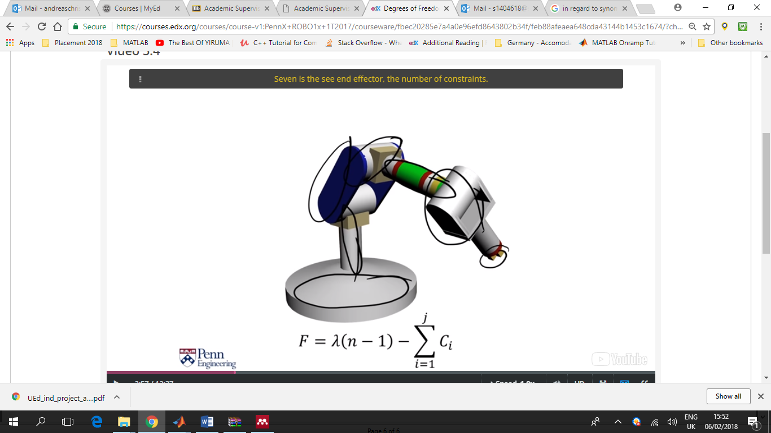

Figure . Dof Example 2

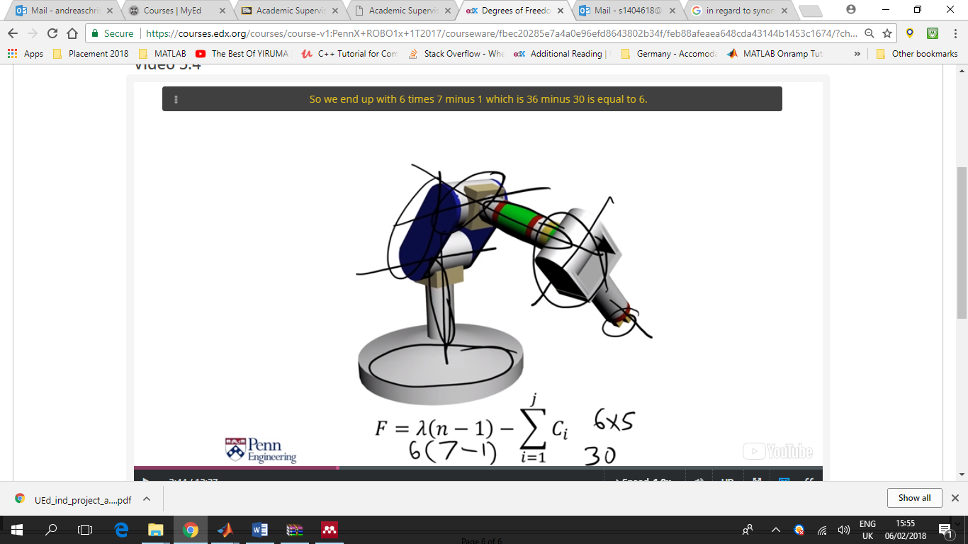

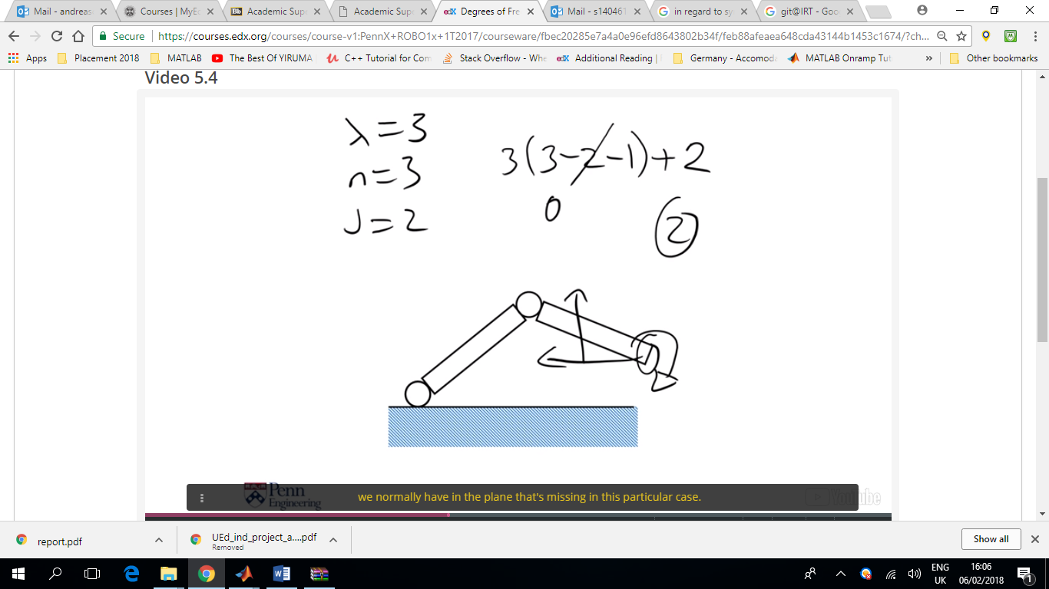

Figure Example 3 (no control of the end effect orientation

Or using the Constraint Method:

F = 3 ( 3 – 1 ) – 2 – 2

F = 2

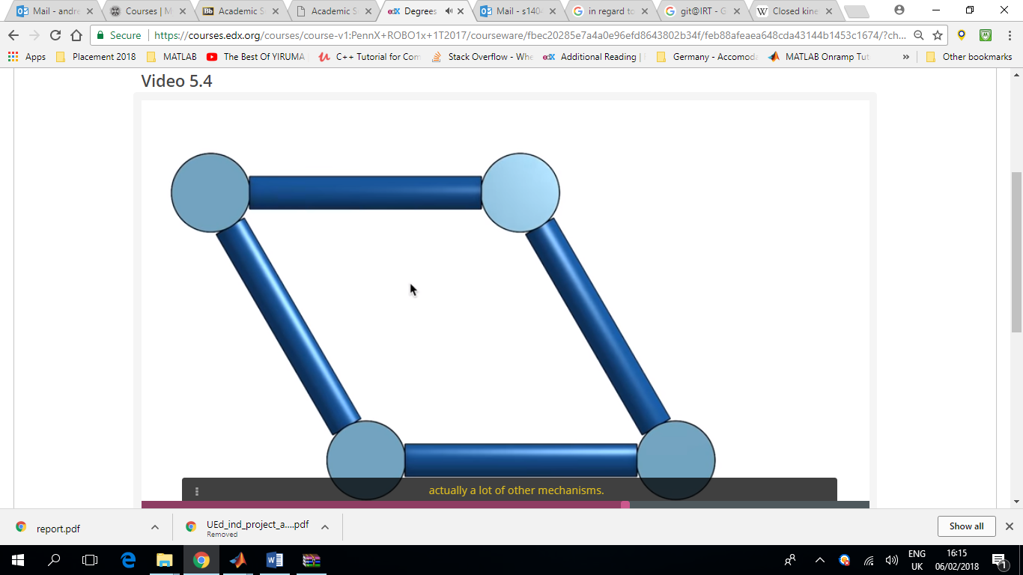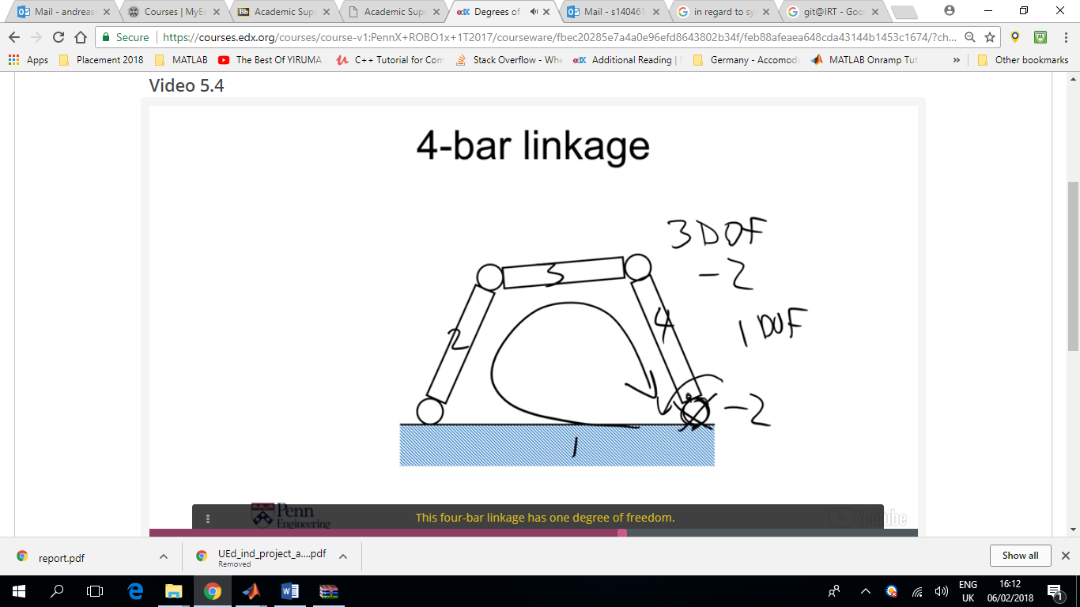

Figure Parallel 4-bar closed chain joint

Figure Example 4 - 1 DoF Closed Chain

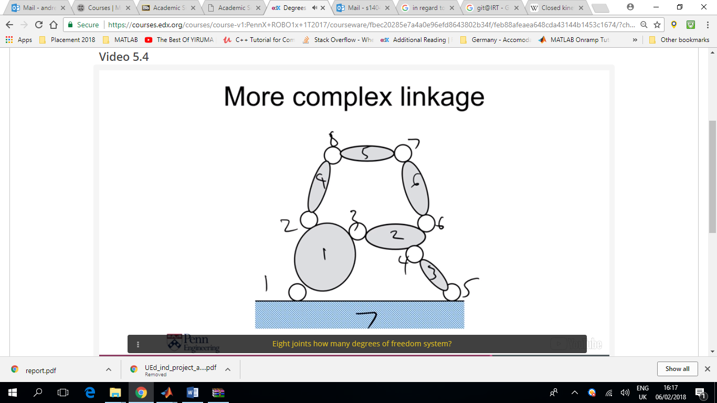

Figure . Example 5 - 7 link, 8 joints

F = 3 ( 7 – 1 ) – (8*2)

F = 2

Can be viewed as two 4-bar linkages

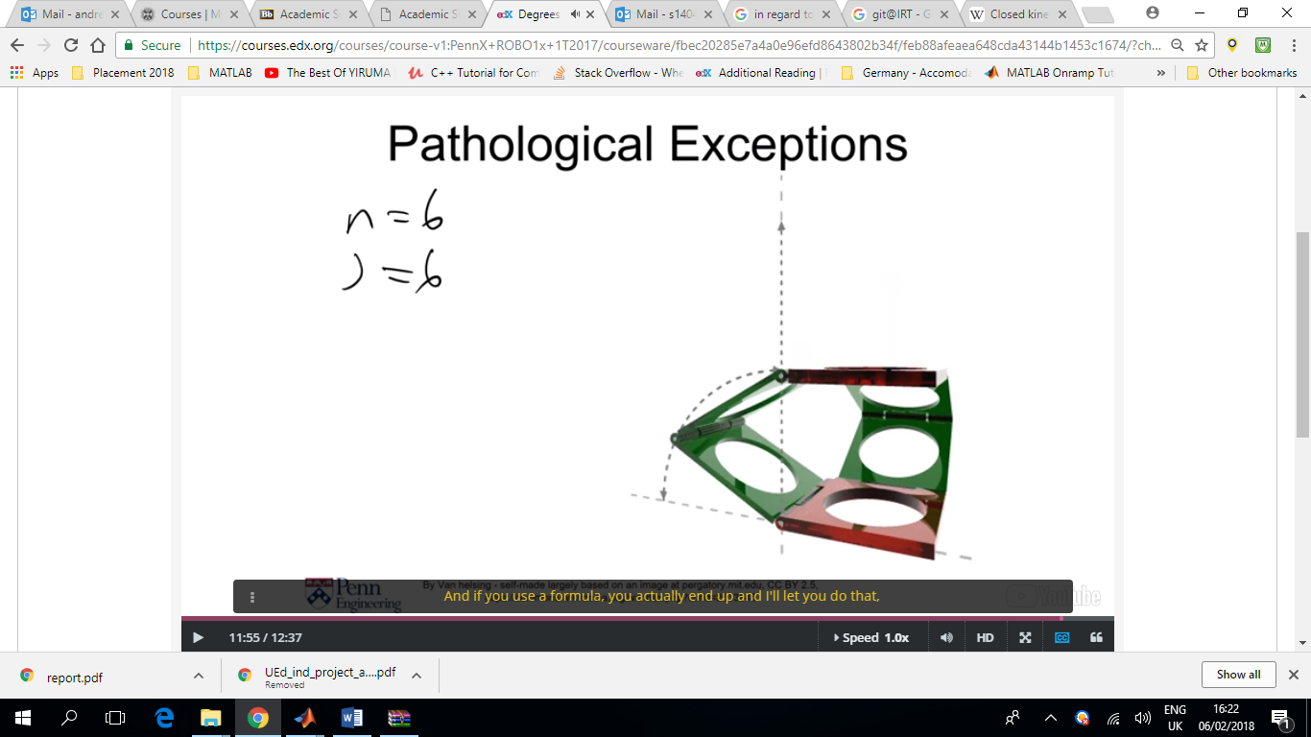Exceptions where the Grubler’s Criterion does not hold. According to Grubler’s Criterion this structure has 0 degress of freedom, yet we can see that it moves. This is because all of the axis are parallel, allowing the structure to move with 1 DoF. If any of the shapes of these links were slightly different, resulting in a different angle, the system would freeze. In this particular case with this particular geometry it actually has 1 DoF.

Forward Kinematics = The positions and orientation of the end effector

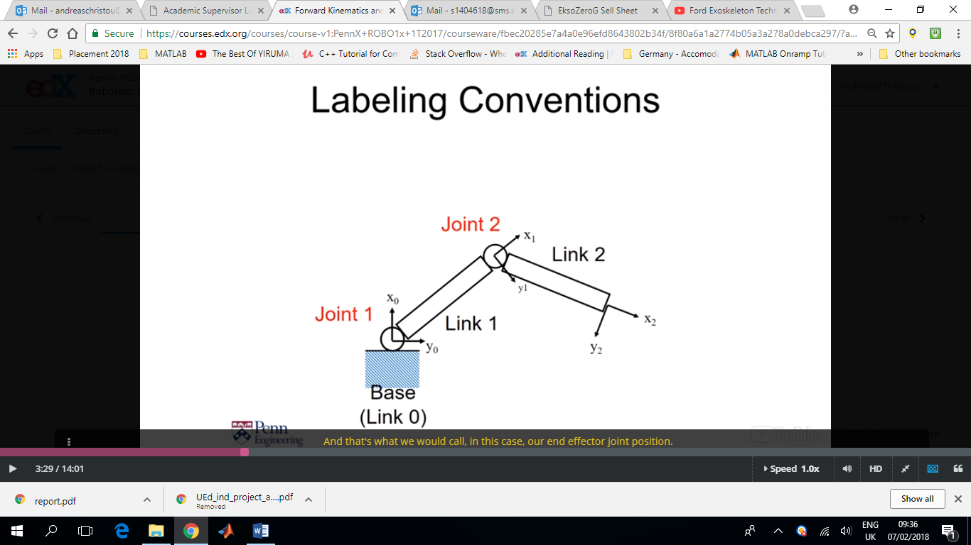

Frame

End effector joint position

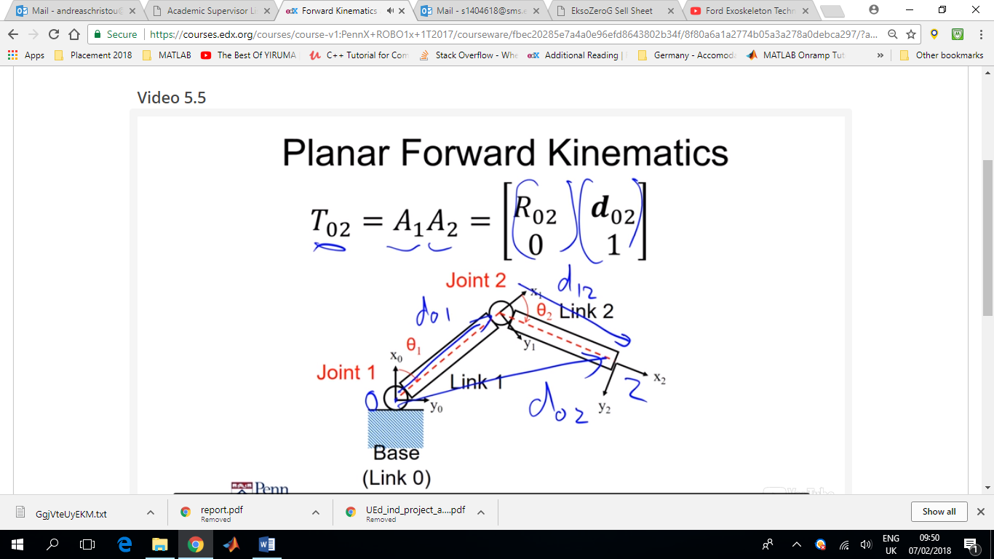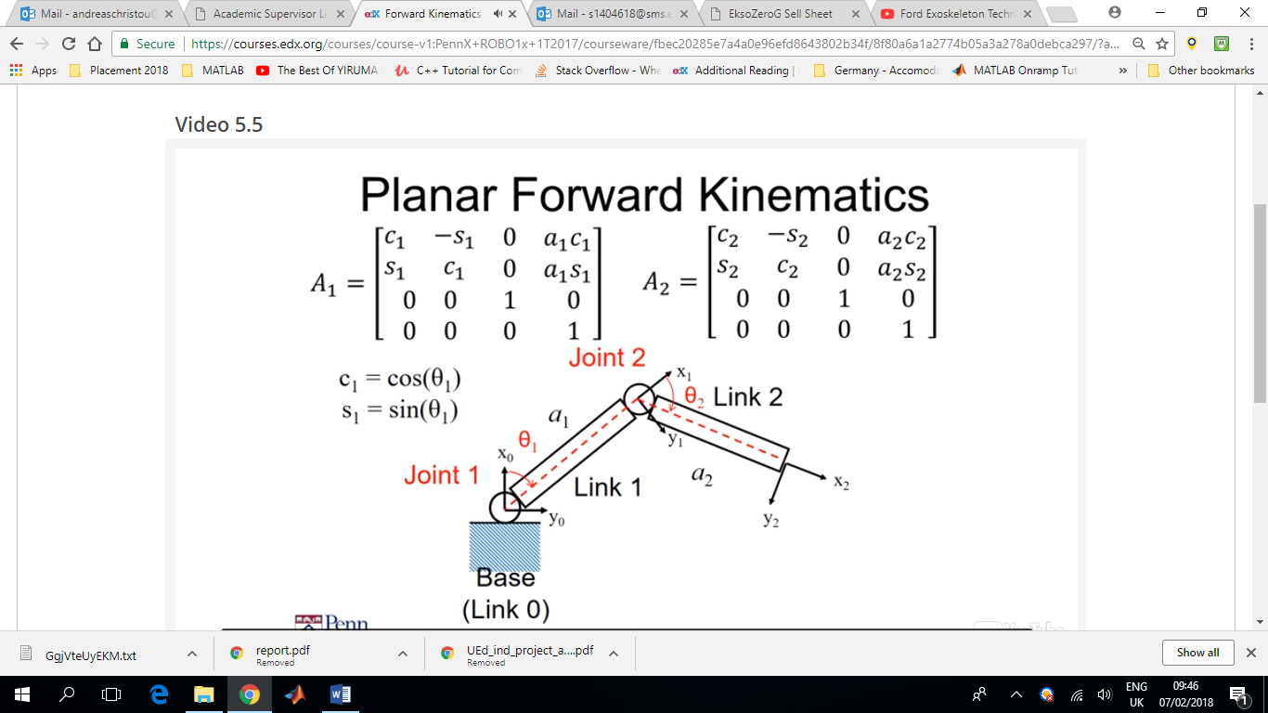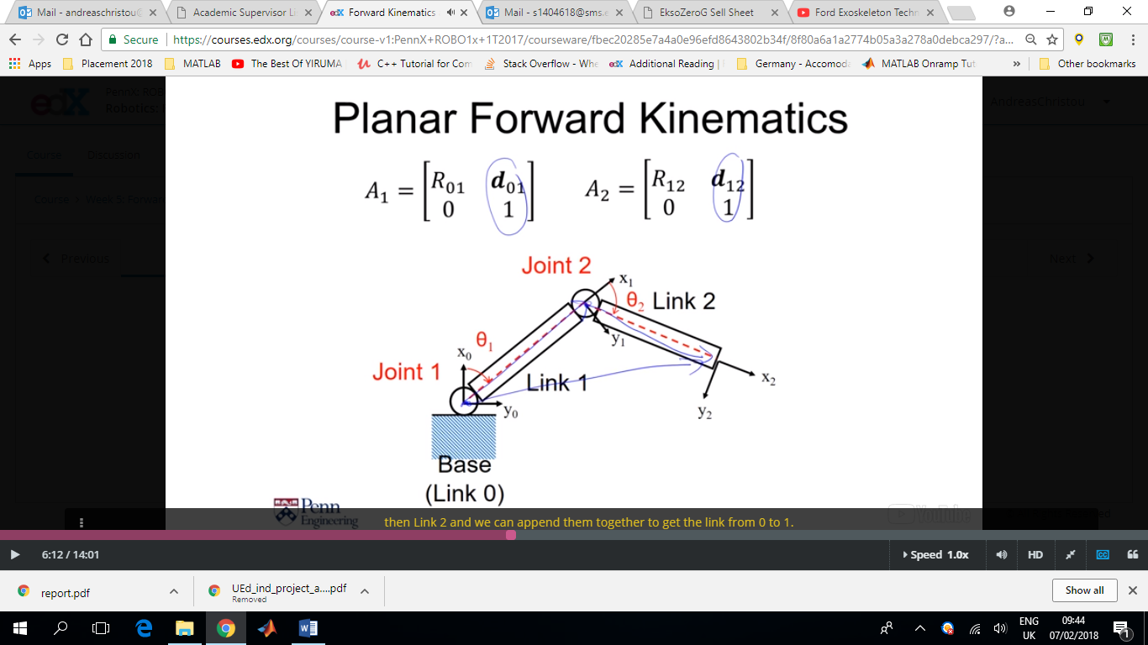

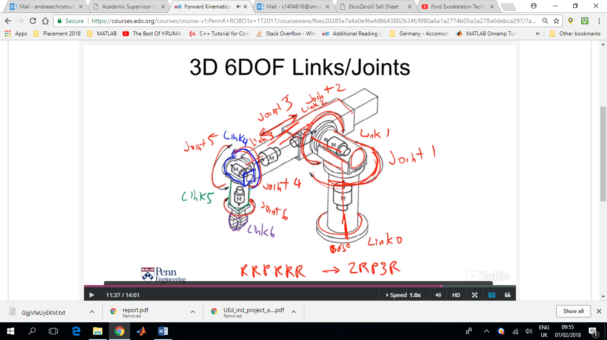 R=revolute joint

P=Prismatic Joint (linear)

In this case, there exist 6 transformation matrices (since we are in 3D space) each of which has 6 variable that need to be defined and forward kinematics might become complicated and tedious.

The Denavit-Hartenberg (DH) Convention is most commonly used as a standard method for defining parameters of robot arms. Uses four (parallel) parameters instead of 6.

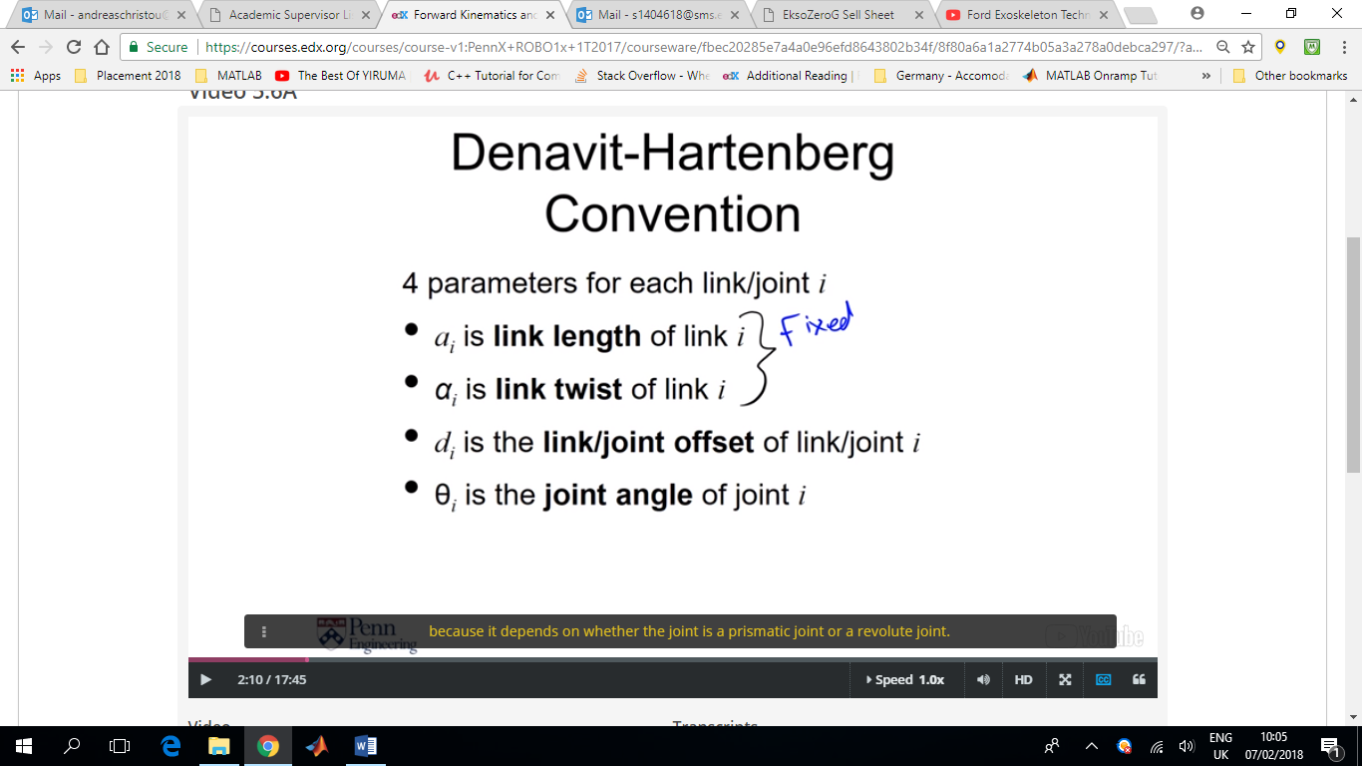

For a Revolute Joint, di is also fixed whereas θι is variable

For a Prismatic joint is the opposite.

We usually call the joint variable **q**i for convenience.

Sometimes ri is used instead of ai since r is visually more distinct from α.

For Angles we always use Greek letters, α, θ, φ etc

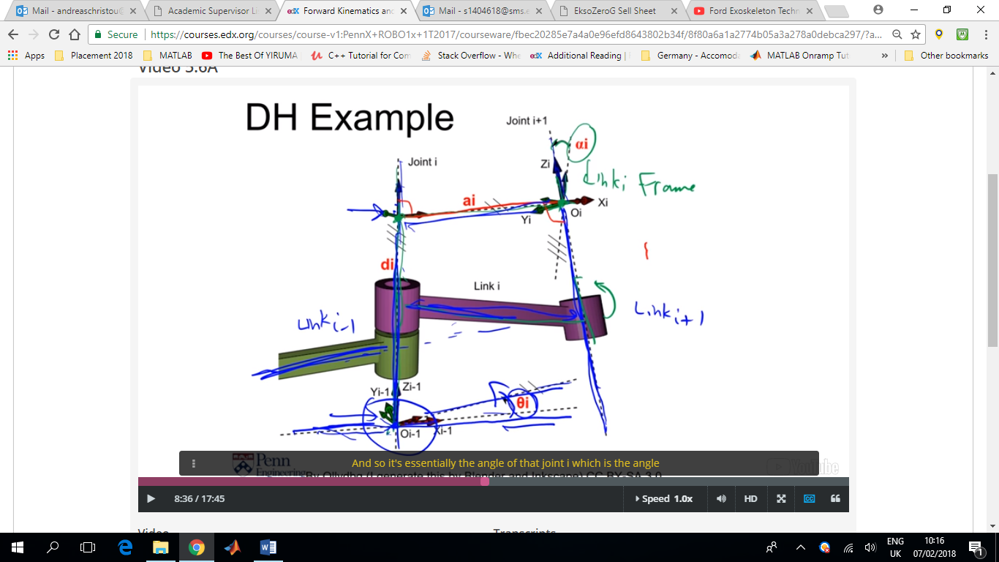

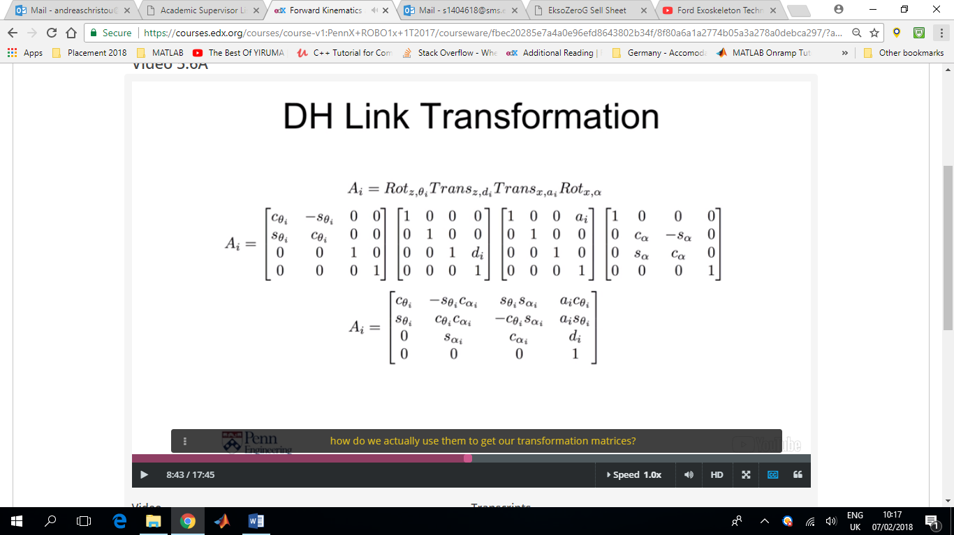

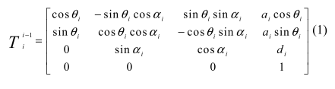

Right hand rule both for rotation and axes system

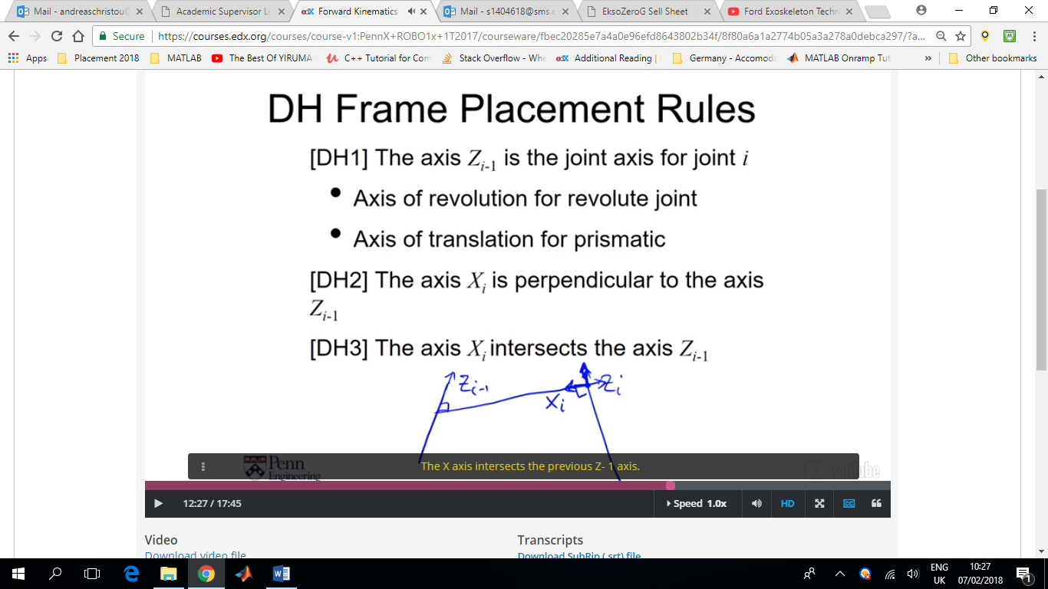The x-axis is the shortest distance between the two z-axes. It can point in whichever direction we choose.

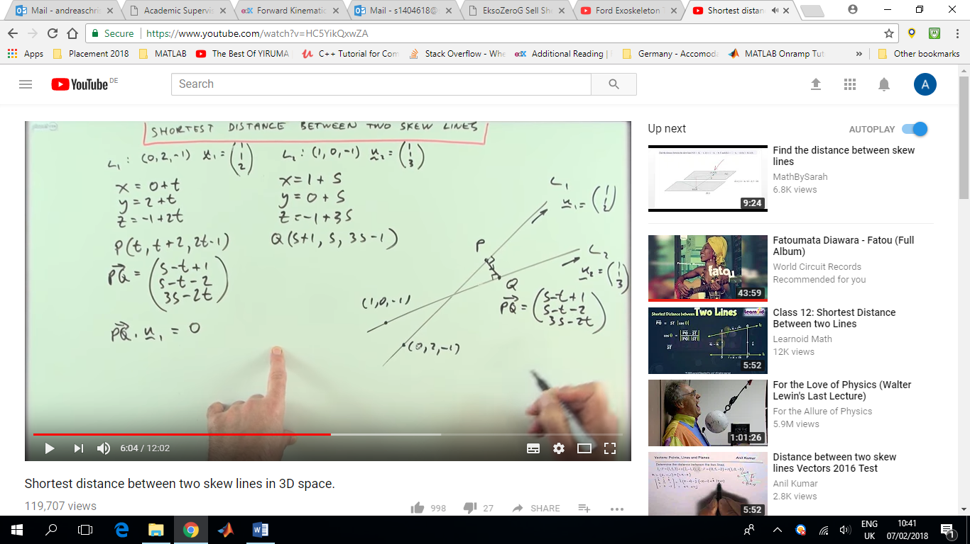

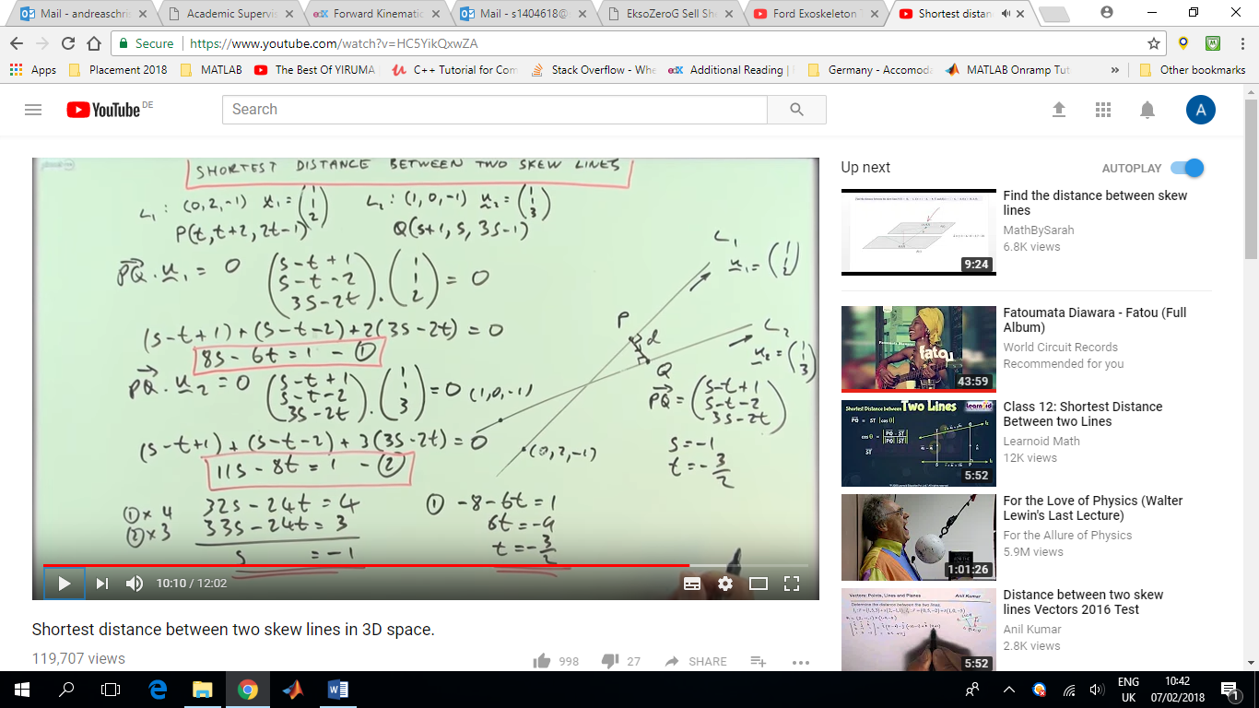

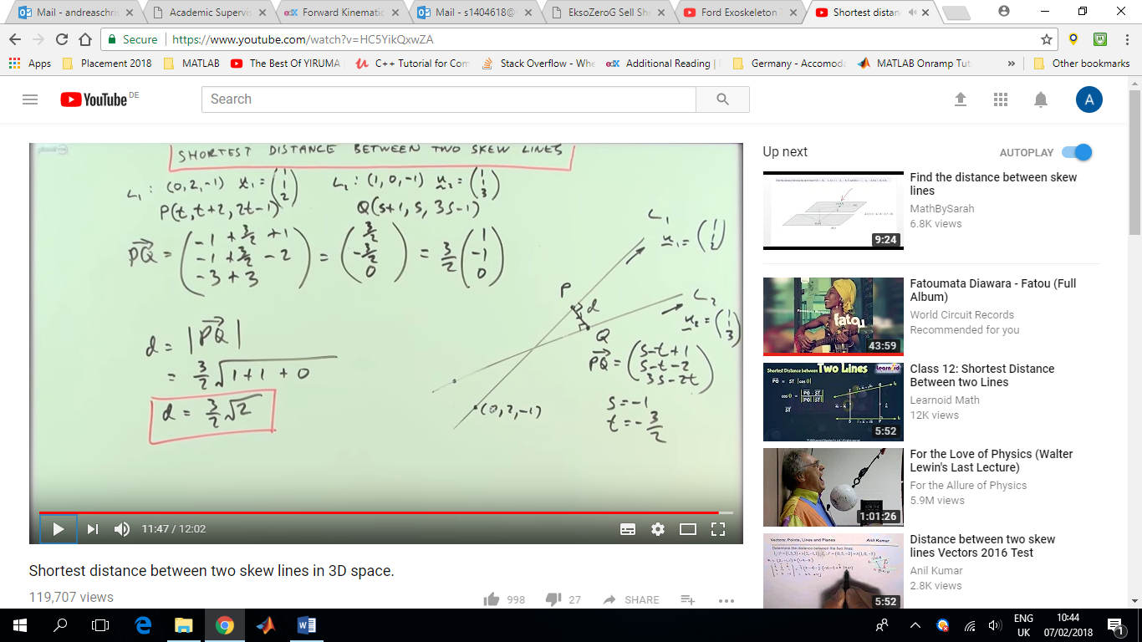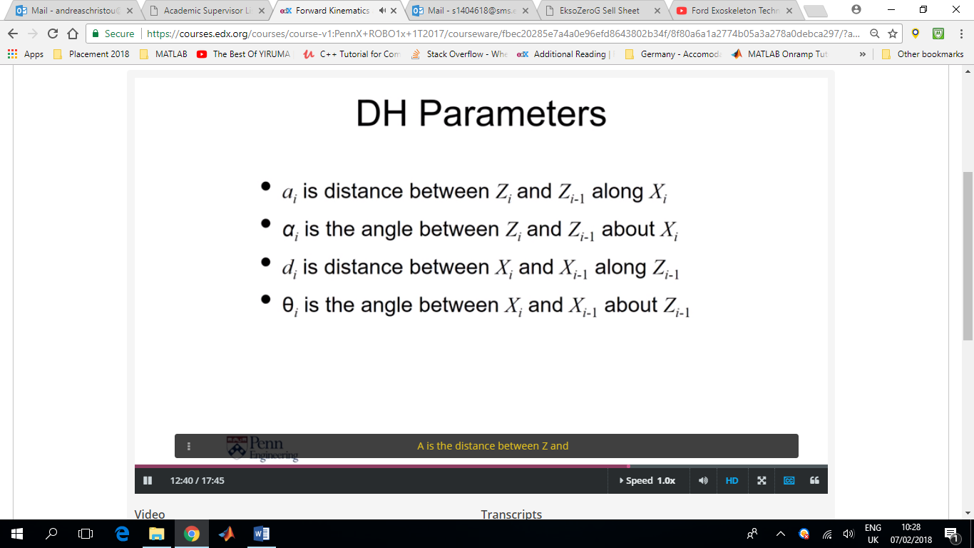

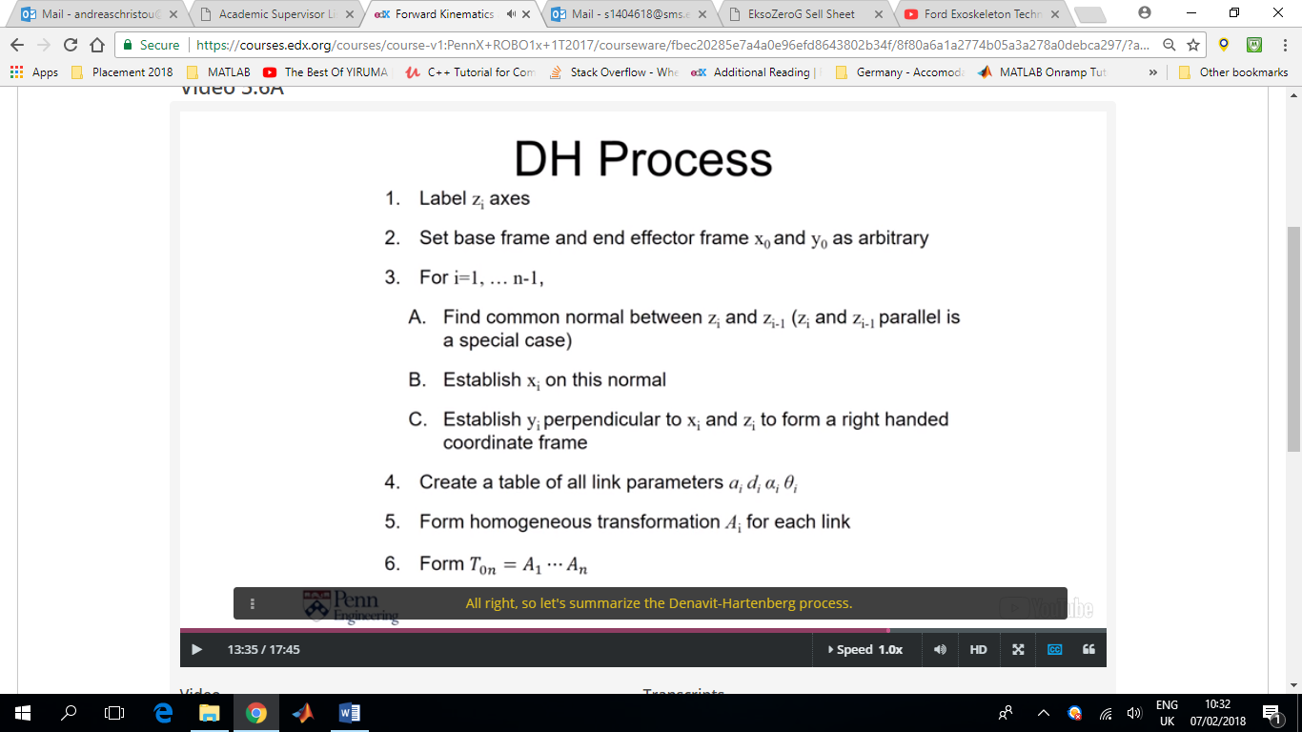

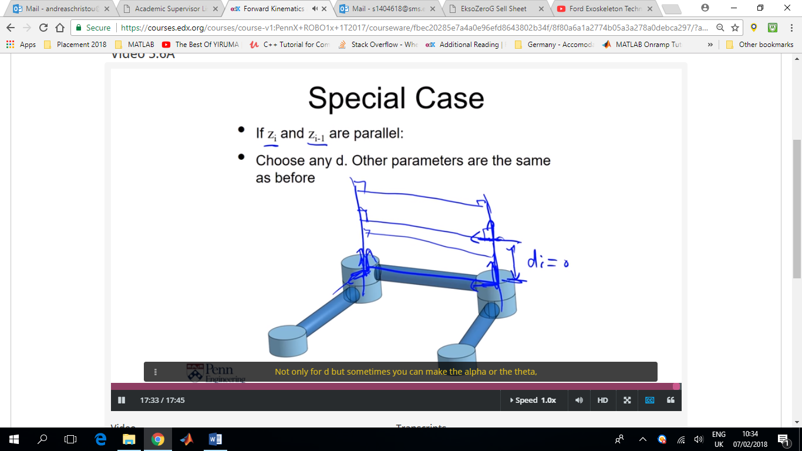

Standard colouring of axis = RGB (red, green, blue) for XYZ

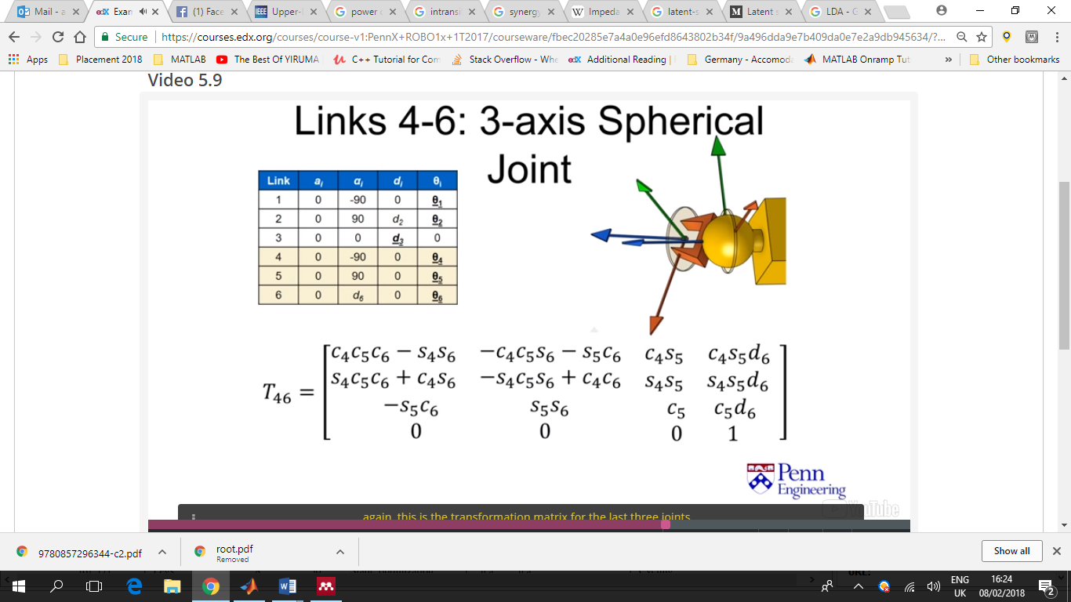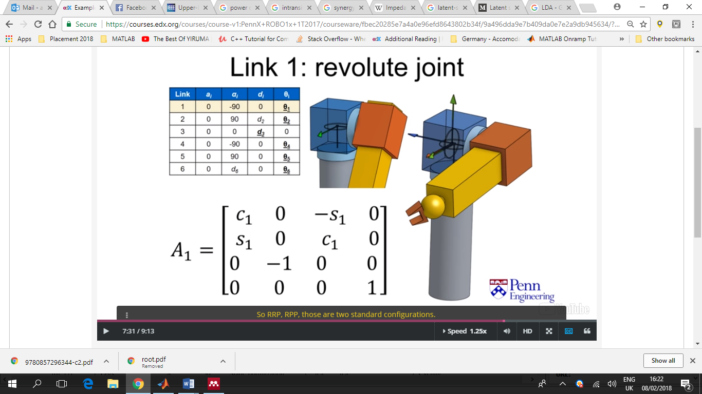

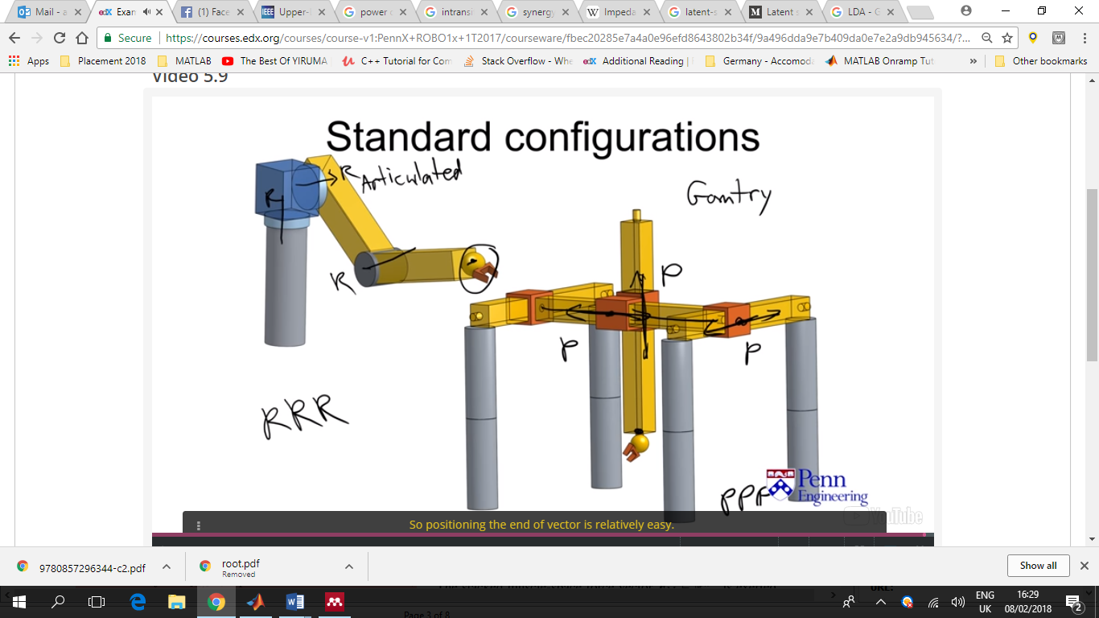

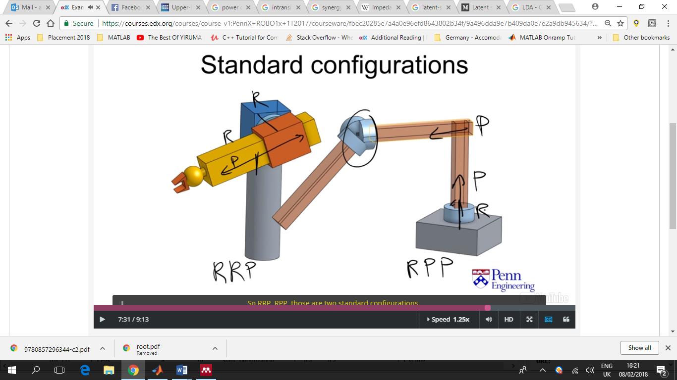

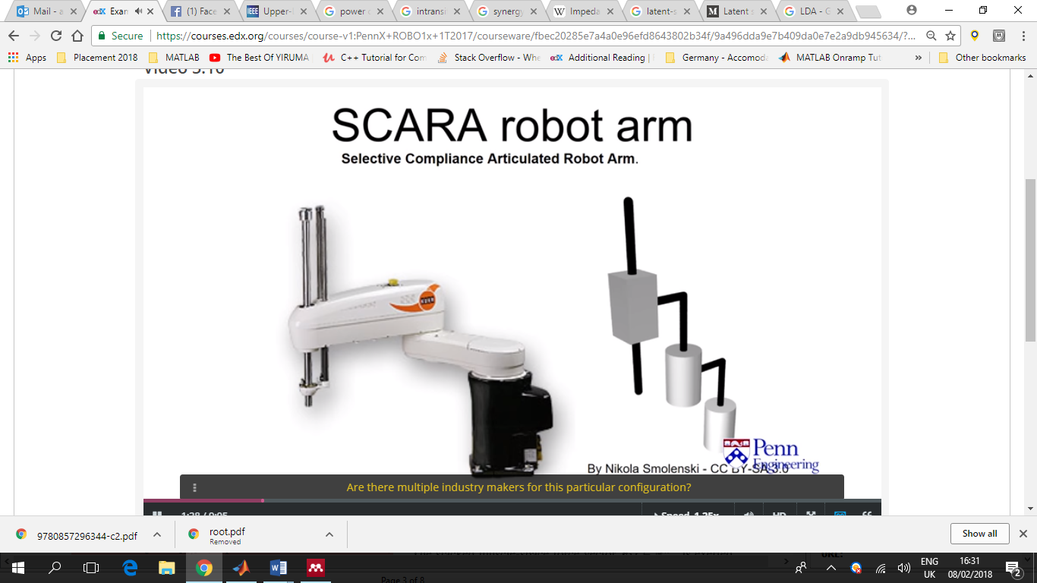

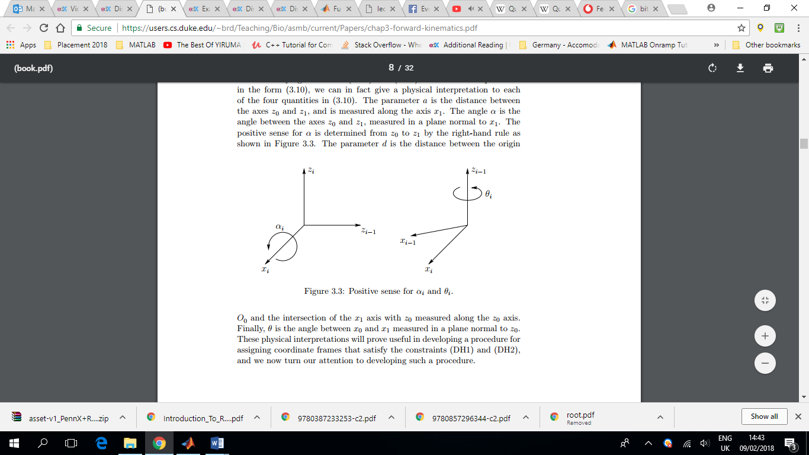

Forward Kinematics = Use the angles to find position and orientation of end effector

Inverse Kinematics = Assuming you know where you want the end effector to be, calculate the possible solutions of angles that can get the end effector to that point.

**H** = position and orientation of end effector

**R =** orientation & **P =** position

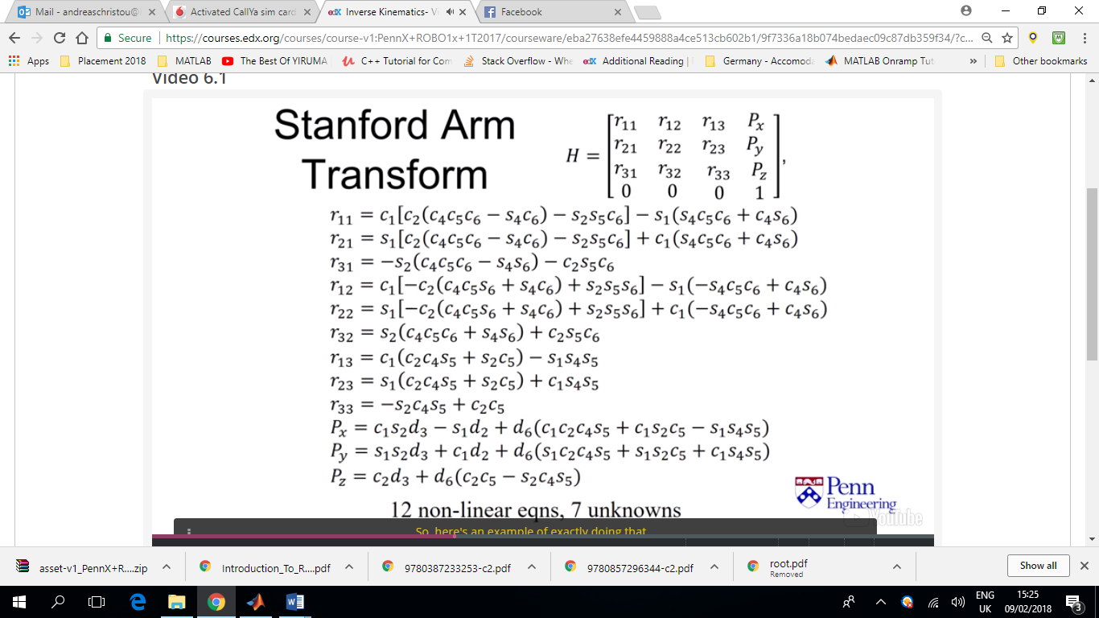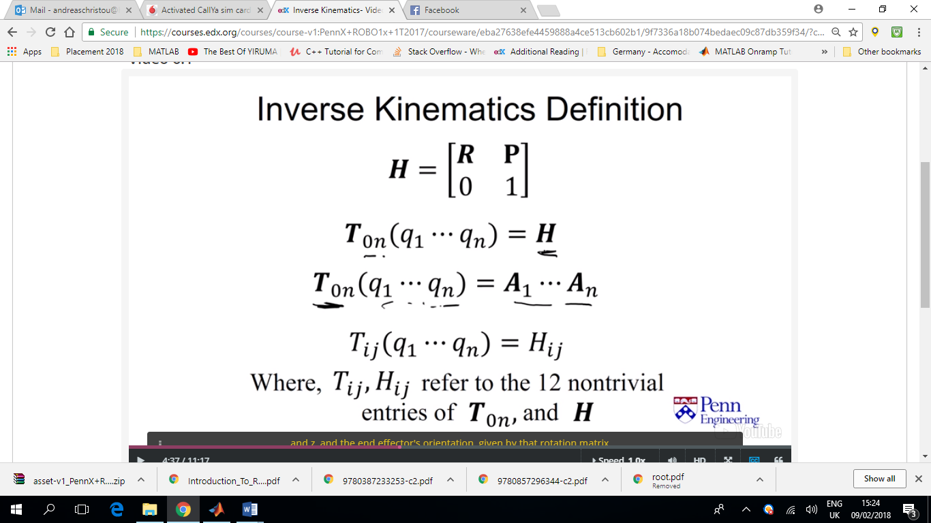

The Stanford Arm does not have any ‘a’ DH parameters that’s why they do not appear in the figure above.

Moreover, most alphas are either π/2 or π which with sins and cosines become 1s and 0s and thus they do not appear in the figure above either.

7 unknows?

Iterative solutions are usually slower, and the time required to find a solution might be variable and thus cannot be predicted.

But exact solutions exist (algebraic, geometric, IKFAST C++)

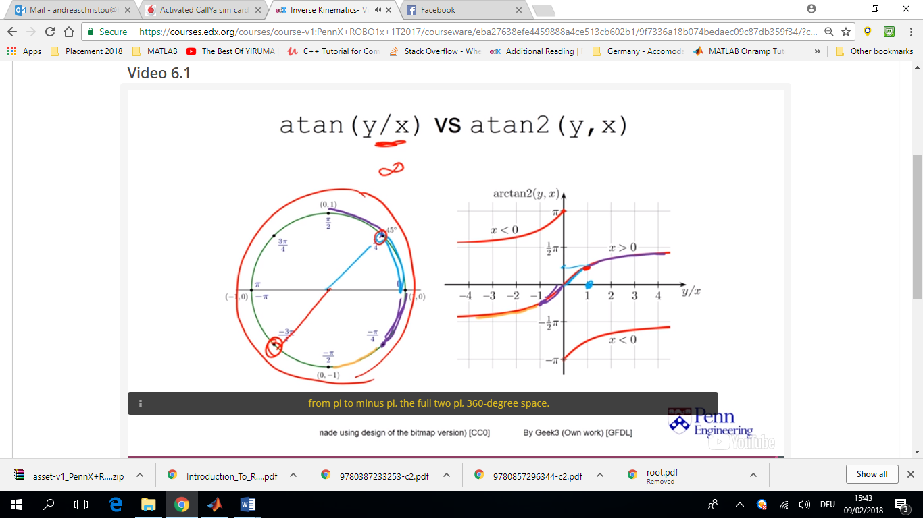Using atan.m and atan2.m

atan() has problems because it uses as input y/x. so if y=1 and x=1 a value of π/4 will be given.

However the same output would be given for the case of (-1,-1) which is not true. atan() covers from (-π/2<θ<π/2). **Always use atan2()!!!**

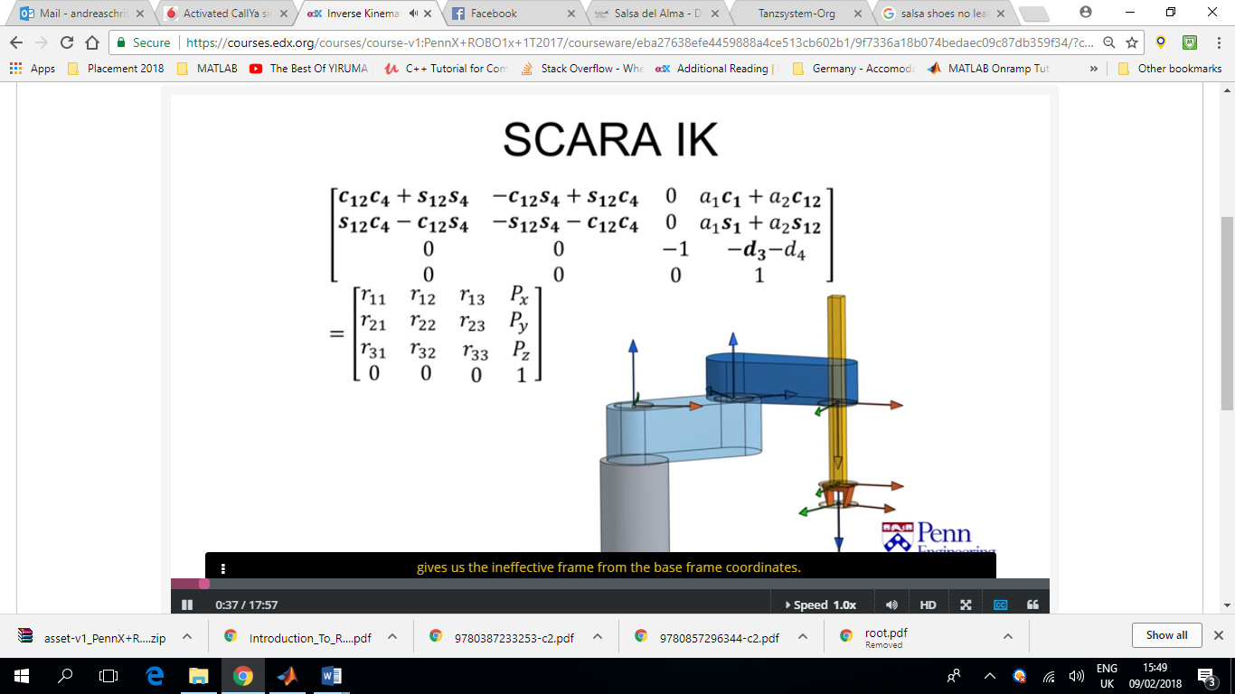Example:

Unknows

* Theta1
* Theta2
* D3
* Theta4

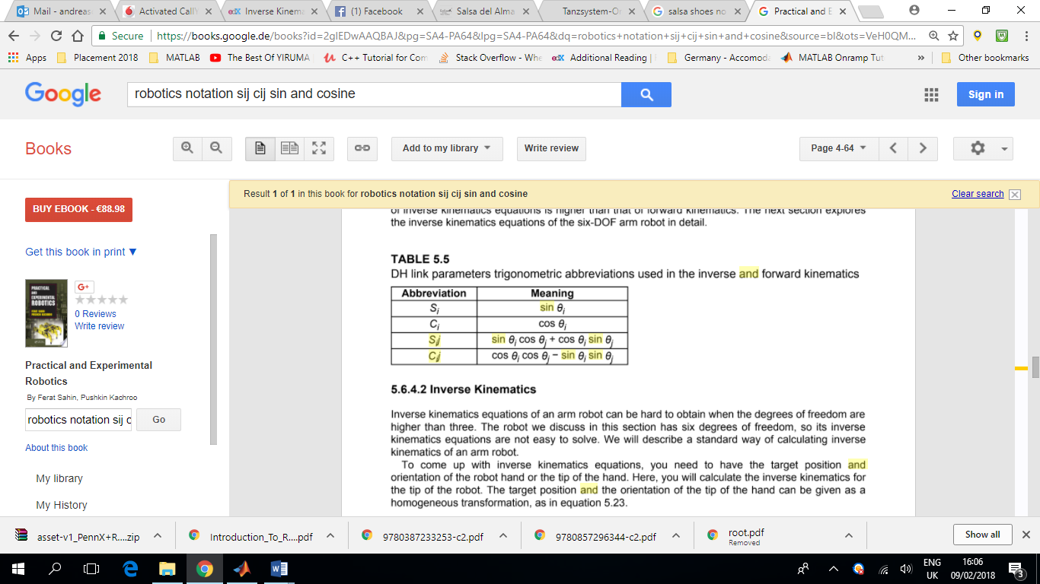

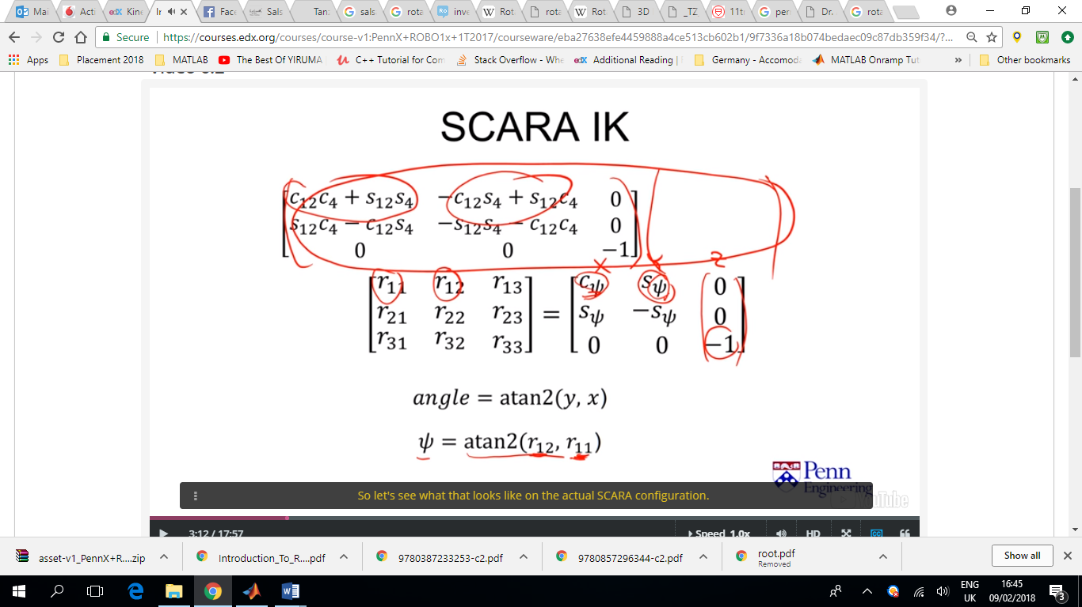

Rotation matrix of z??

S2=sqrt(1-c2)

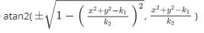Therefor to be accurate,

θ2=

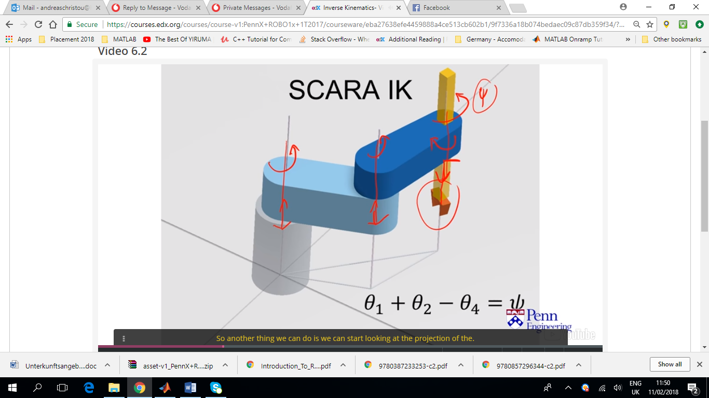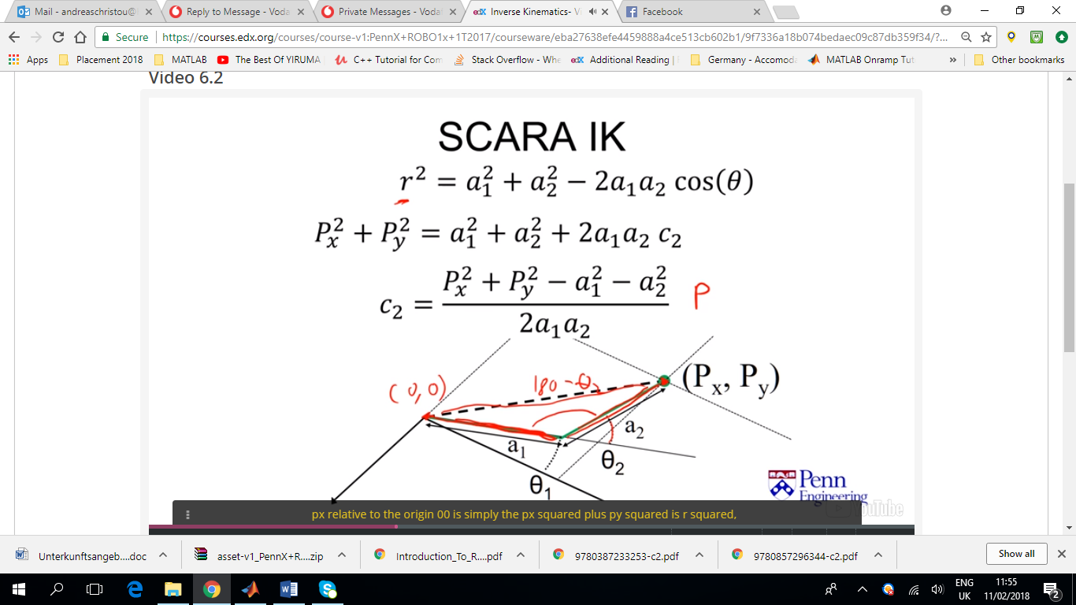

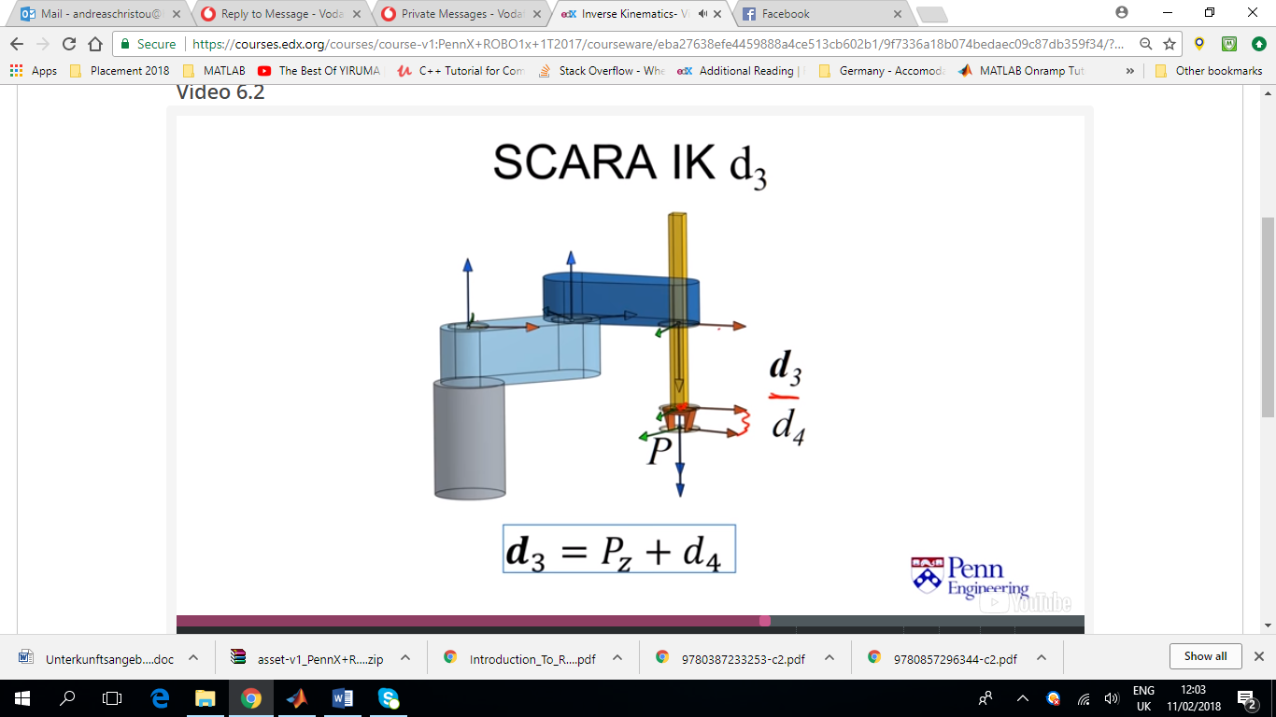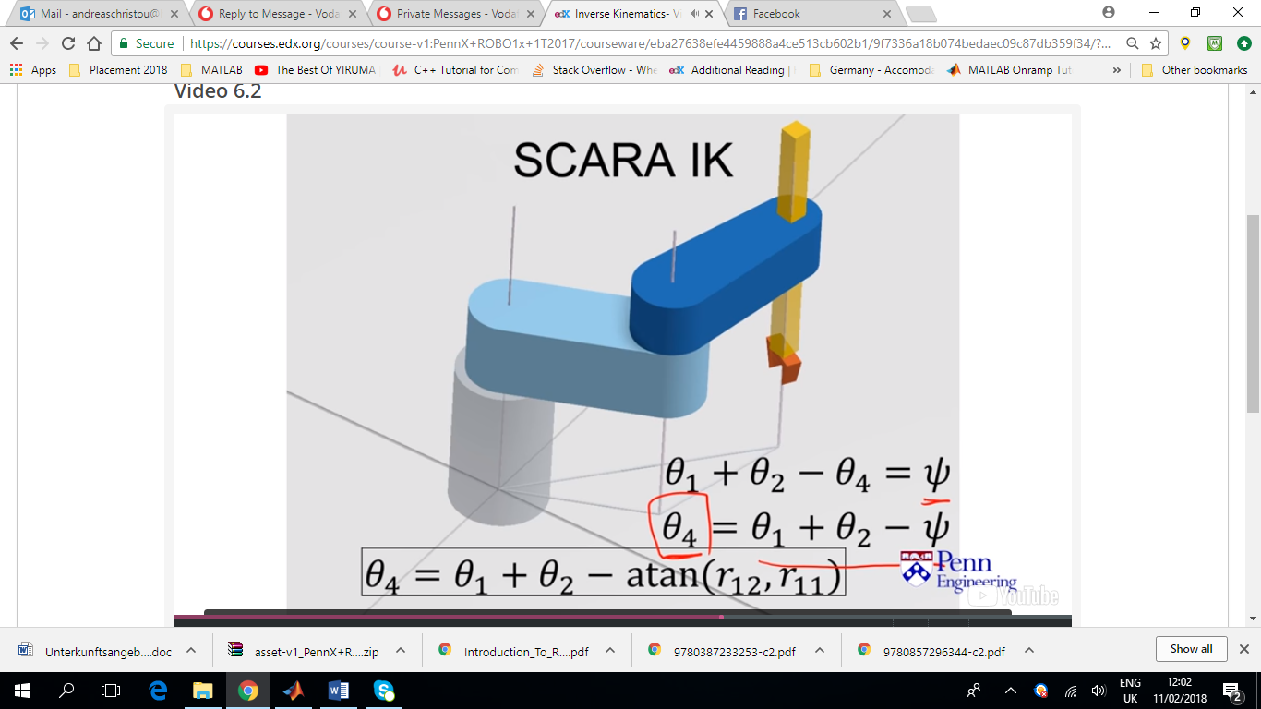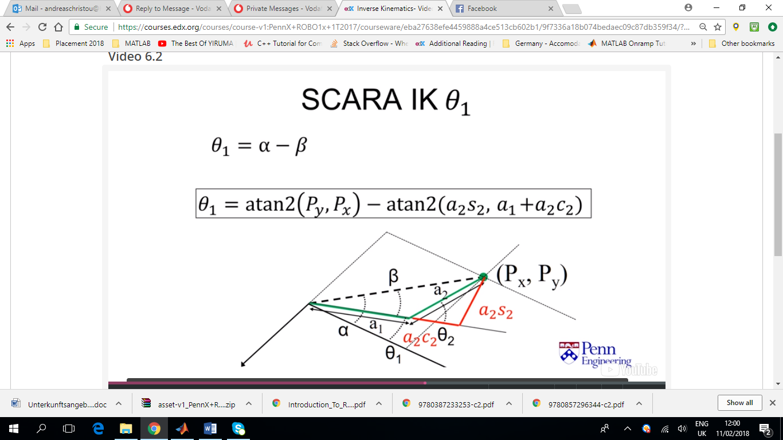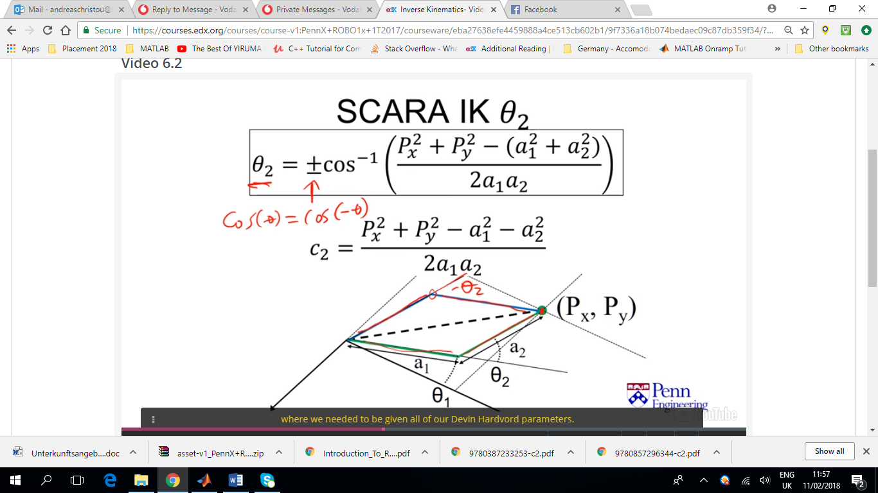

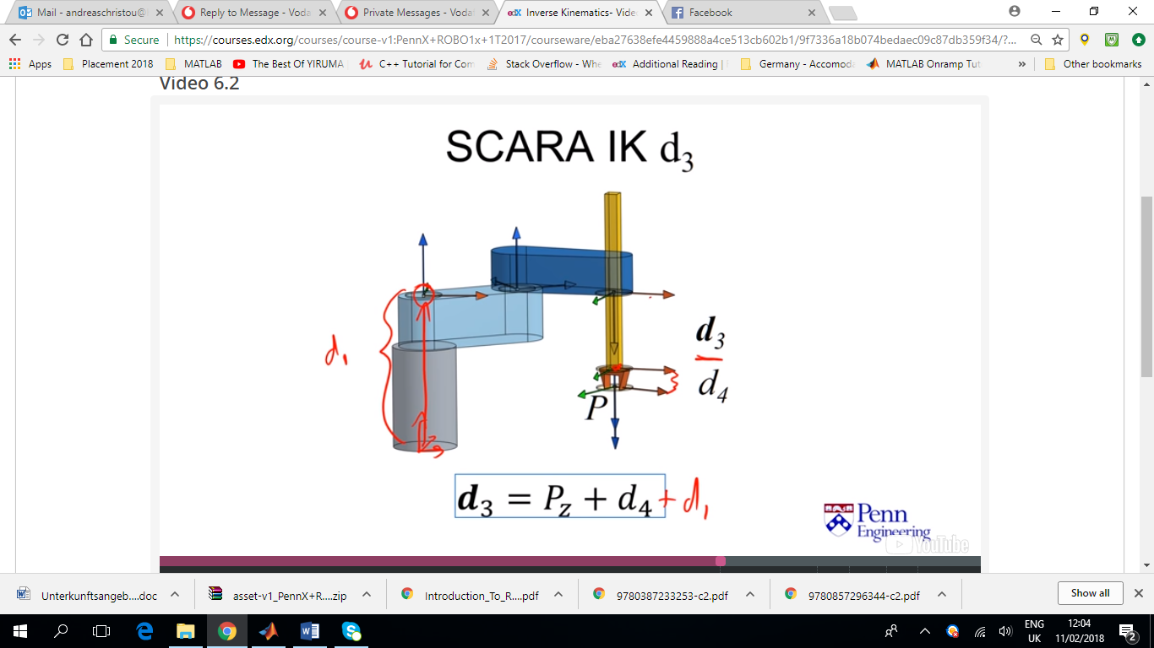In the case above the base is taken to be at the first joint thus d1 is not needed. If base is chosen to be at the point shown in the picture on the left then d1 is needed to describe d3.

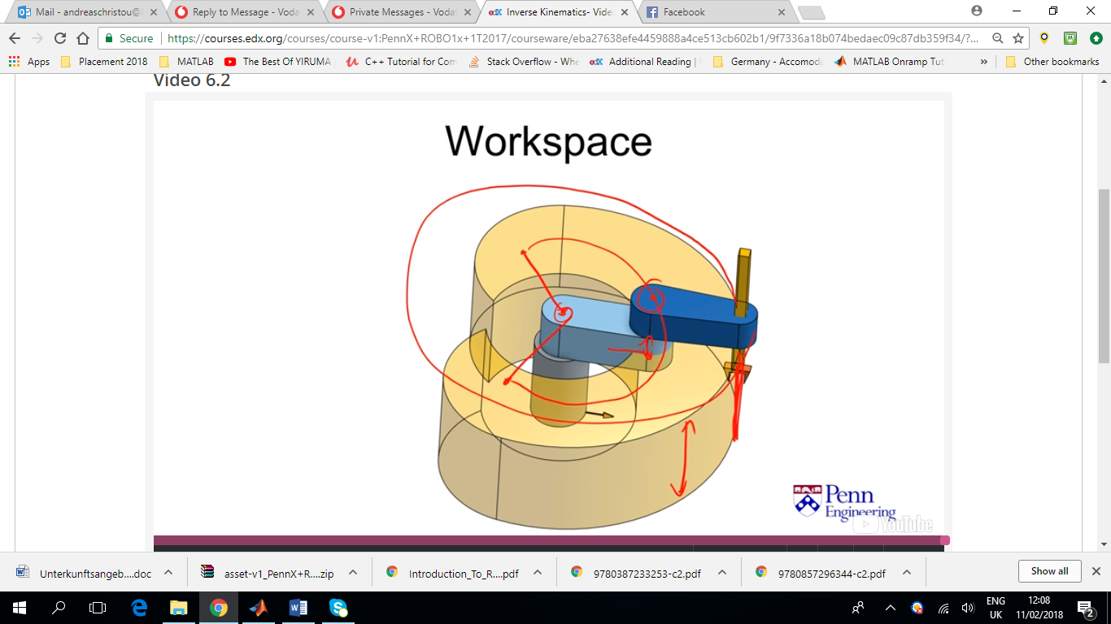

The workspace depends on the limitations imposed on each joint (or their range of motion)

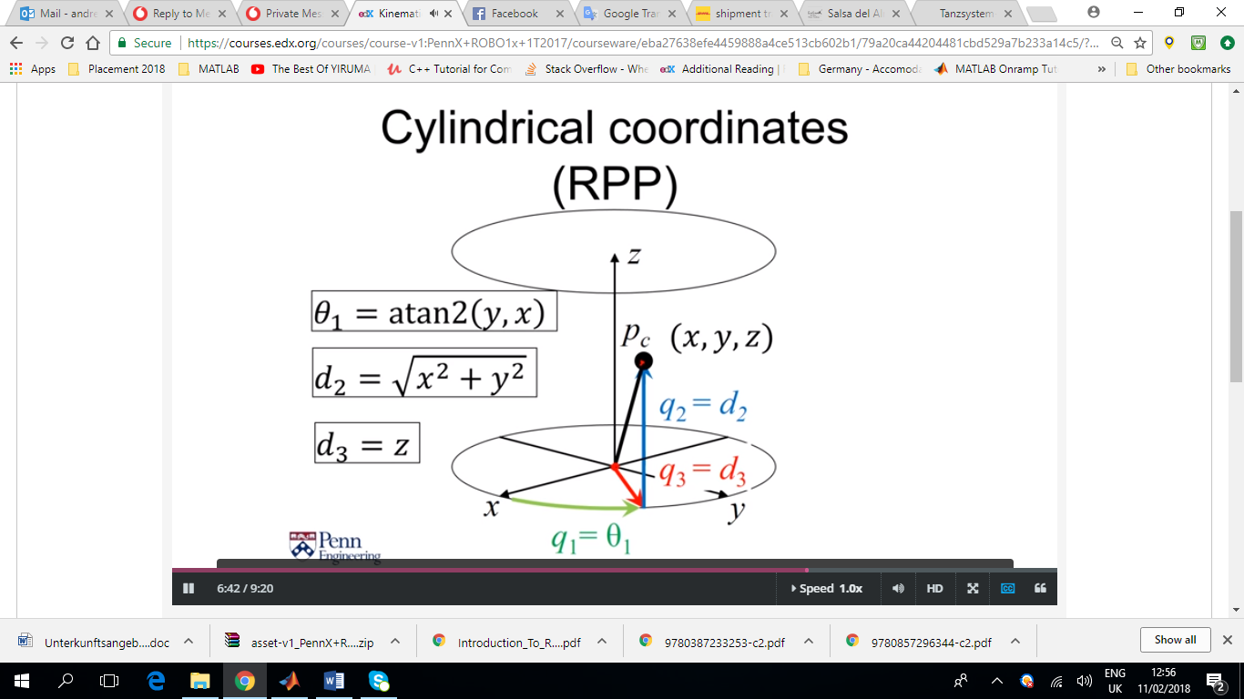

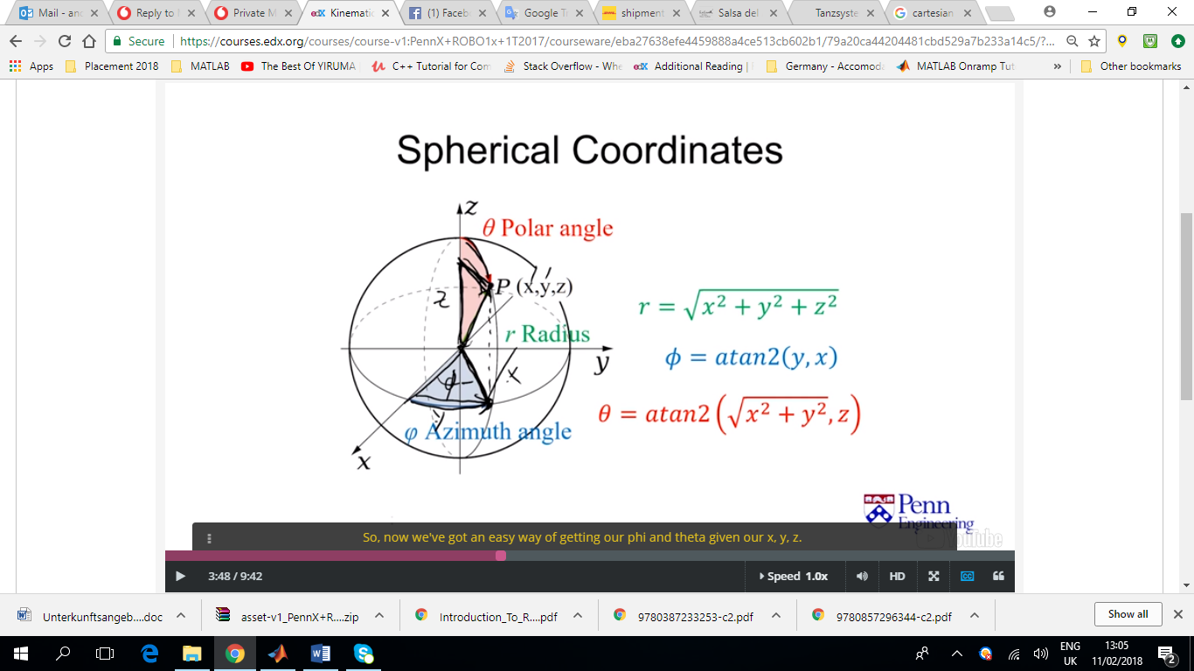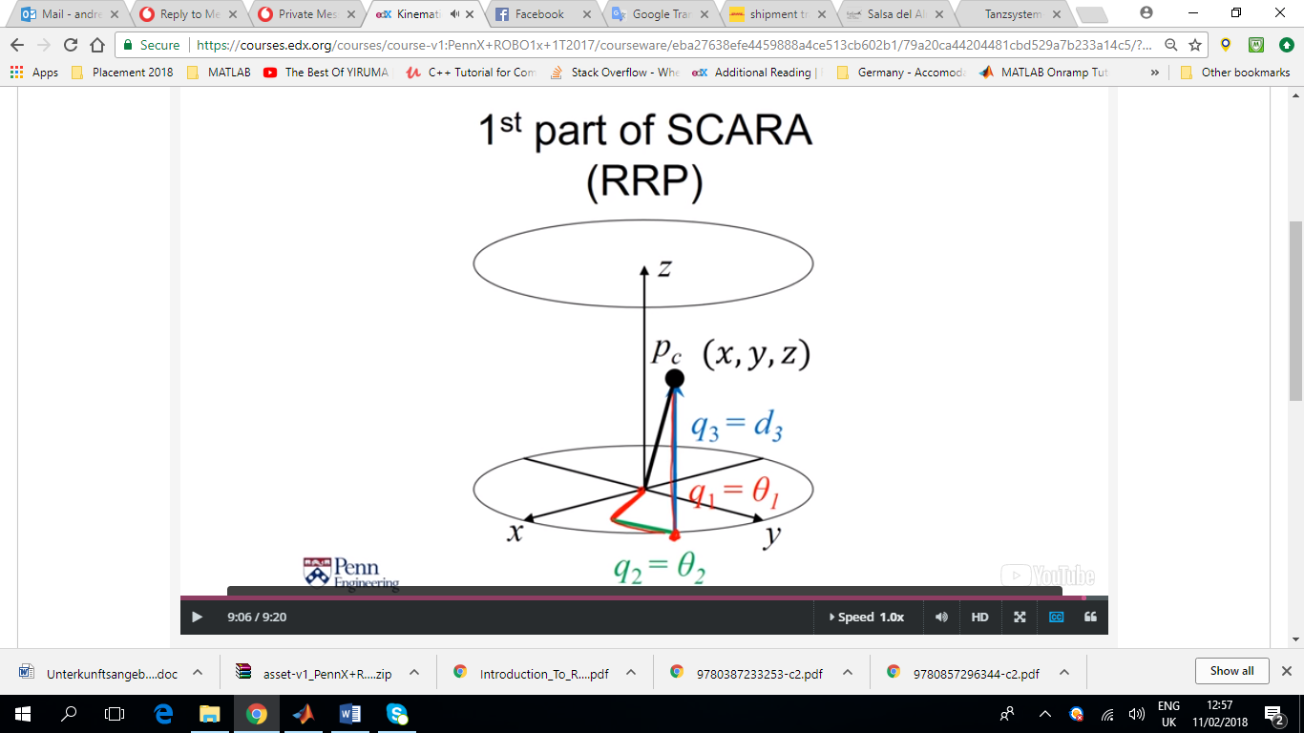

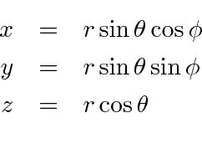

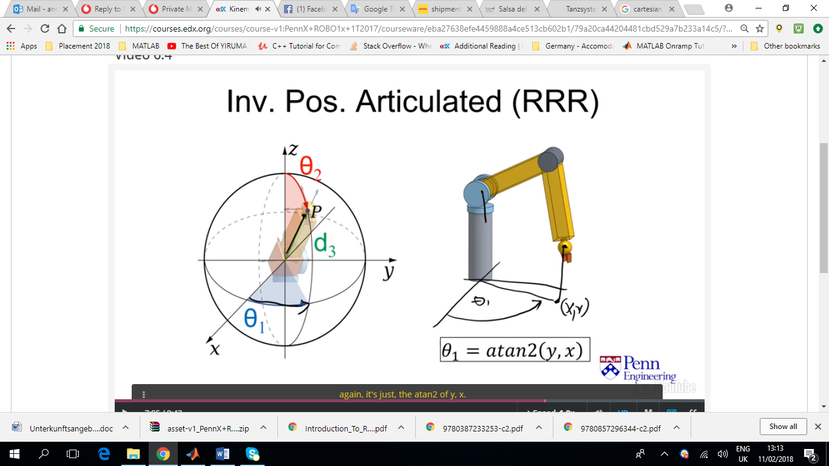

The RRP robot on the left is somewhat intuitive, whereas the one on the right might be so straight forward.

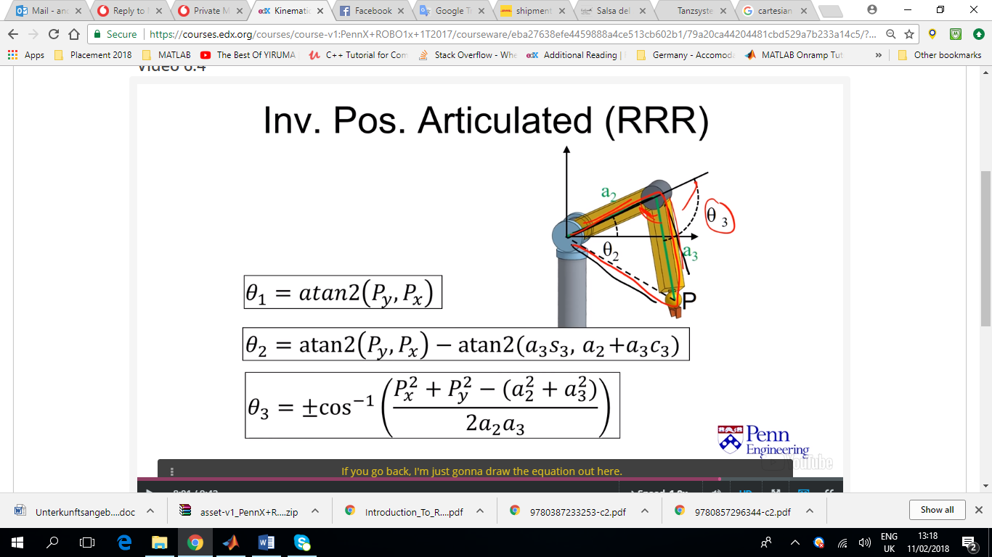Using the law of cosines (side-angle-side) we can solve for θ3 and then we can use θ3 to solve for θ2. Both 2 and 3 have two solutions.

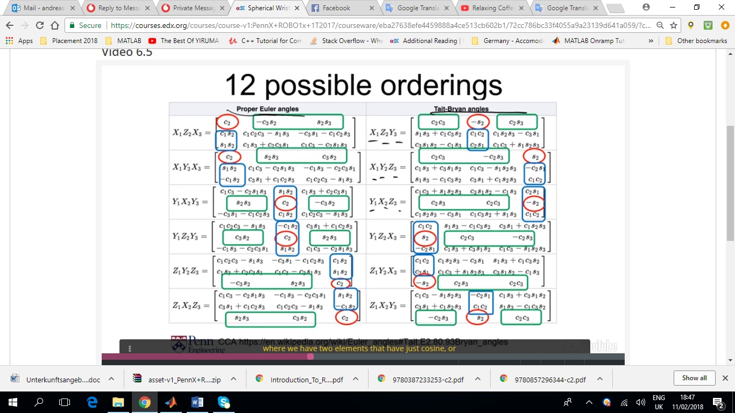Sequential Rotations

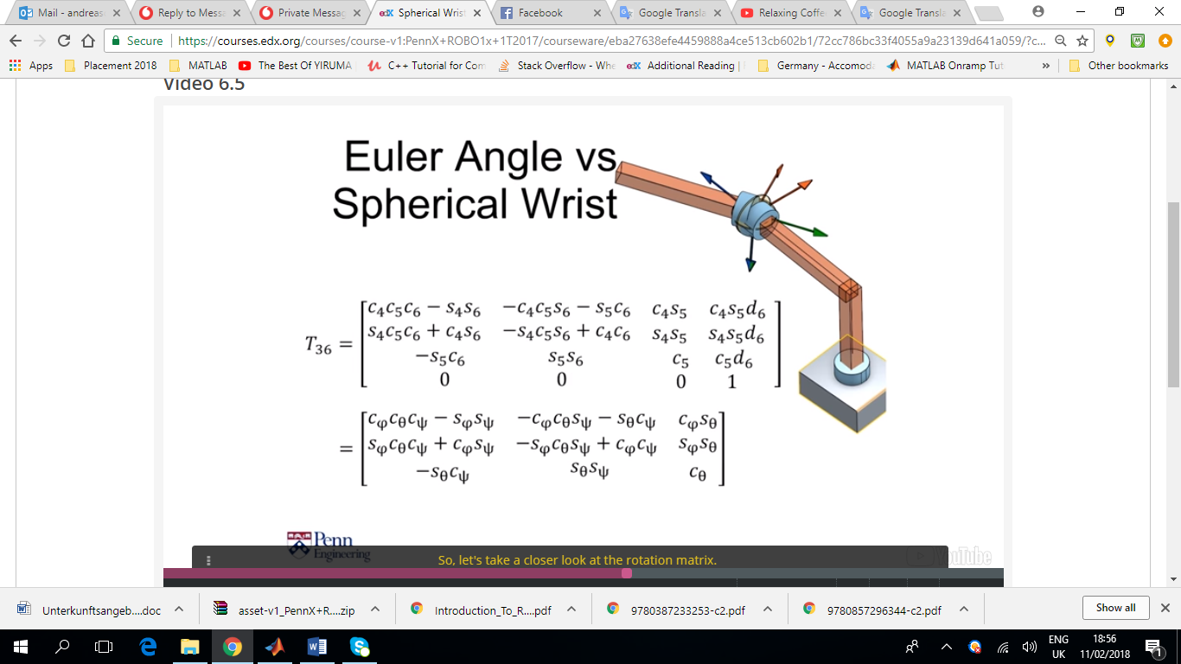It can be seen that the transformation matrix of the spherical wrist is exactly the same as the ZYZ Euler Angle Rotation. This is some times convenient because it allows us to solve the problem using inverse kinematics as it can be seen in the figure below.

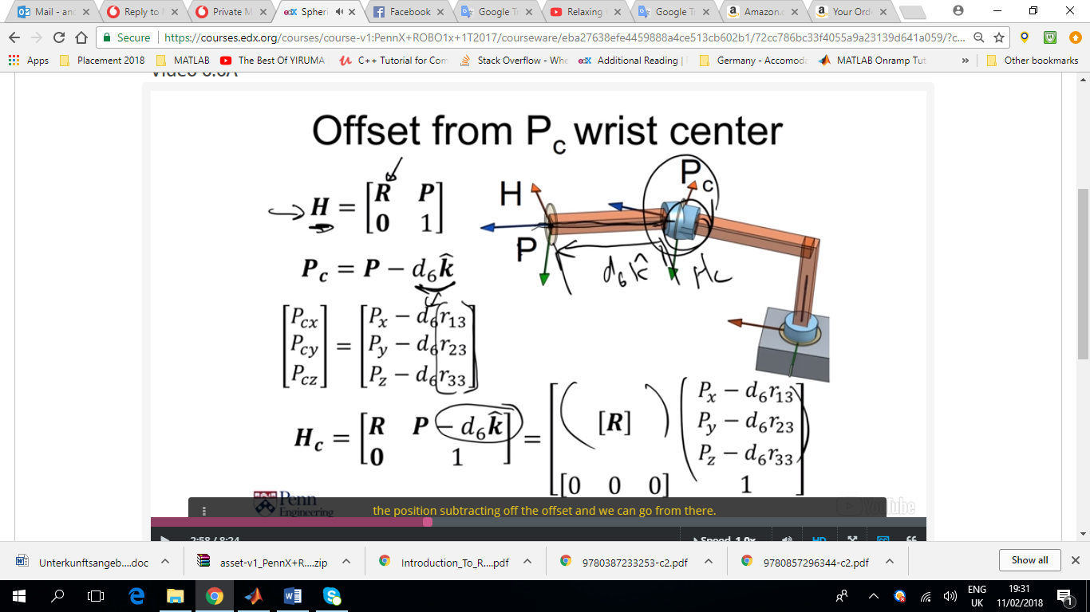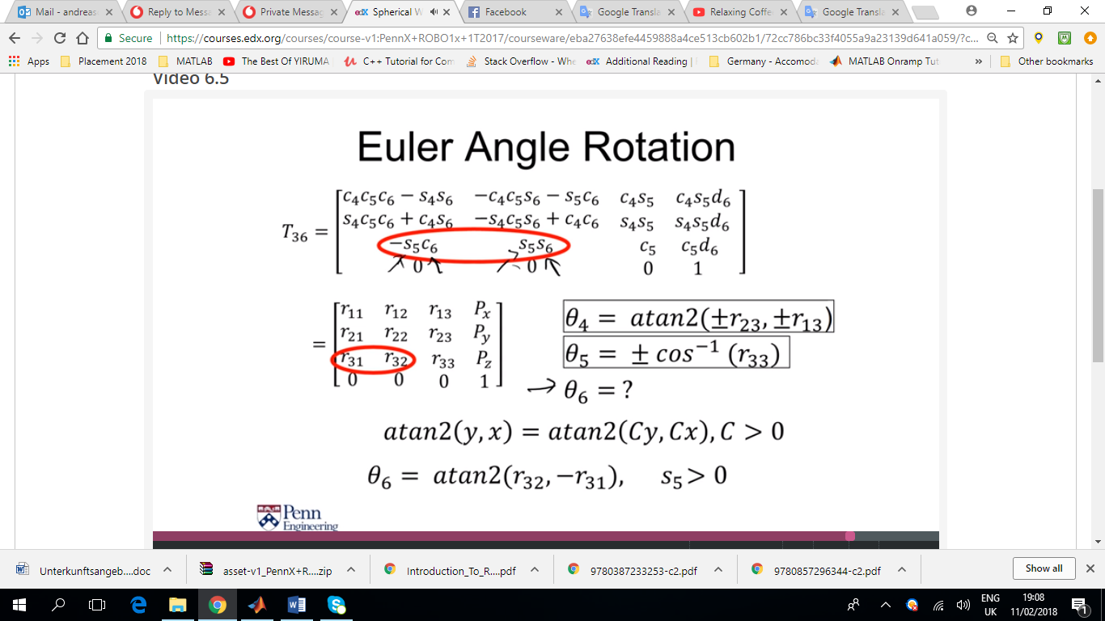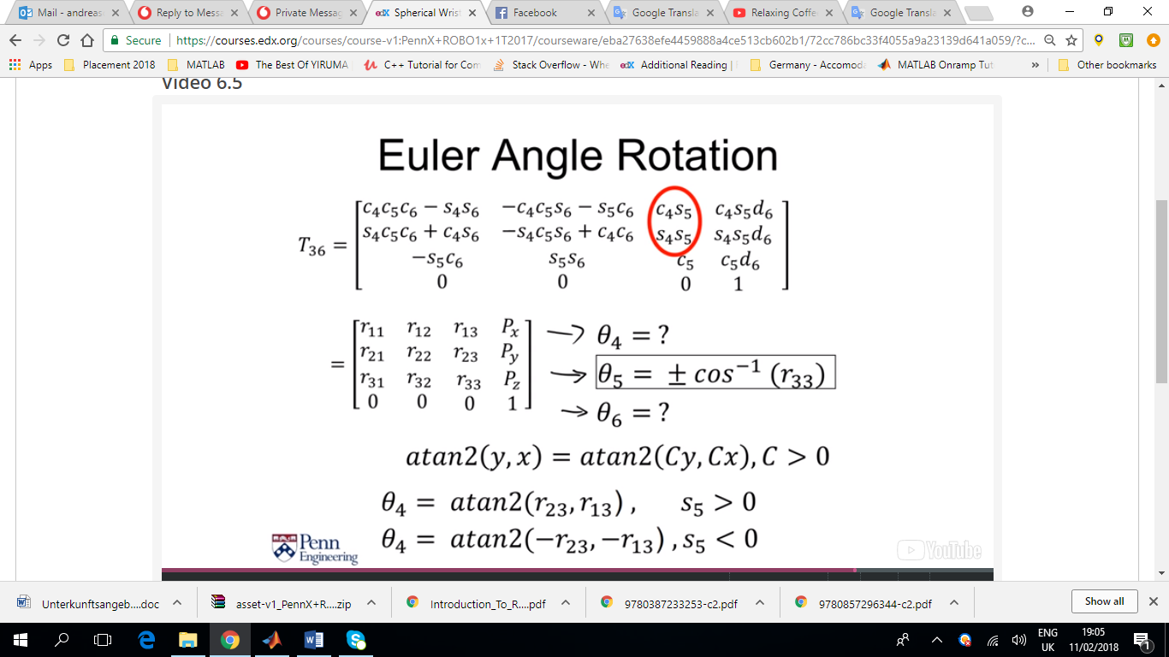

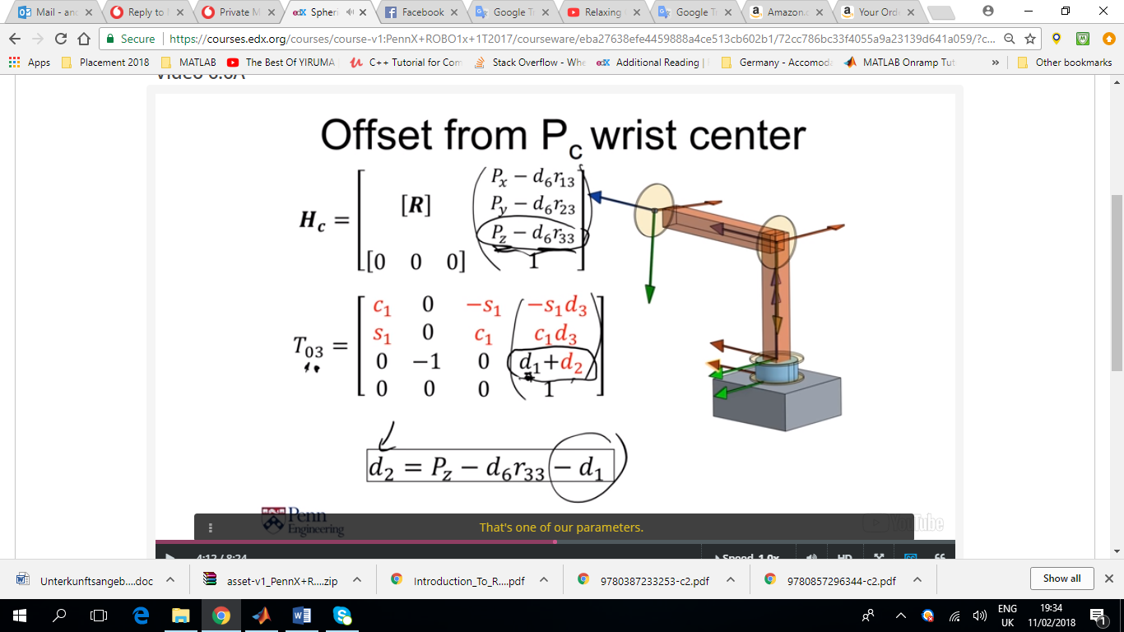

Figure . All the variable parameters are in red. (d1 is constant, in joint 1, theta is the variable)

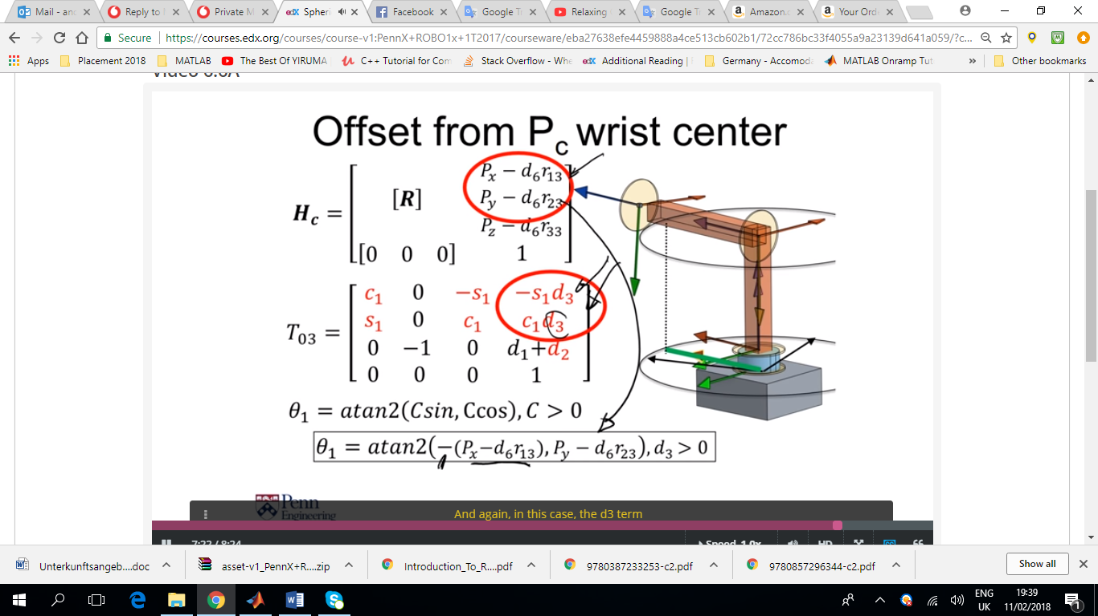

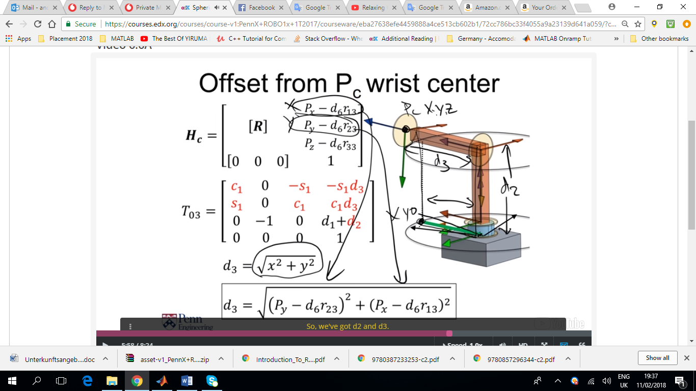

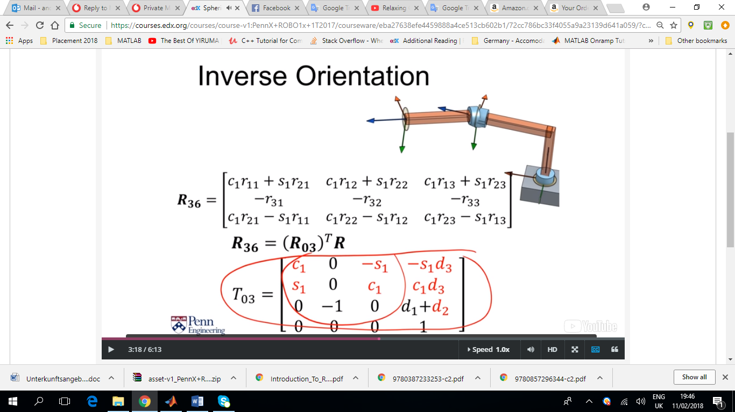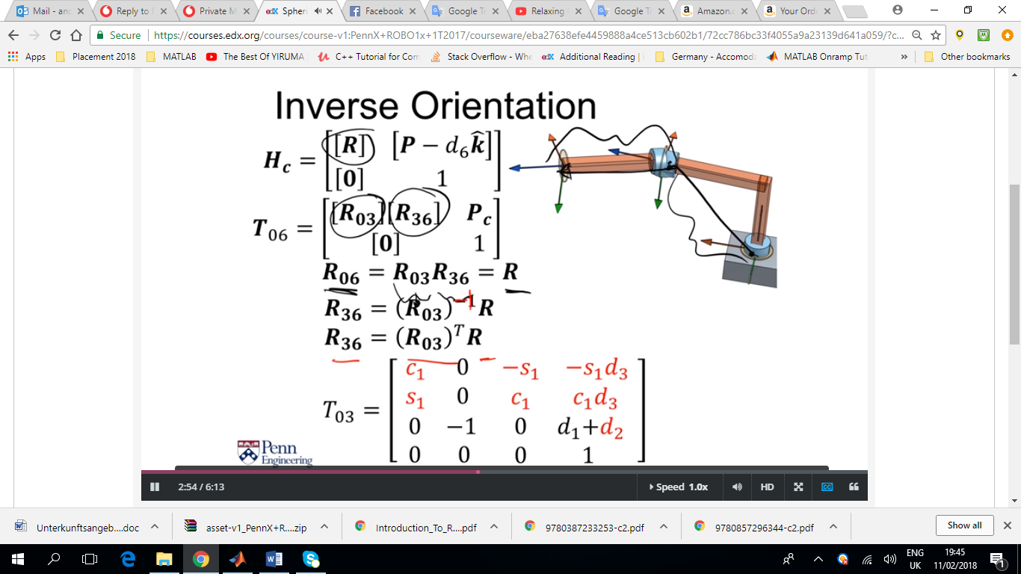

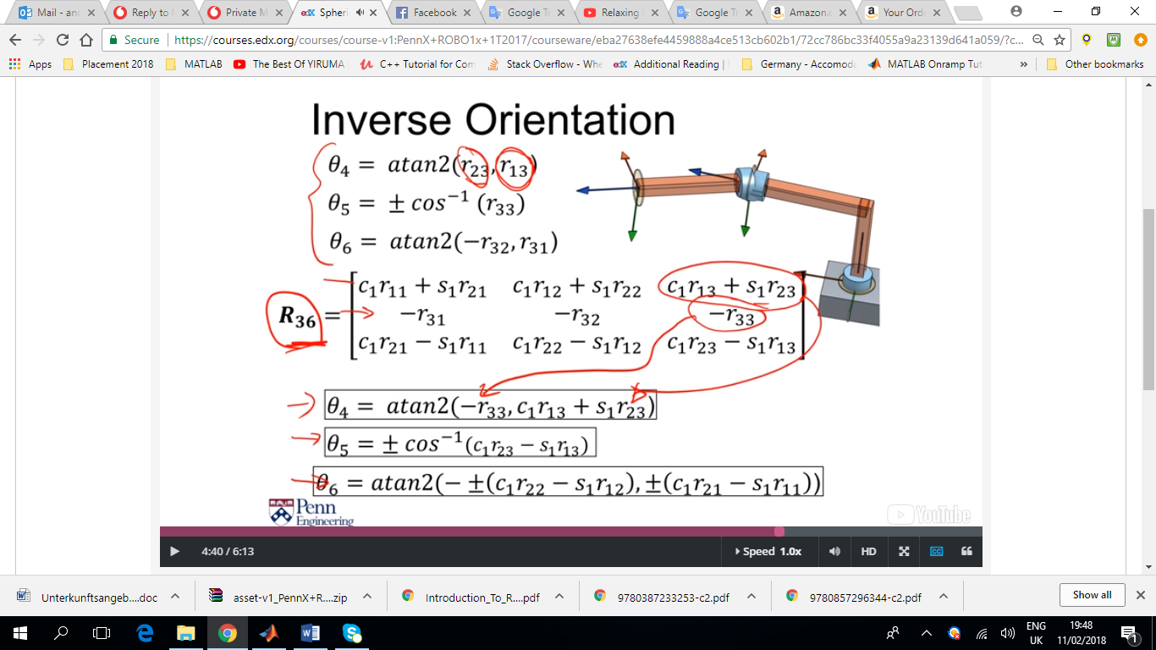

Figure . We take theta4-6 and we compare it with R36

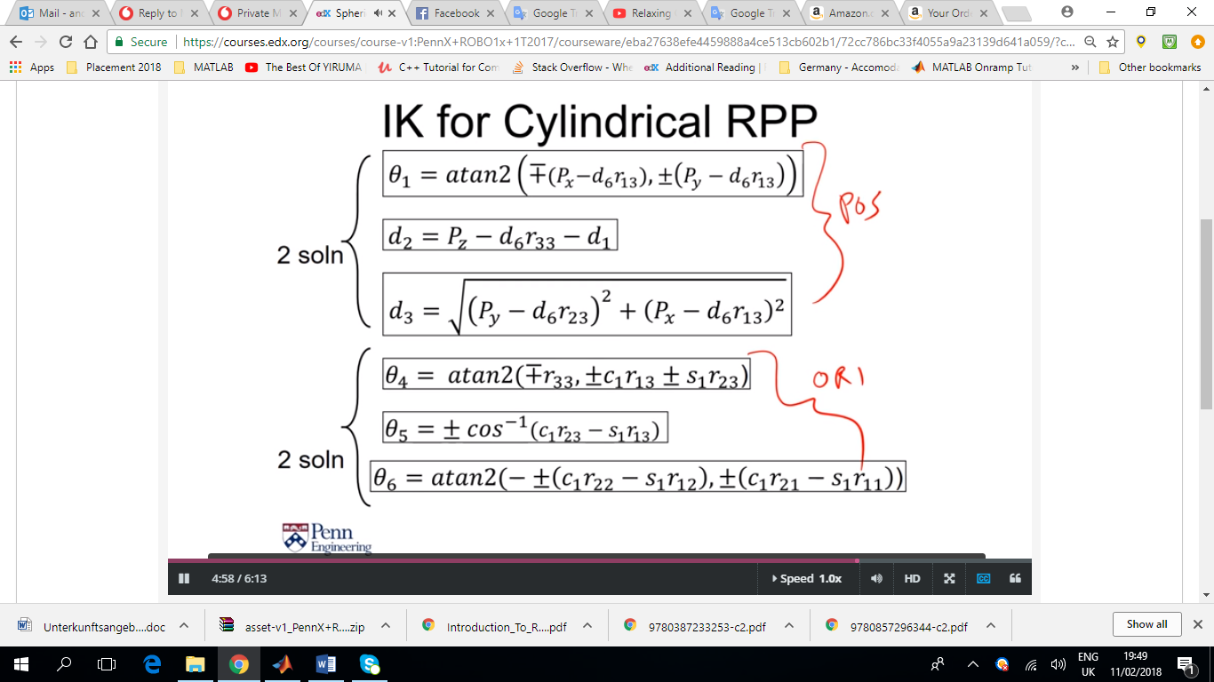

To avoid discontinuities that can be caused due to the multiple solutions, we have to be careful which solution we are using when we are de/prescribing the motion of a robot arm so that we are consistent and avoid discontinuities that may be bad for the user, the robot or the environment.

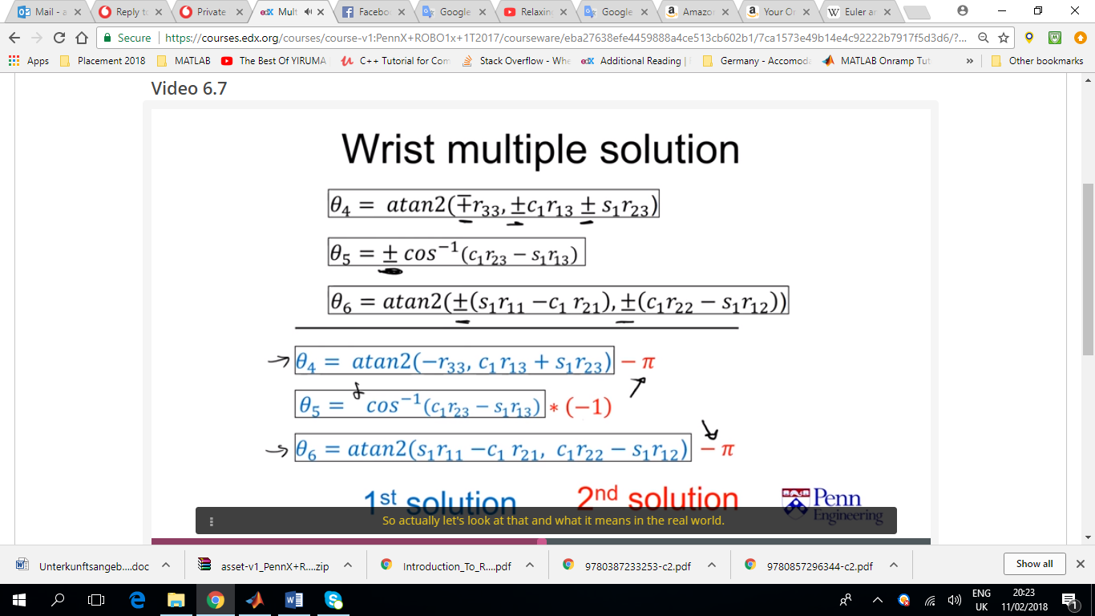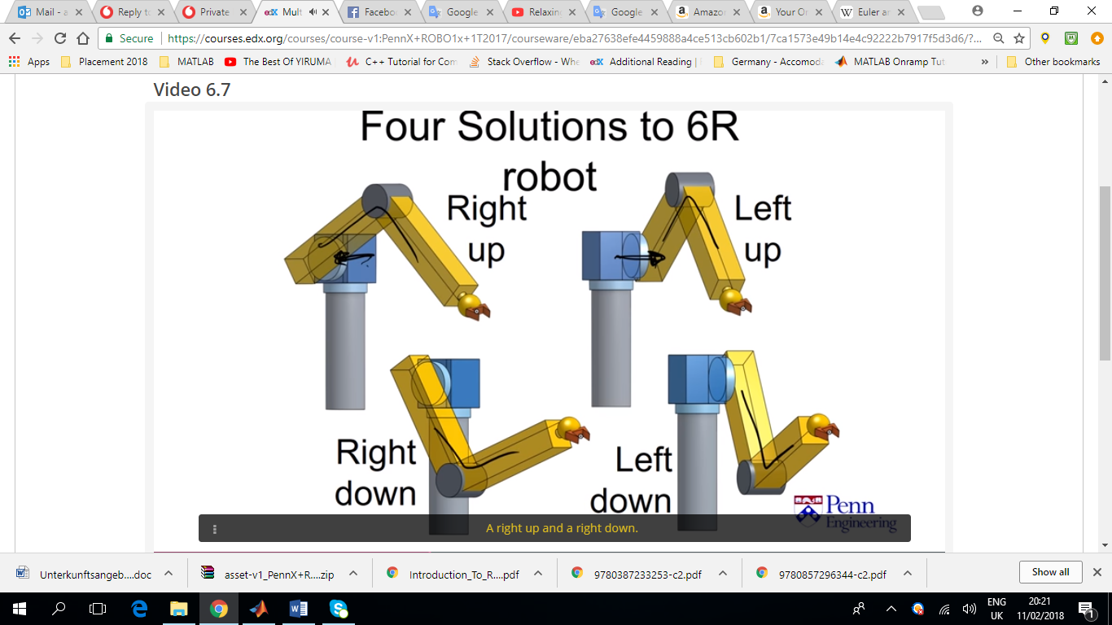

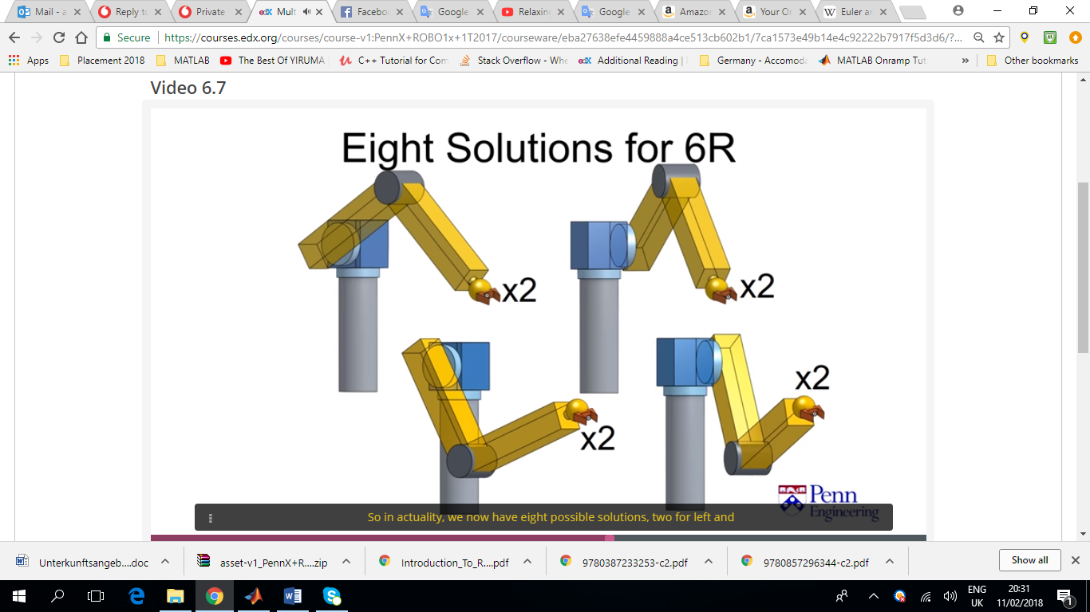

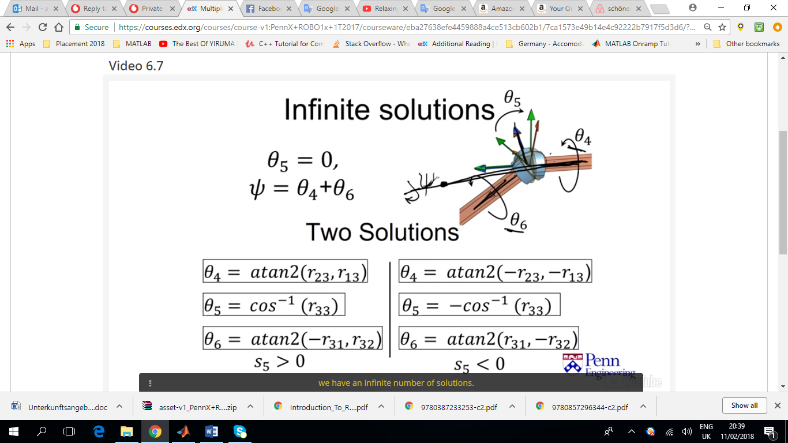

Figure . When theta=0 you get what you call in aeronautics 'gimble lock' where a singularity is introduce, the degree of freedom is lost and the results might be undesirable

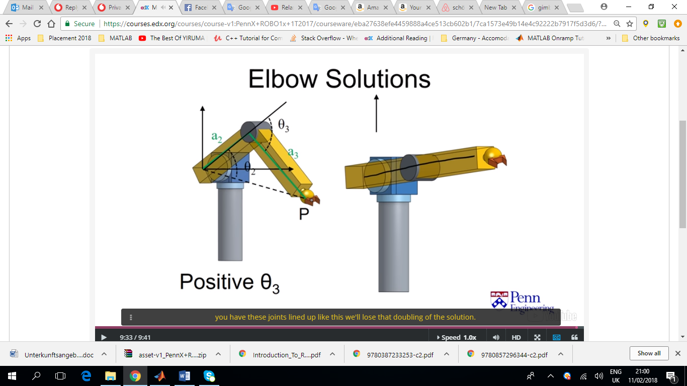In this case, when theta=0 there is only one solution.

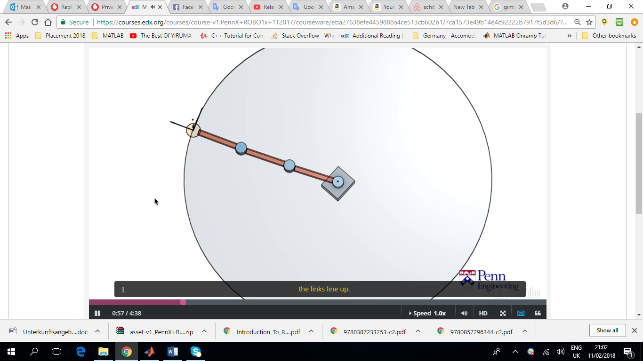 Two solution for every position of the end effector (reflections). Single solutions when the links are aligned and there is no reflection and the Jacobian loses rank (will be discussed later).

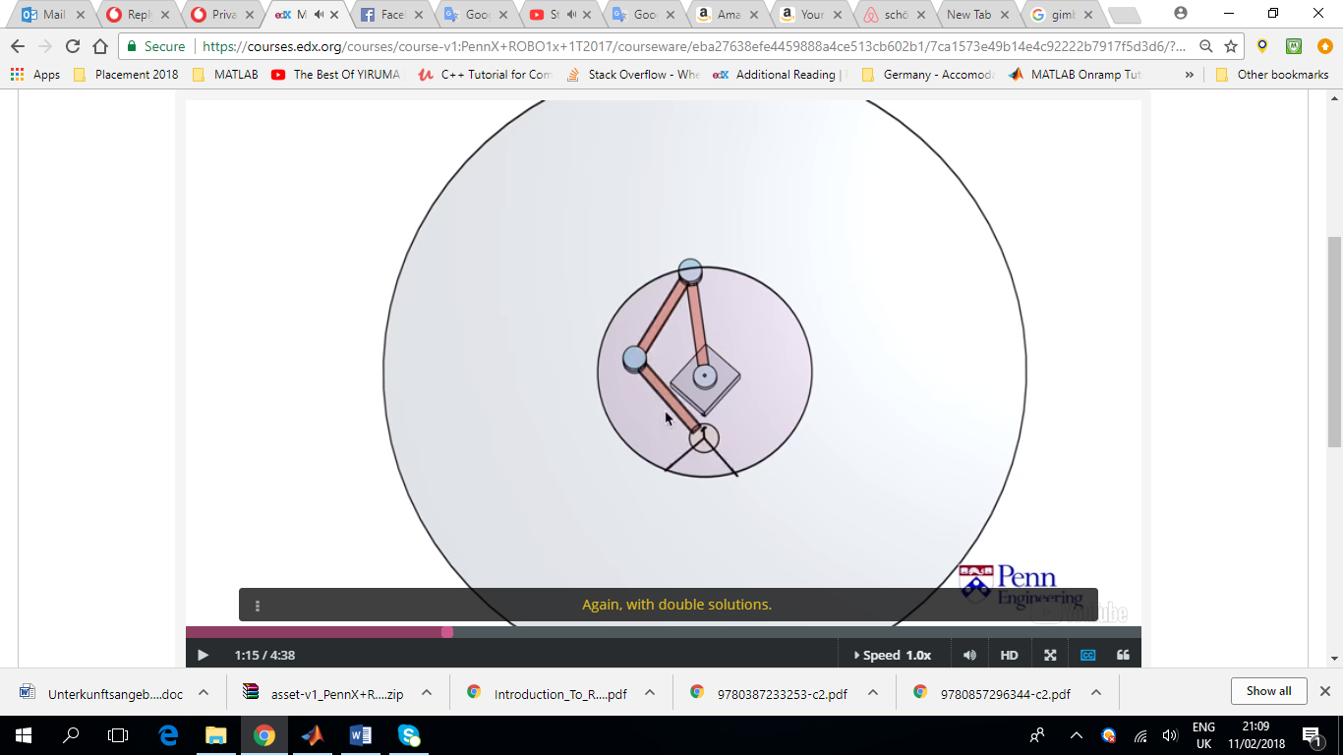

In the dextrose area, any orientation can be obtained with double solutions.

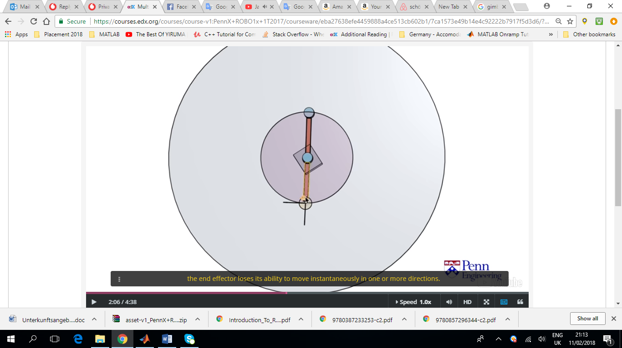For the full 6dof robots there is also something called the dextrose workspace where the end effector is capable or reaching any 3D orientation and any 3D position.

Singularities again may arise and as a result the end effector loses its ability to move in any direction instantaneously (eg up and down in the figure on the right, as it first needs to move right and then up). At singularities, velocities get really fast (jumping around). Adding an extra joint makes the system more redundant and we can avoid singularities.

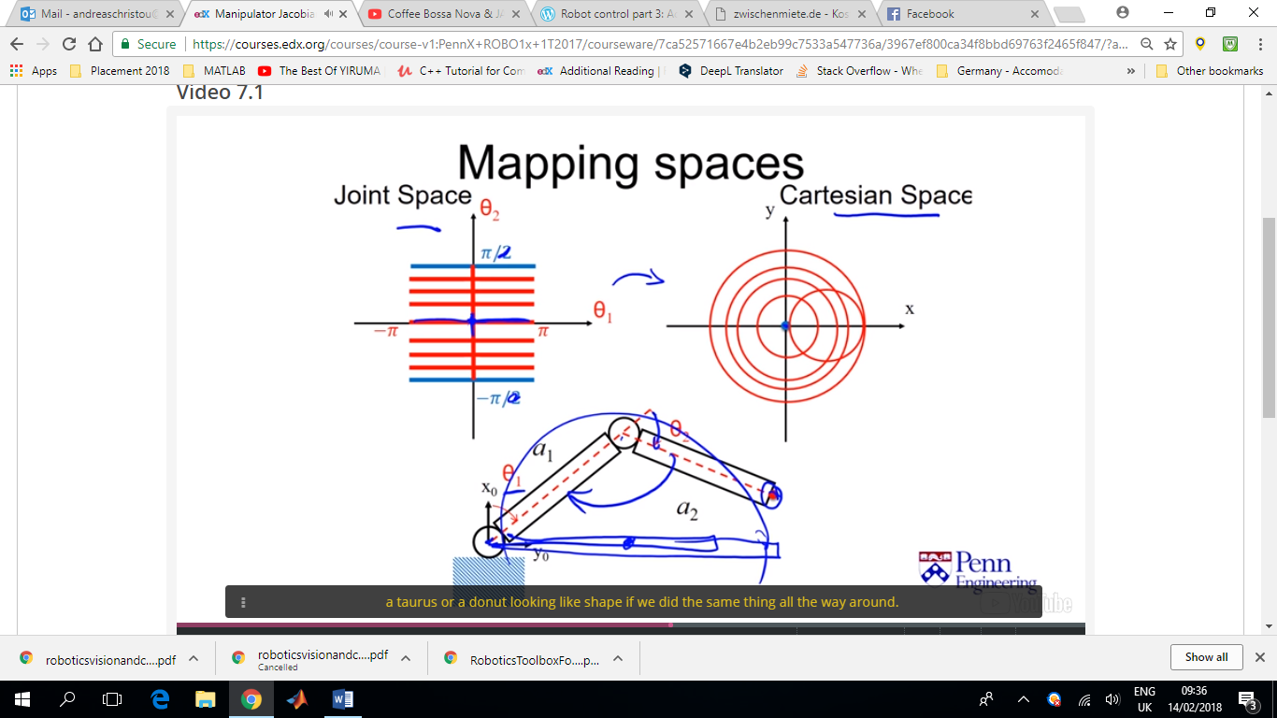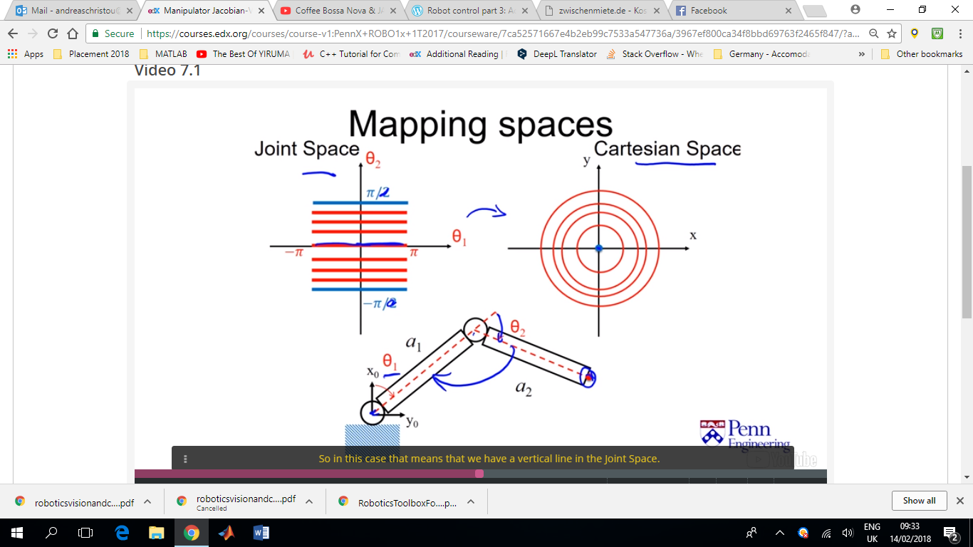

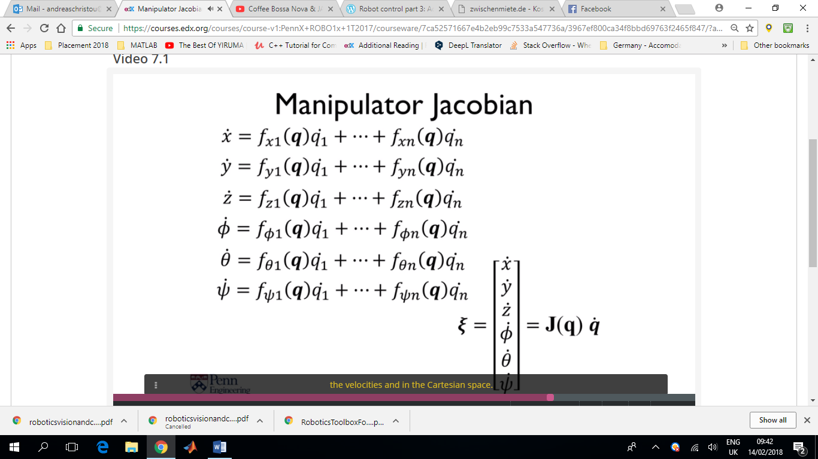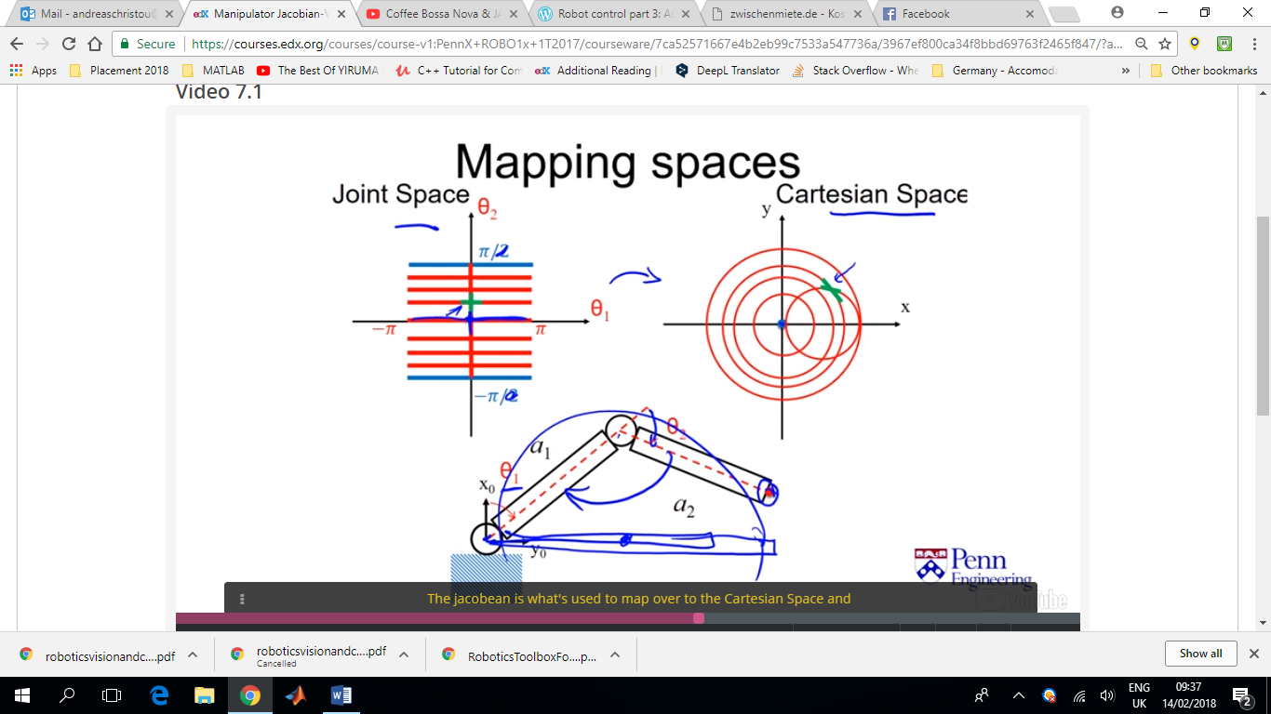For this specific green cross, the **Jacobian** (linear approximation) is what we use to map from the joint space to the Cartesian Space. The cross looks slightly different because we are looking at velocities (the derivatives of position, which is essentially what we are looking at here). Even though we are dealing with circles, those circles become pretty much straight when we zoom in (at the limit we assume straight lines).

**ξ** is an expression of the velocities in the cartesian space. The equations are a function of the configuration as well as the joint velocities.

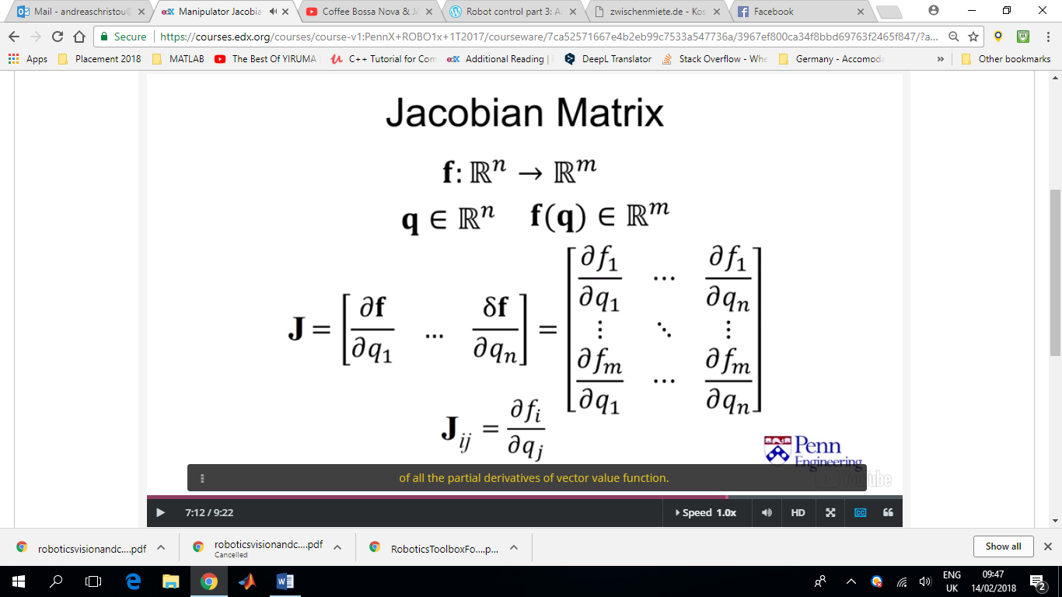So strictly speaking the Jacobian is a matrix of all the partial derivatives of vector value function.

Linear map from an ‘n’ dimensional space into an ‘m’ dimensional space.

In our case, there are ‘n’ joints, and maps into ‘m’ workspace dimensions (*m* x *n* matrix).

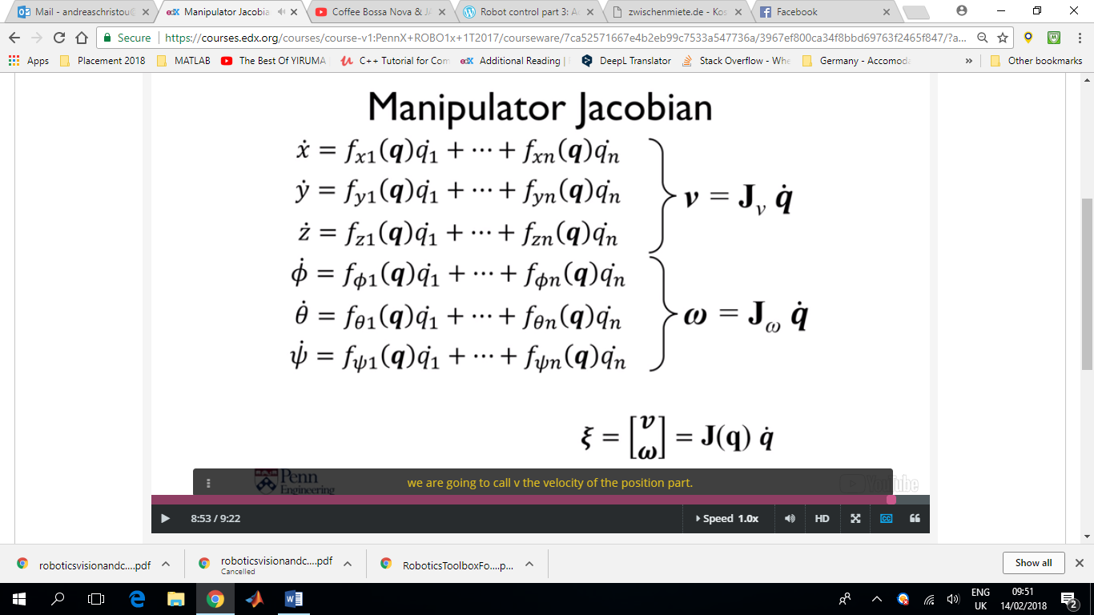**J**v = Position Jacobian

**J**ω = Orientation Jacobian

Starting off by analysing the **Position Jacobian** first.

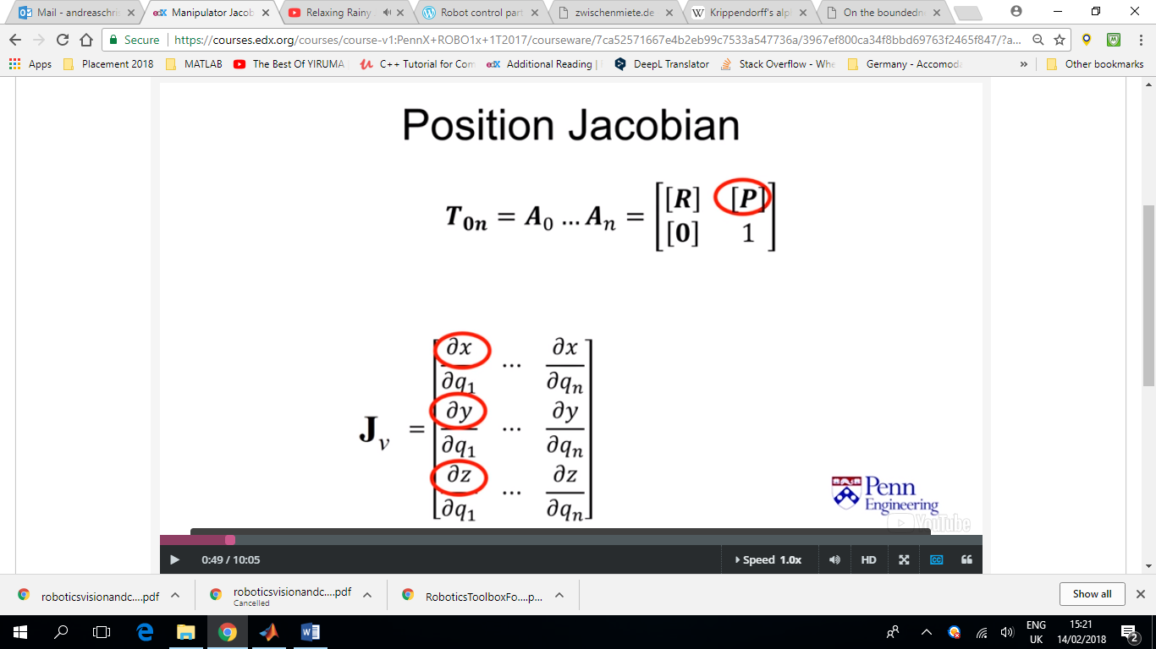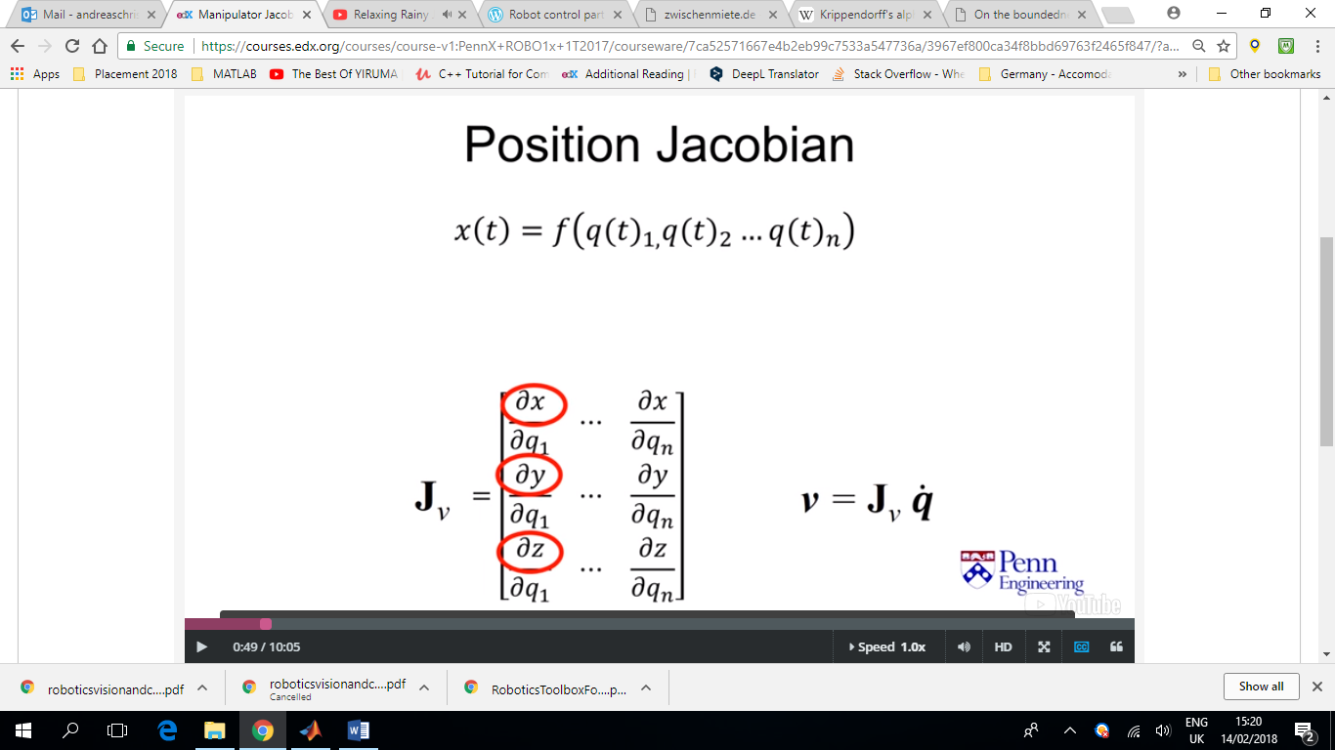

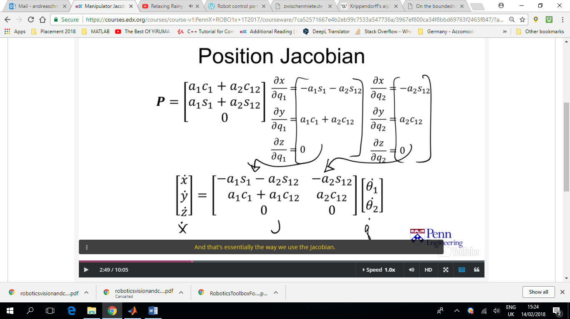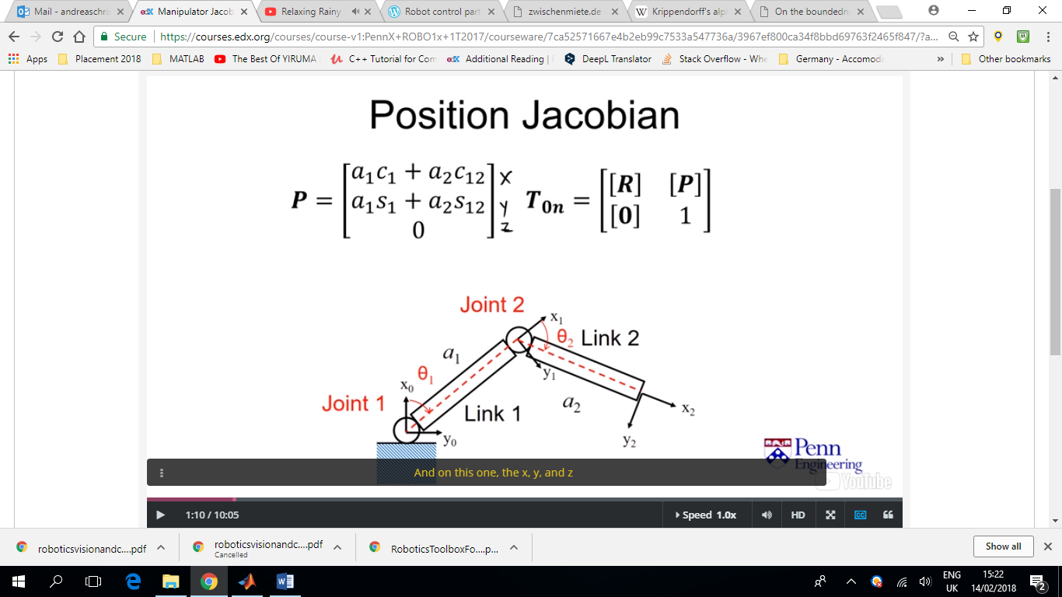

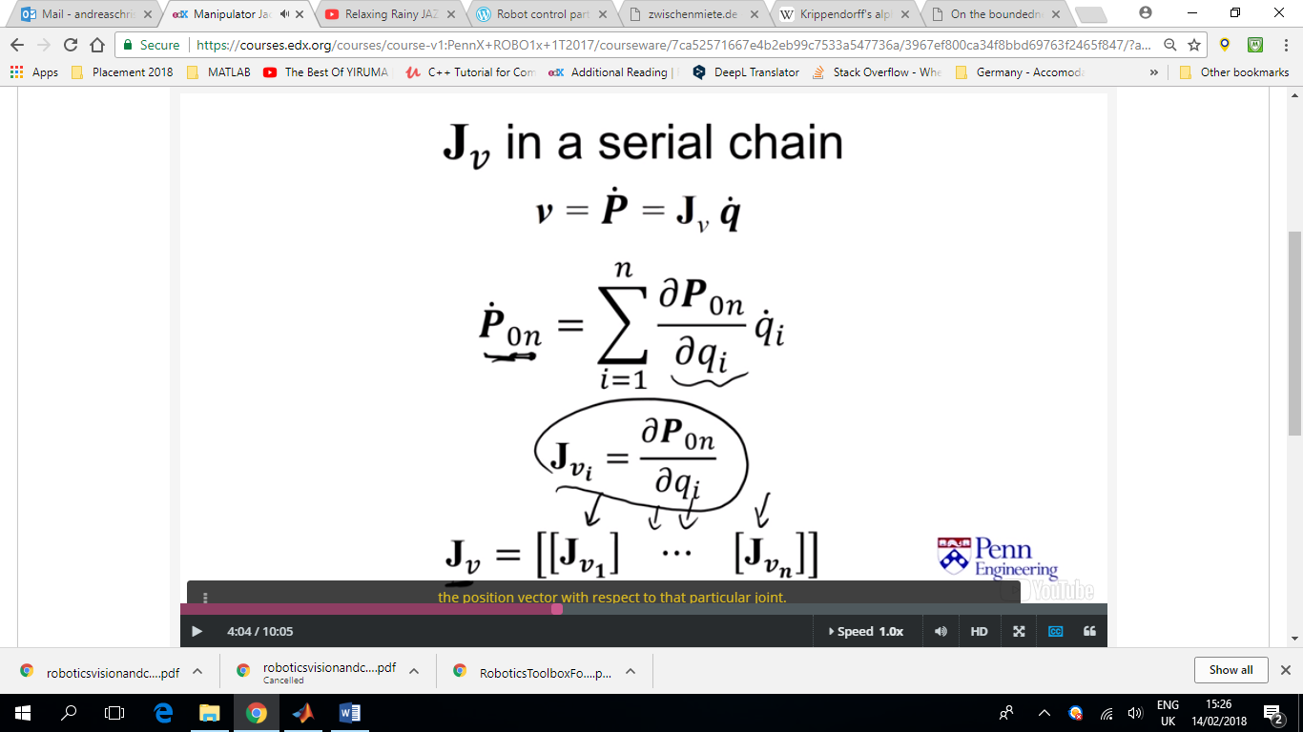Another way of writing the Position Jacobian

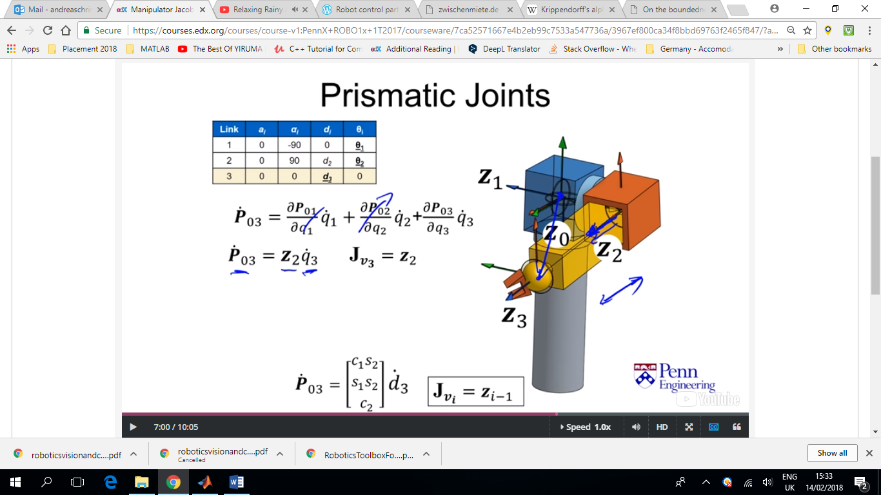Taking as a simple example the case where only the prismatic joint moves (while the two revolute joints remain stationary).

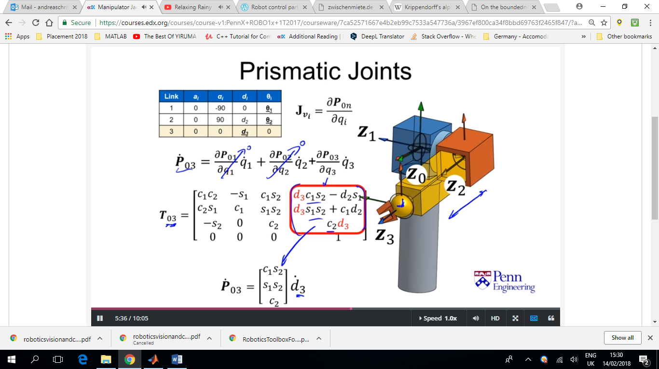

The velocity of the end effector is simply its velocity along the axis of action, **z**2. Therefor the velocity of the end effector can be expressed as:

**P_dot =** d3_dot * **z2**(direction)

**Jv3 = z2**

Where **z2** can be found both from calculating the derivative as we did before but also using the forward kinematics Transformation matrix of the previous joint. Simply because the rotation matrix forms the basis of our frame and the third column is the z-axis.

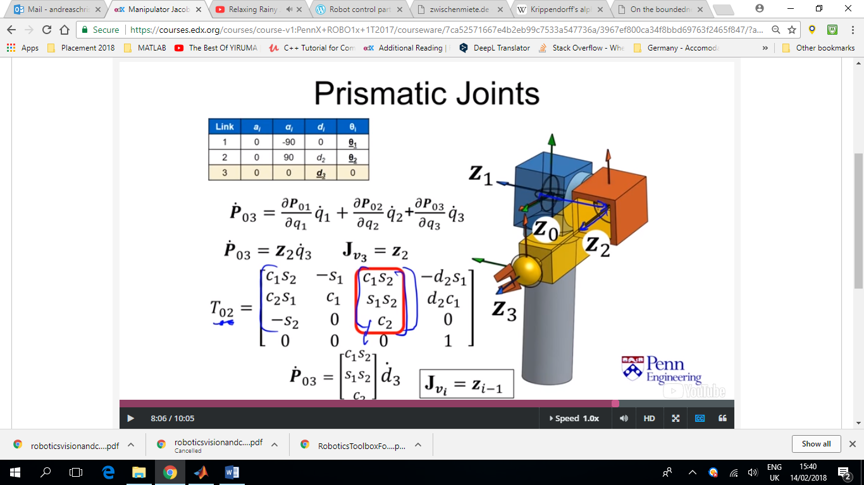

For **Revolute joints** the velocity of a point a result of rotation is defined as the angular velocity vector, **ω,** crossed with the position vector, **r,** relative to the center of rotation. For link 2, omega is the rotation about **z**1 and the position vector, **r**, goes from the wrist (point) centre, to the centre of rotation.

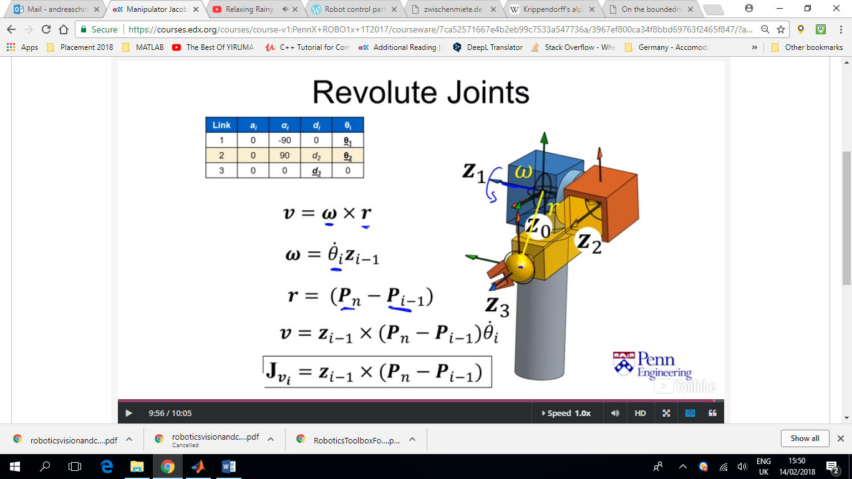

So in this case it would be:

**ω = z1** * theta2_dot

**r = (P2 – P1)**

**v = z1** x (**P2 – P1**)*theta2_dot

**Jv2 = z1** x (**P2 – P1**)

The **Orientation Jacobian** involve angular velocities of frames on a robot. If we attach a frame to a link it might rotate with the link in which case it has no relative angular speed to the base but it has a rotation speed relative to the base **frame**.

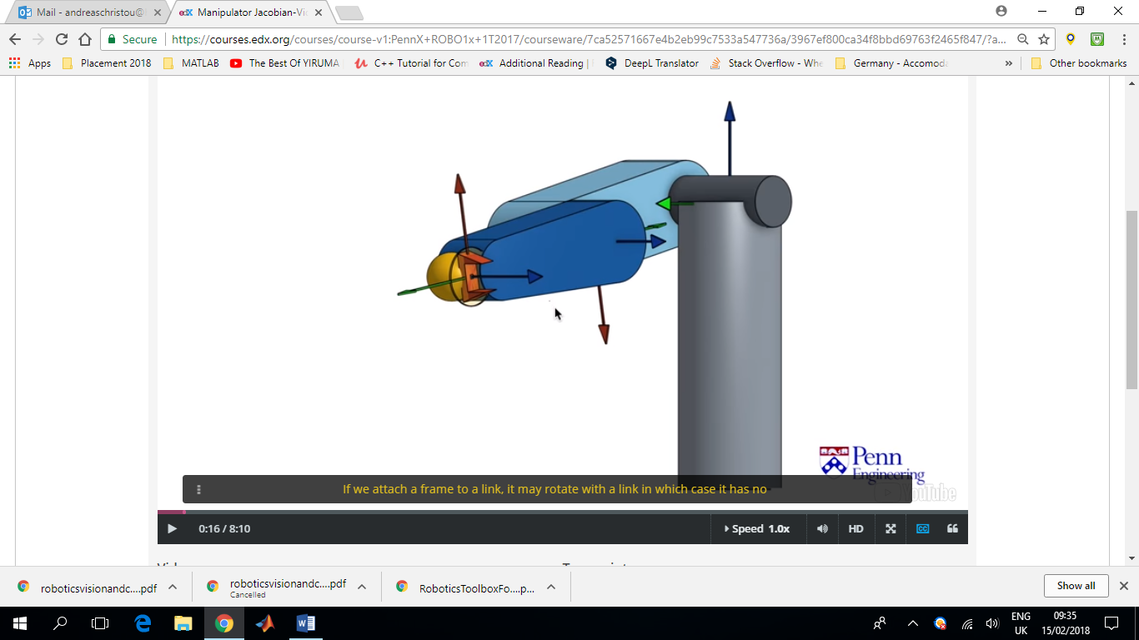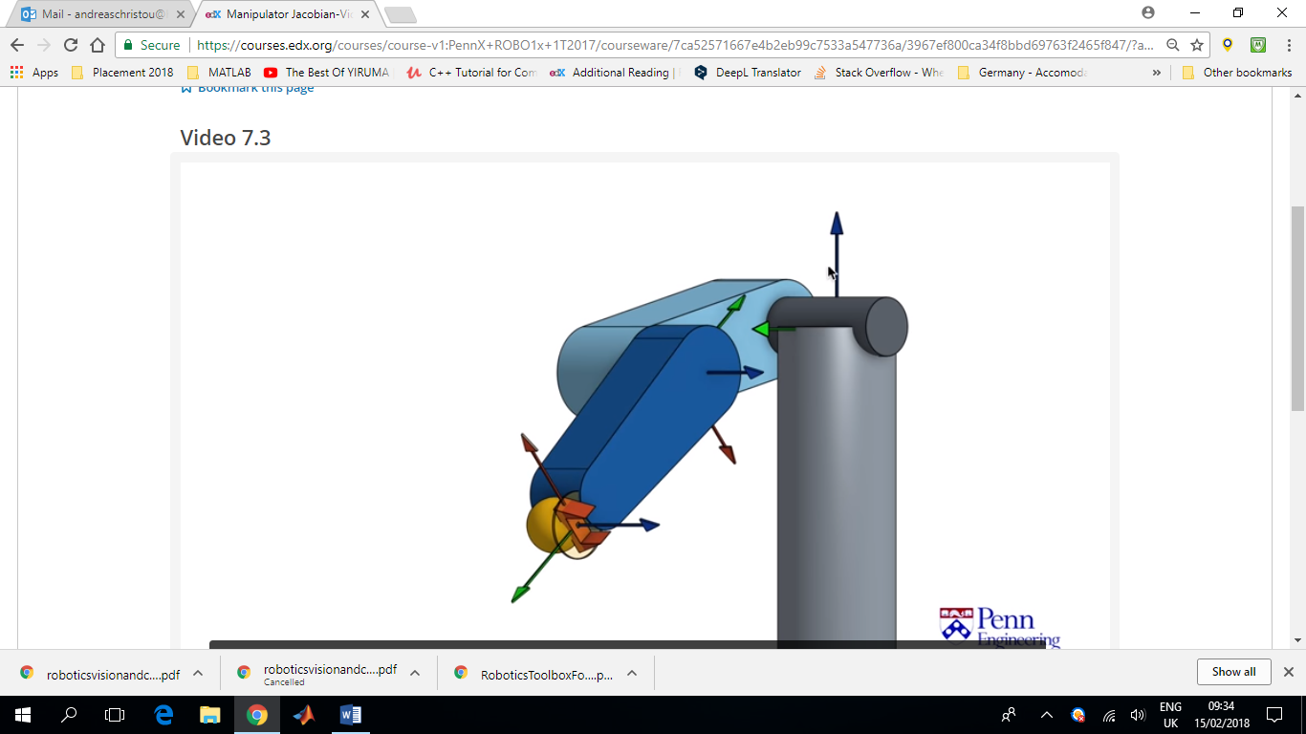

On the other hand we might have a frame that’s attached to a link but doesn’t rotate with it. In this case the frame has no angular velocity relative to the base frame but it does have an angular velocity relative to the link base. (last frame??)

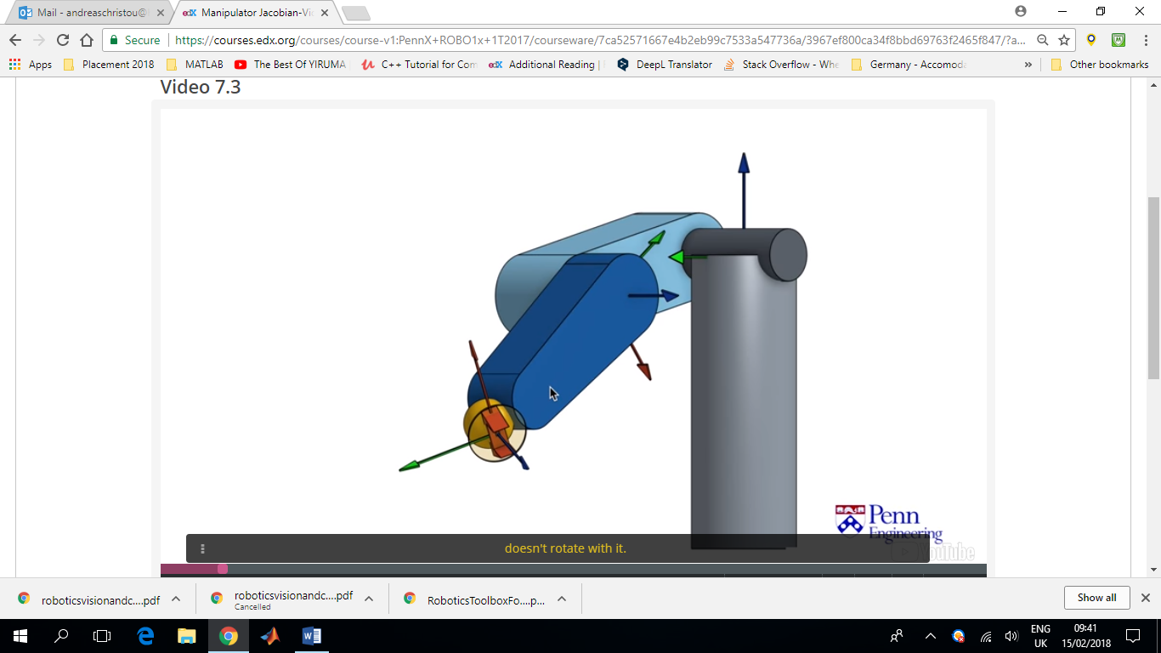

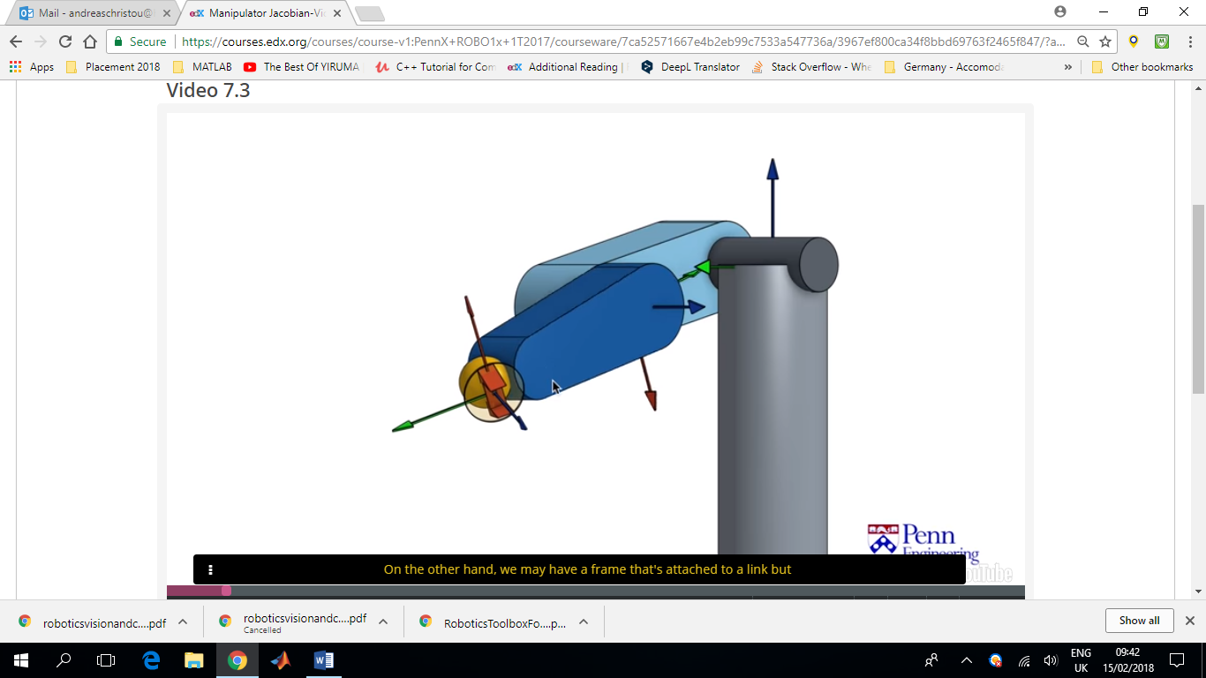

So, how we specify the angular velocity depends on the relative rotation velocity between two frames we have to specify which frame rotation is relative to, but we also need to specify which frame of reference the rotation is taking place. In this case we have frame j which is attached to the end effector and we are looking at the rotation of this frame relative to frame i, expressed in terms of the base frame k.

In the first case where j was attached to (and rotating with) frame ‘i’ omega was 0.

In the second case, ‘j’ was rotating exactly opposite as ‘i’ and so omegaijk was zero.

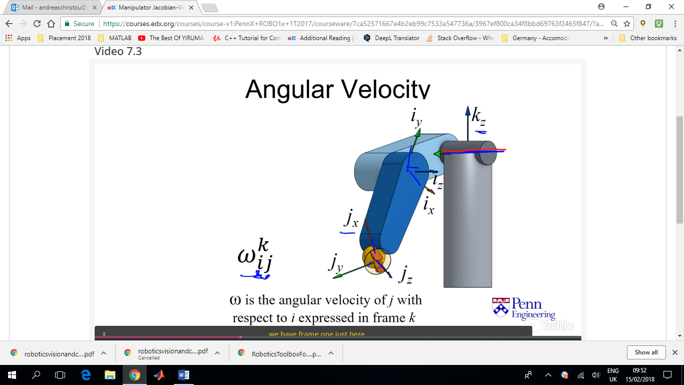

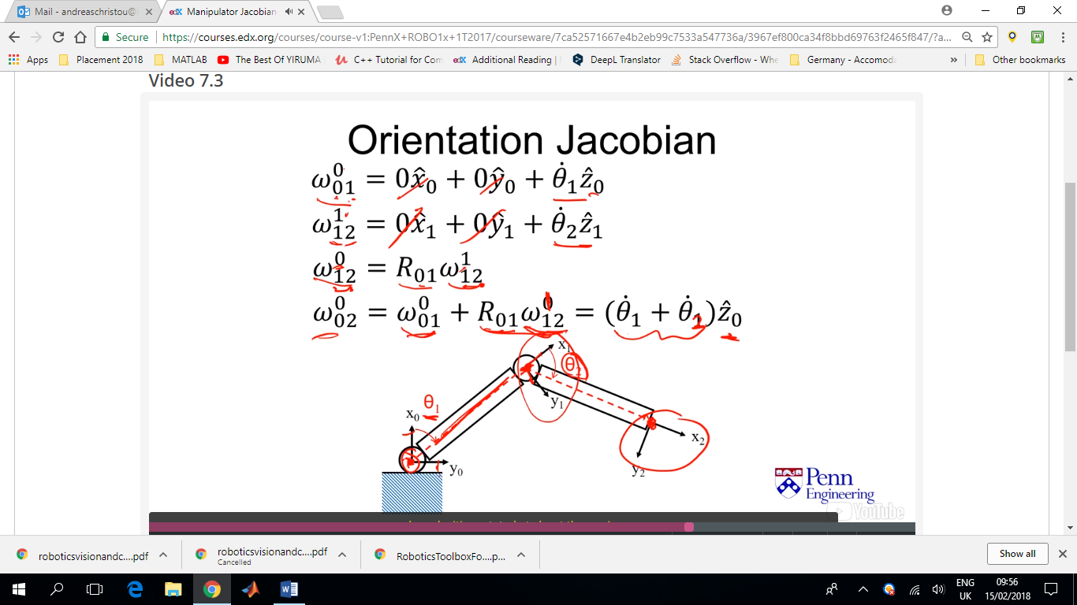

Here we have the angular velocity of frame 1, is the velocity of theta1 about the z0 axis.

Then the rotation of the frame 2 relative to frame 1, **expressed in frame 1,** is just the velocity of theta2 about the z1 axis.

Since frame one is actually rotating relative to frame zero too, in order to find frame’s rotation relative to the base frame we need to express the rotation of frame 2 relative to frame 1, in the coordinates of frame zero. To do this we rotate the vector using the R01 rotation matrix. We end up with:

Omega020 = omega010 + R01omega121 = (theta1_dot + theta2_dot) z0_hat

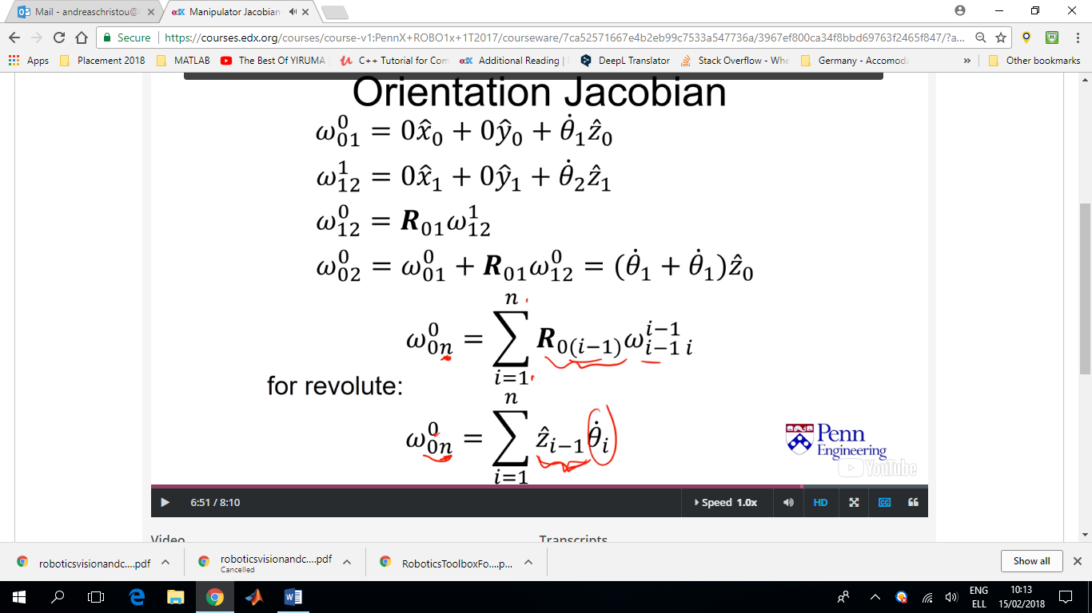The generalisation of this process, is to say that for serial change, the angular velocity is the sum of the velocities of each link rotated to get that link frame into the base frame coordinates. This first expression can also be written for the Denavit Hartenberg cases in a different way, because we know that rotating each one sequentially ultimately ends up with the z axis of the previous link.

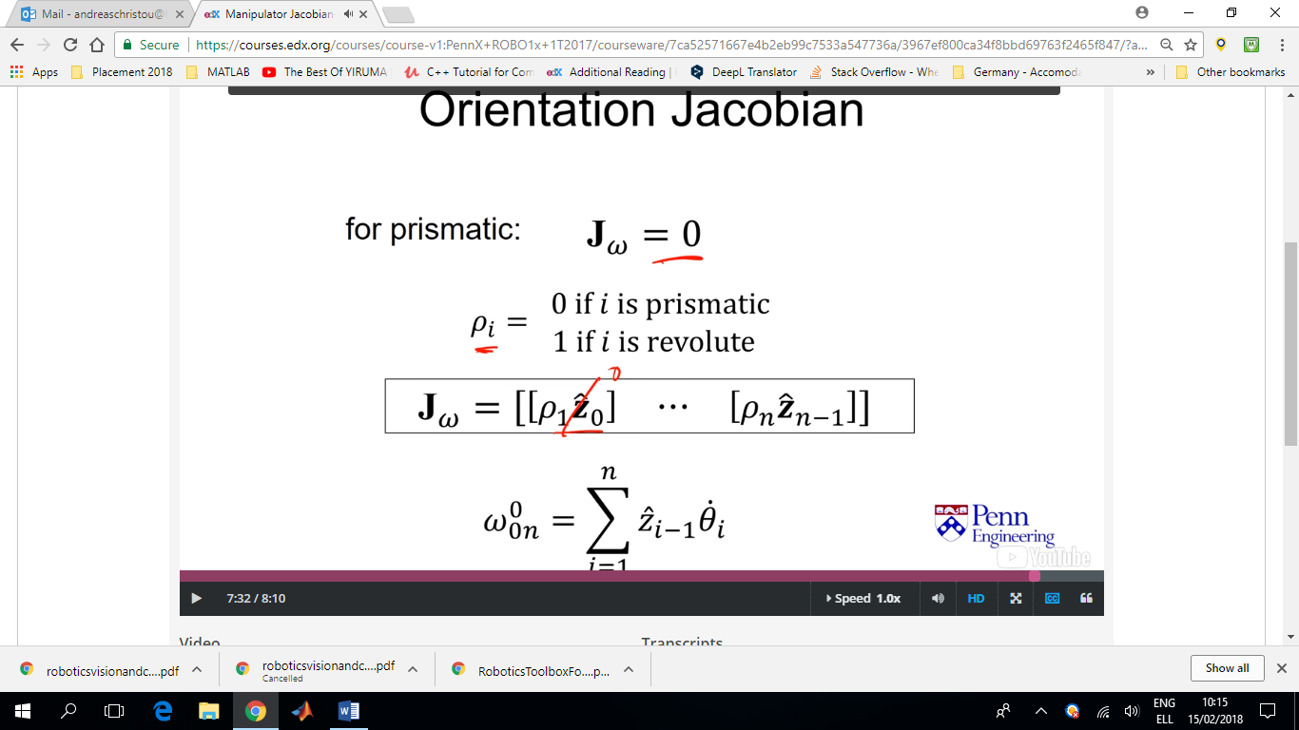For Prismatic joints the orientation jacobian is always zero.

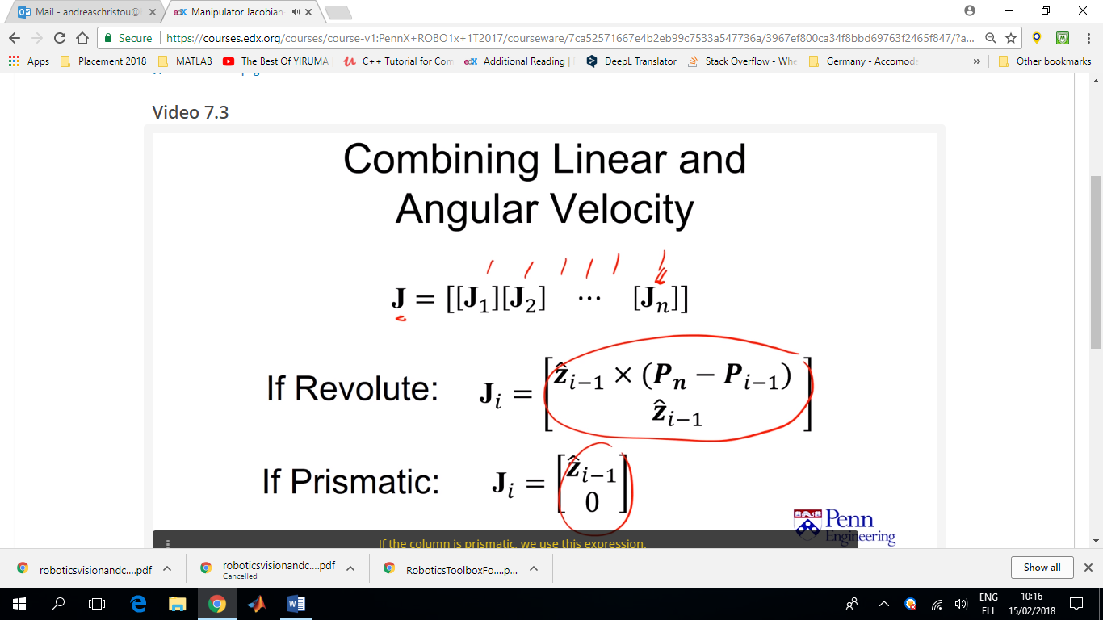

Now that we have expressions for the Jacobian of both revolute and prismatic joints, we can calculate the Jacobian for each joint, insert it to the right column in the full Jacobian matrix

Example 1:

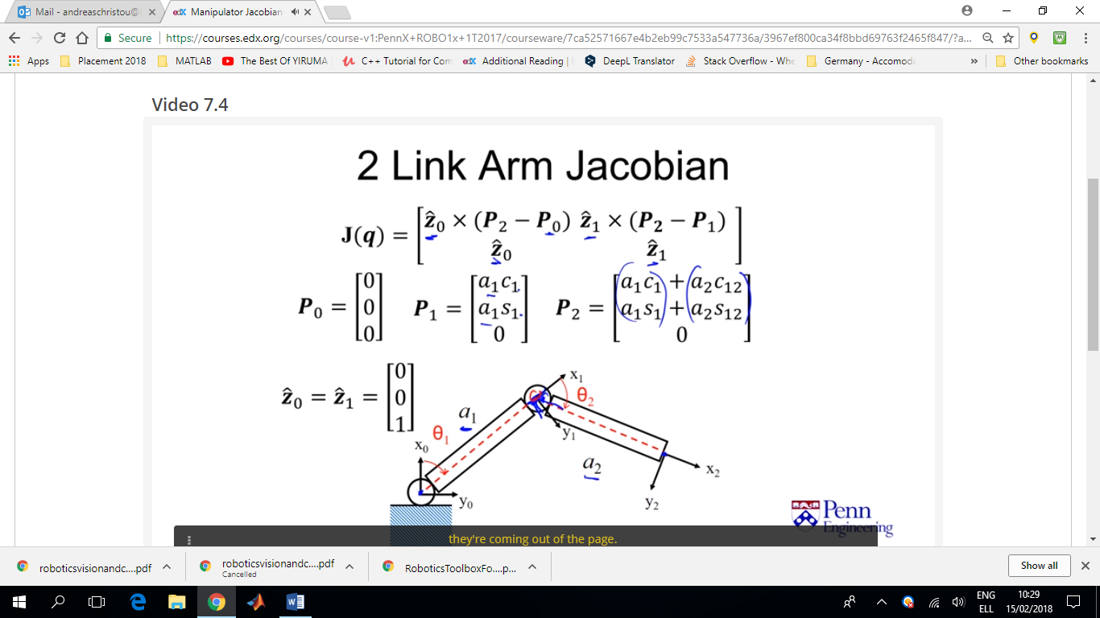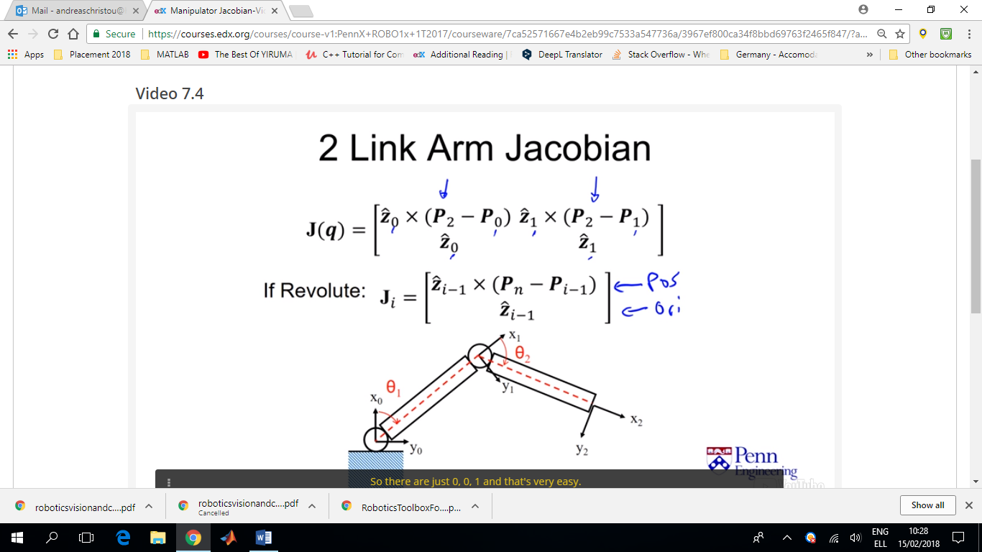

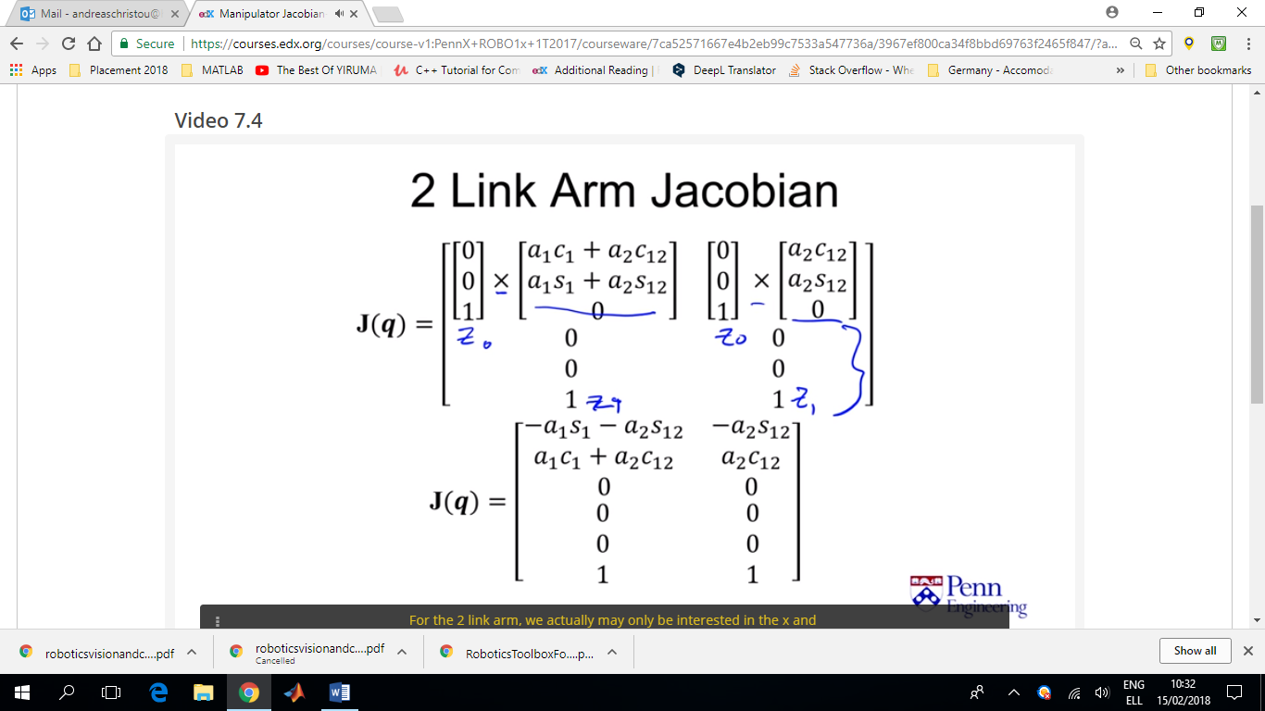Usually for the planar robot arm, we are mostly interested in the xy position of the end effector and not the rotation, so we end up with a 2x2 square matrix for the Jacobian.

Example 2:

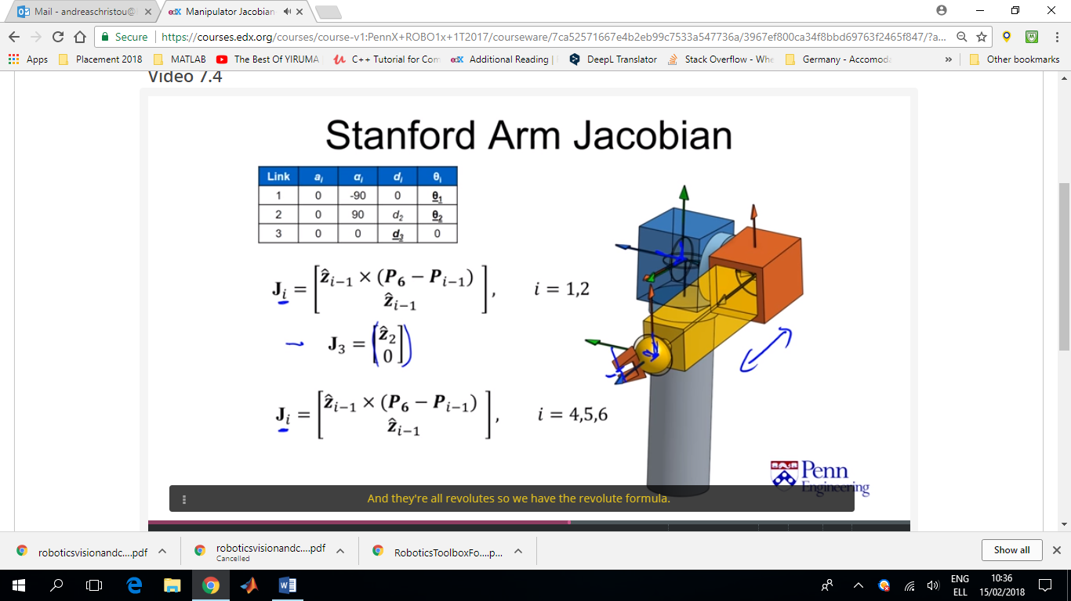To solve for **zi** and **Pi** we are going to use the formulas from forward kinematics.

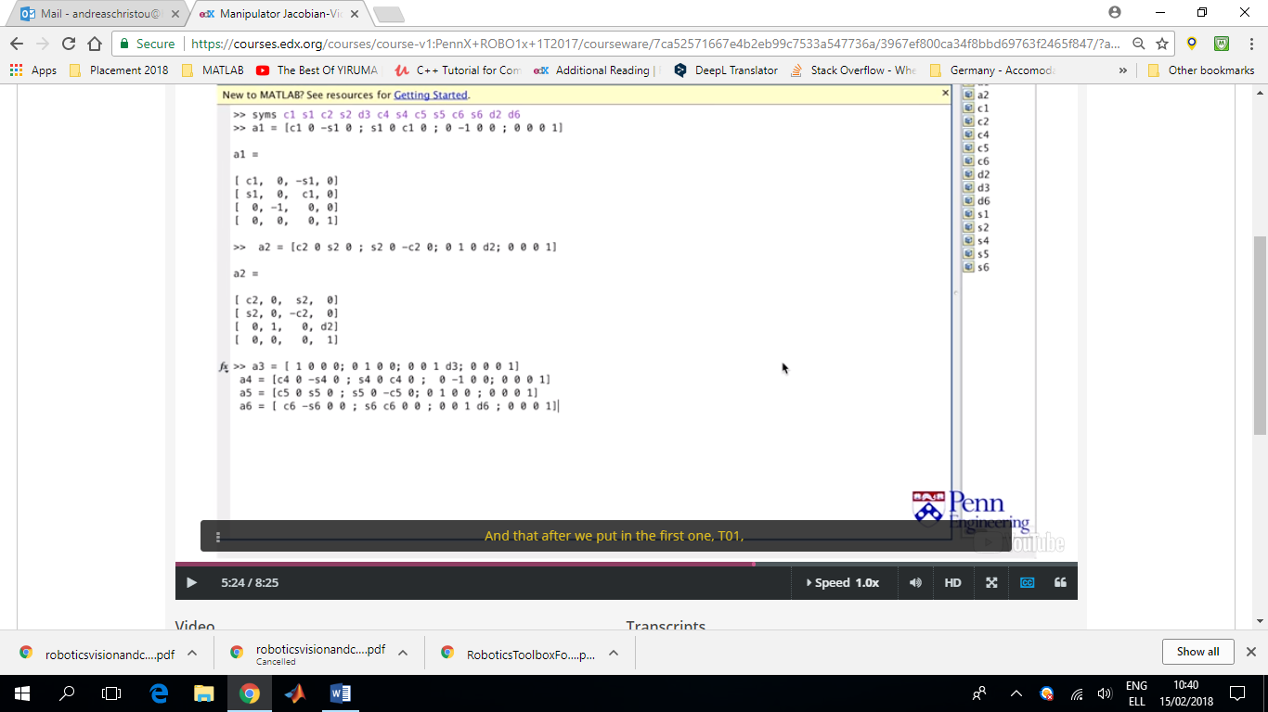

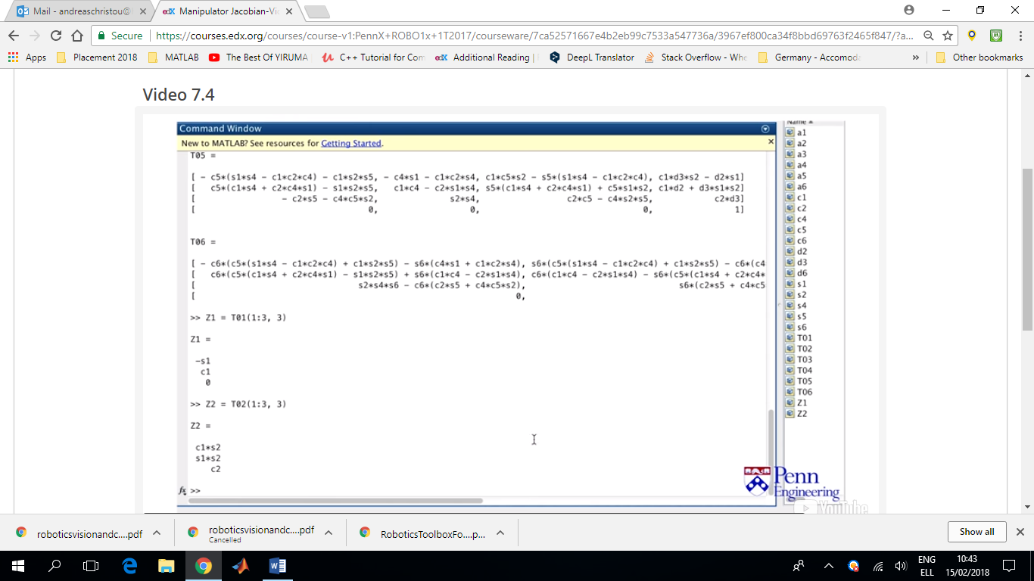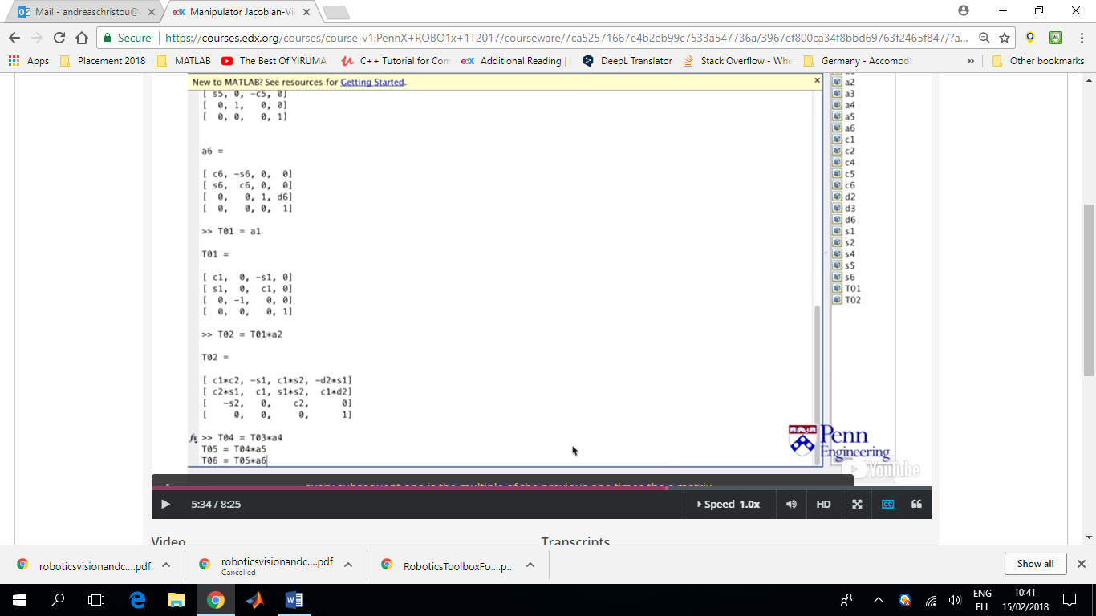

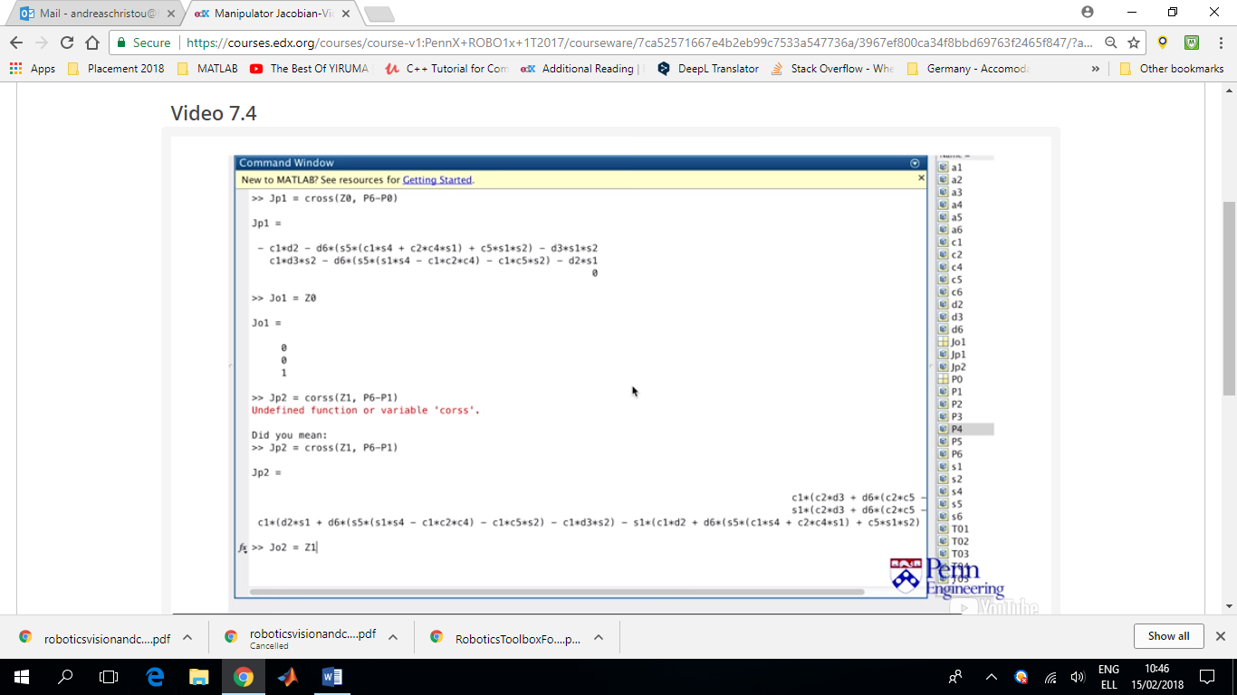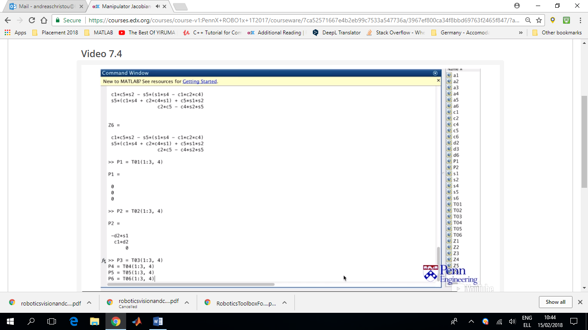After we add z0=[0;0;1] and P0=[0;0;0]

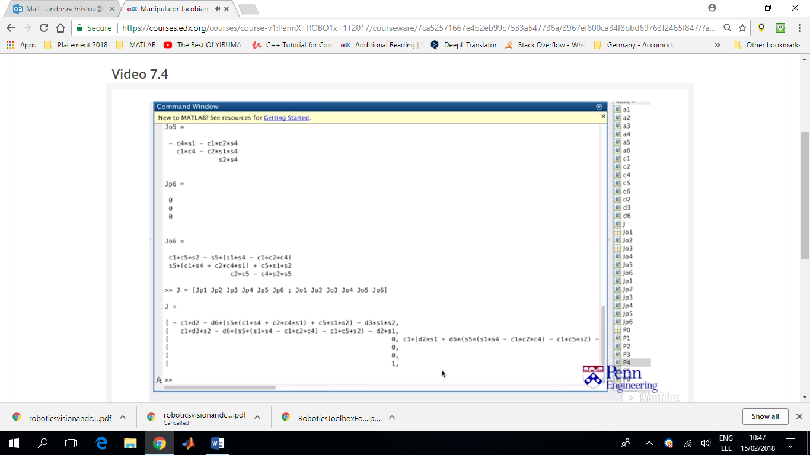

**Singularities**

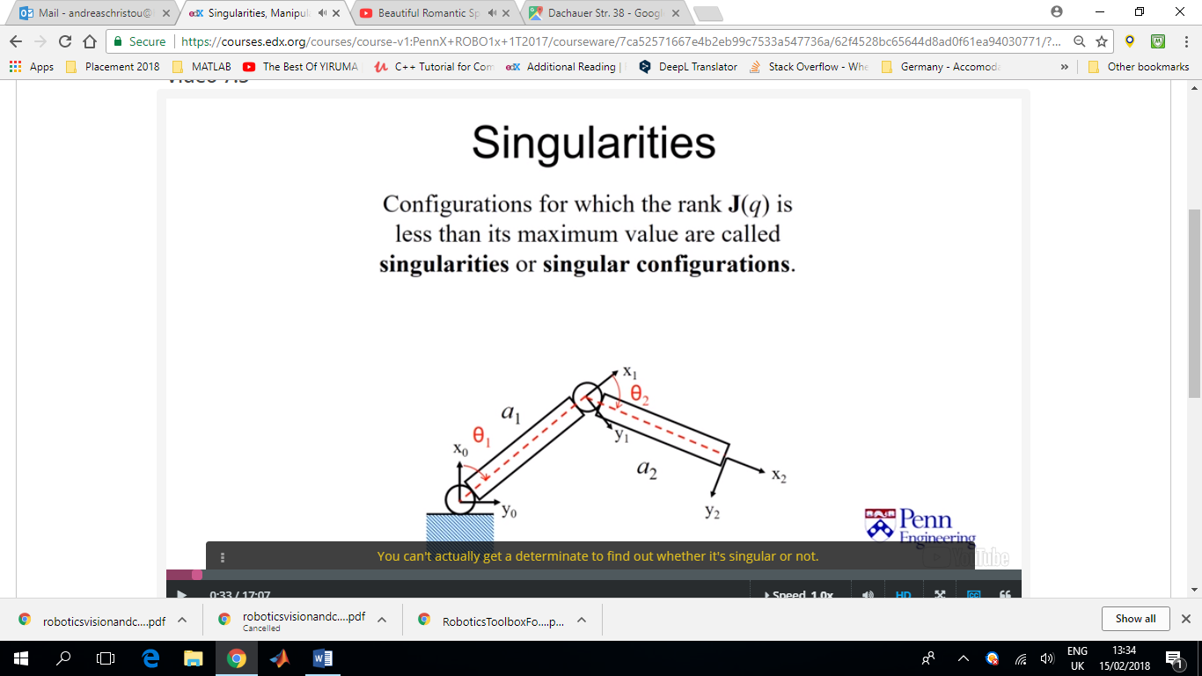Singular configurations are those in which a Jacobian loses Rank. We like to think about singularities as occurring when a Jacobian matrix becomes singular. That’s mostly true except sometimes a Jacobian matrix isn’t always square which means it can’t actually become singular (you can’t get the determinant to find out whether it’s singular or not).

In this case the Jacobian is clearly not a square matrix.

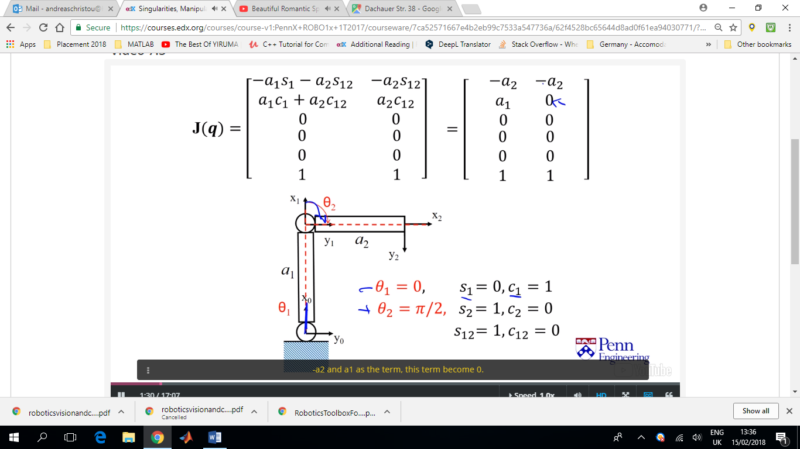

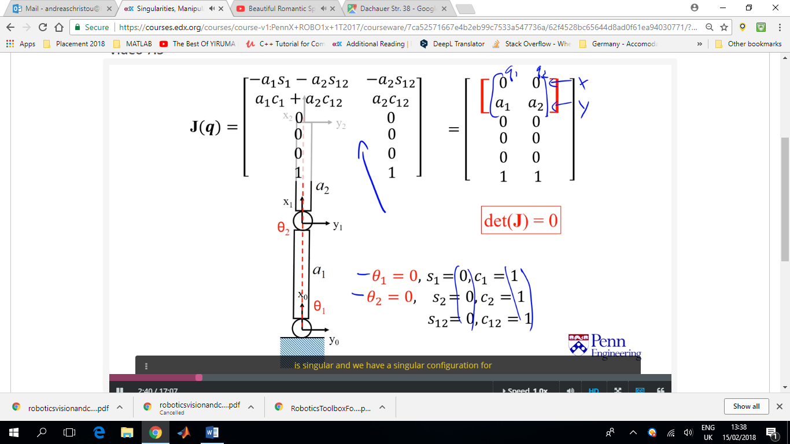In this configuration, the determinant of the 2x2 position matrix is zero i.e. the matrix is singular.

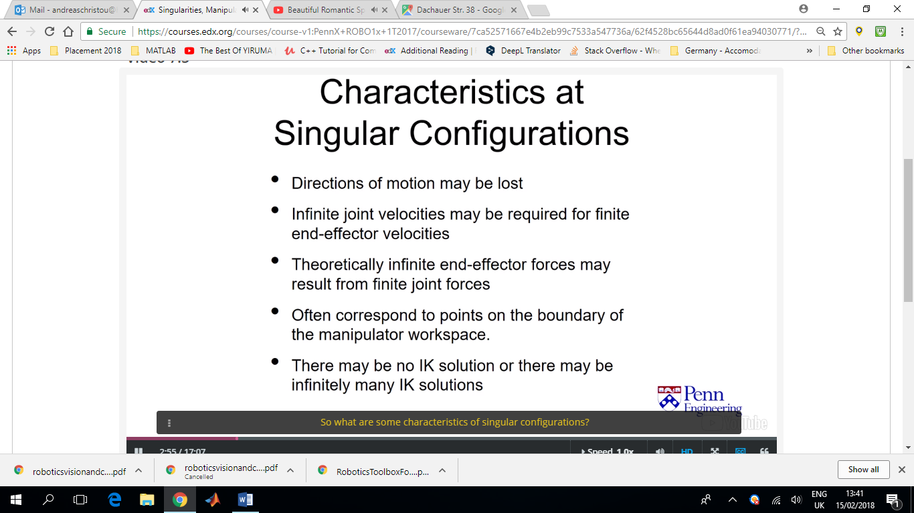They generally occur when revolute joints line up.

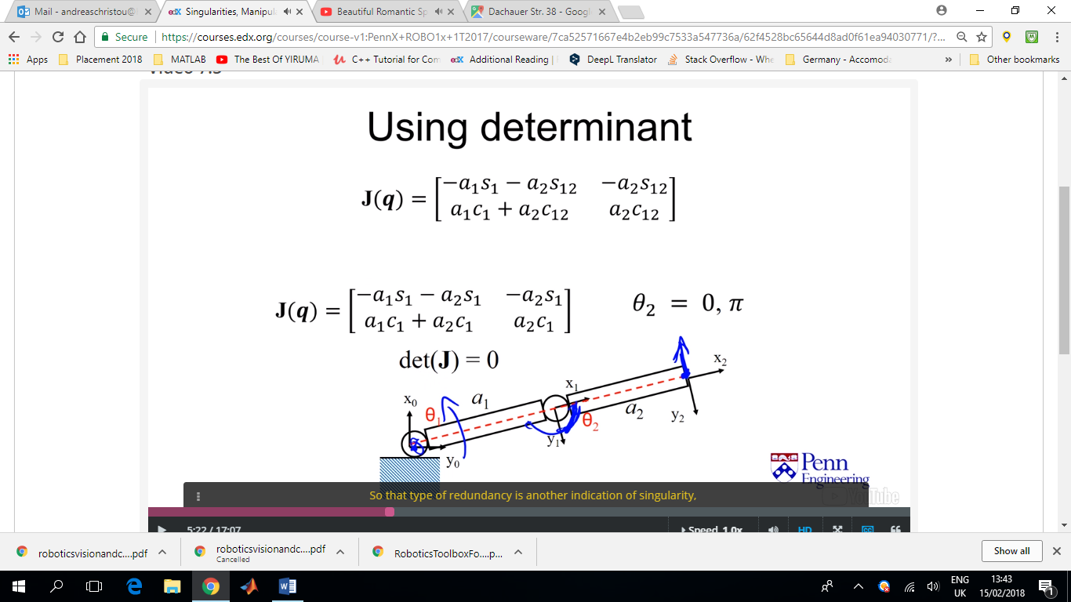

Another indication of a singularity is that if we move link 1 by theta1 then the end effector motion is in exactly the same way to theta1. This type of redundancy is another indication of a singularity.

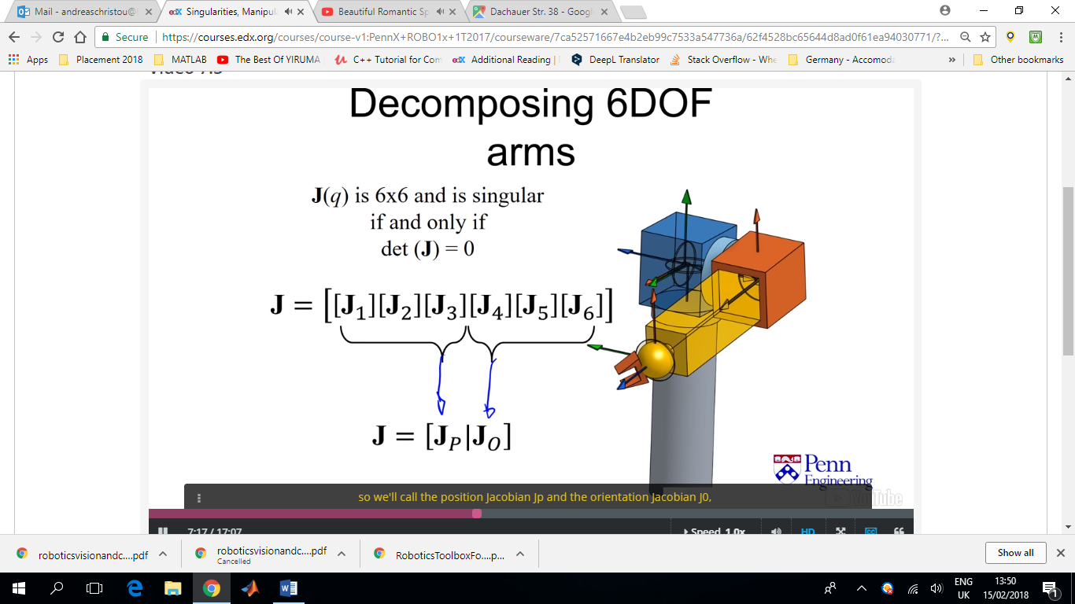

In a 6DoF robot (6x6 Jacobian matrix), consisting of a 3DoF positioning arm and a 3DoF wrist, there can be singularities both due to the positioning and the wrist.

**JP=**Positioning Jacobian

**Jo=**Orientation Jacobian

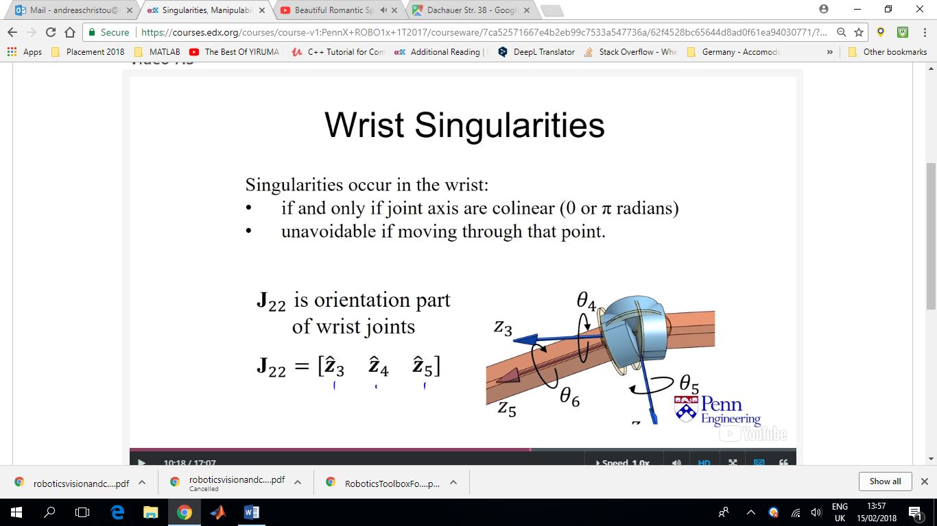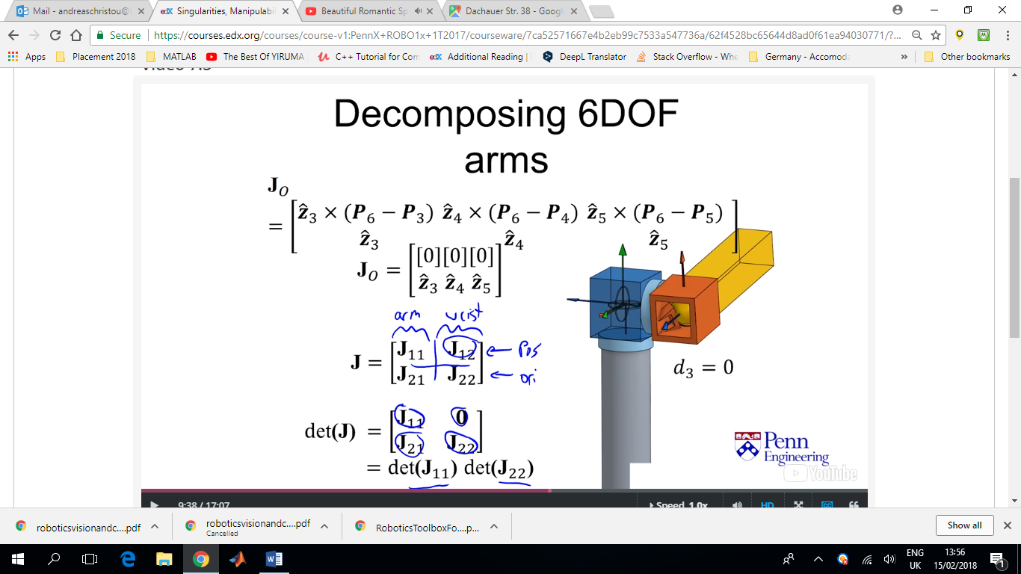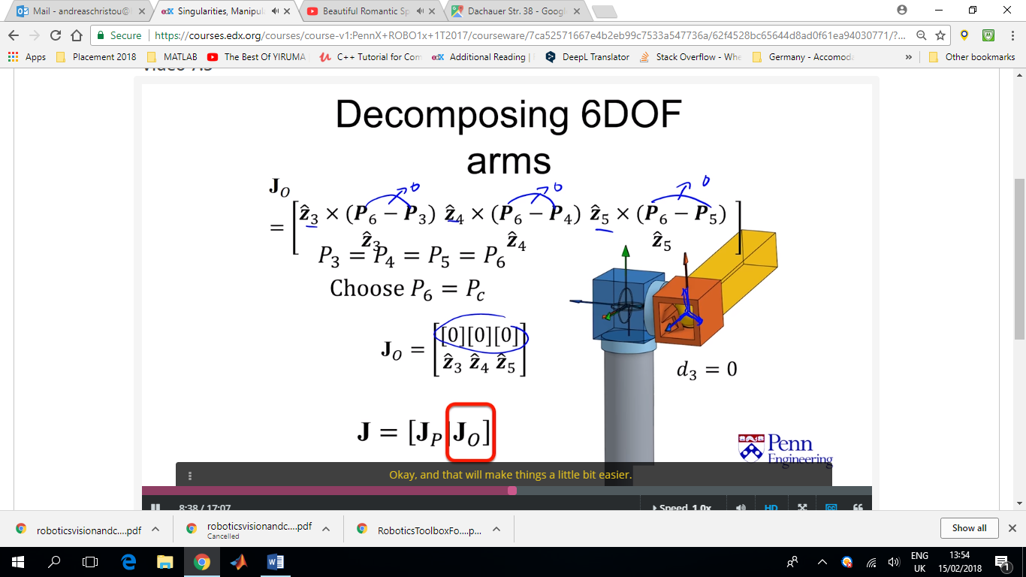If we choose the positioning of the last link (end effector) to be the same as the wrist the positioning Jacobian of the wrist becomes zero. Which leaves the determinant of the Jacobian, dependent only on the Arm positioning and the orientation of the wrist. For the orientation of the wrist, if the angle between any of the frames goes to zero or π then singularities are introduced. Sometimes, people use a ‘hard stop’ in order to avoid this.

Sometimes, the representation itself, when using Euler angles, might have a singularity (representational singularities). Usually this kind of singularities have nothing to do with the physical device. This a reason why quite often quaternions are used for representing rotations in robotics.

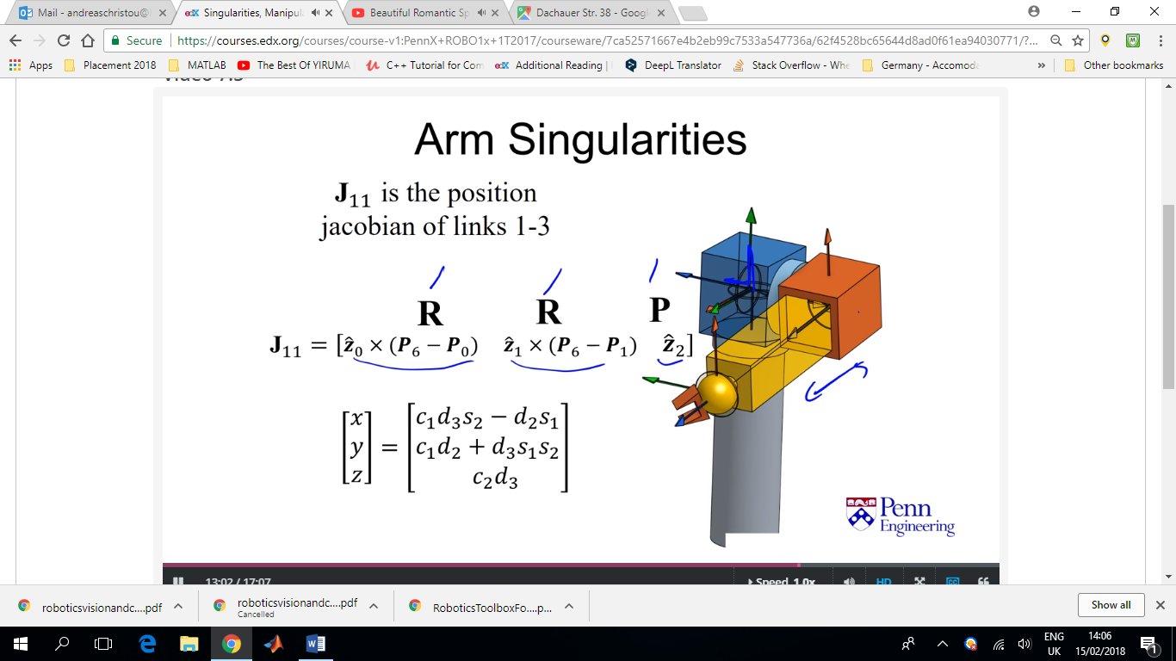Calculating the partial differentials of the position matrix obtained from the forward kinematics is another method for obtaining the Position Jacobian of the arm.

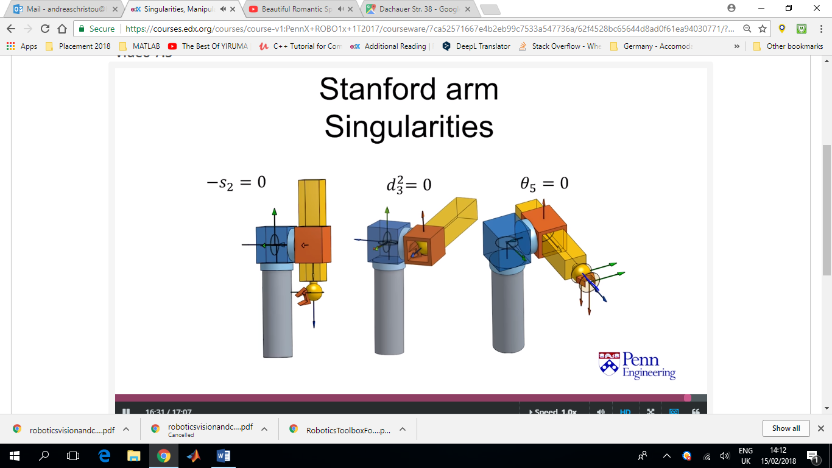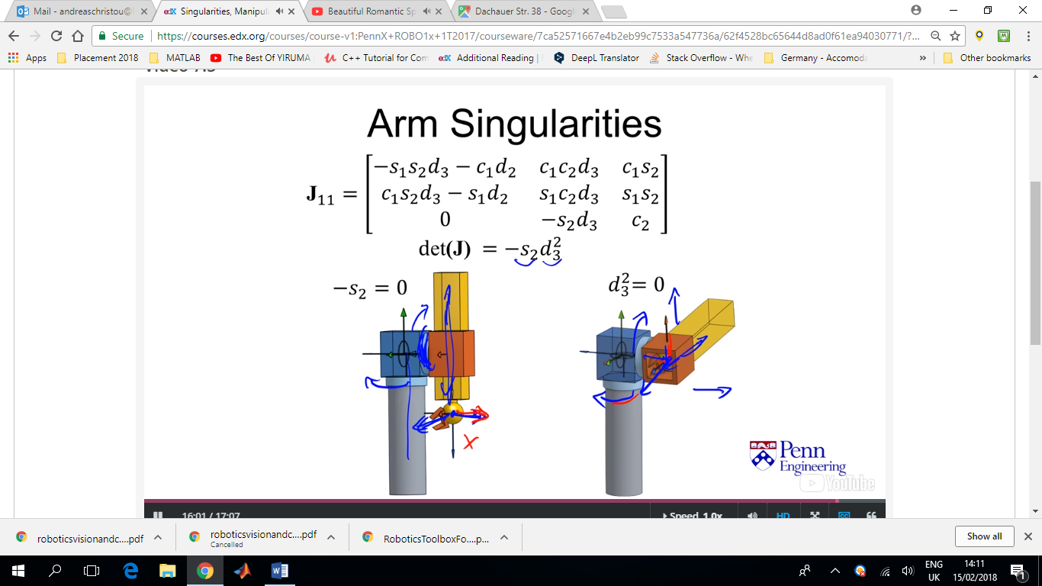

In this case that a singularity arises when theta5 is zero might be problematic. Depending on the tasks that the robot is designed to do, theta5=0 might be a common position for the robot arm.

We can use the Jacobian to analyse the potential motions of the end effector and how that changes with the different positions of the robot joints. It may be that moving in certain directions is easier or harder depending on the joint positions. So we can start by looking if we freeze all the joints except one, eg joint 1, how does the end effector move. The velocity of the end effector is going to be some kind of linear function depended on the rotation of joint 1 and the distance between the end effector and the centre of rotation.

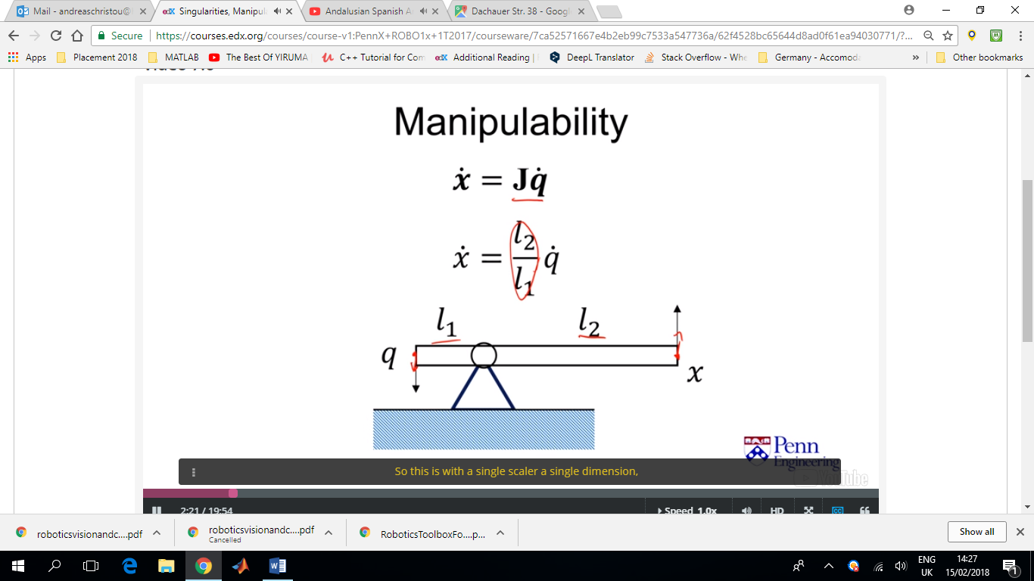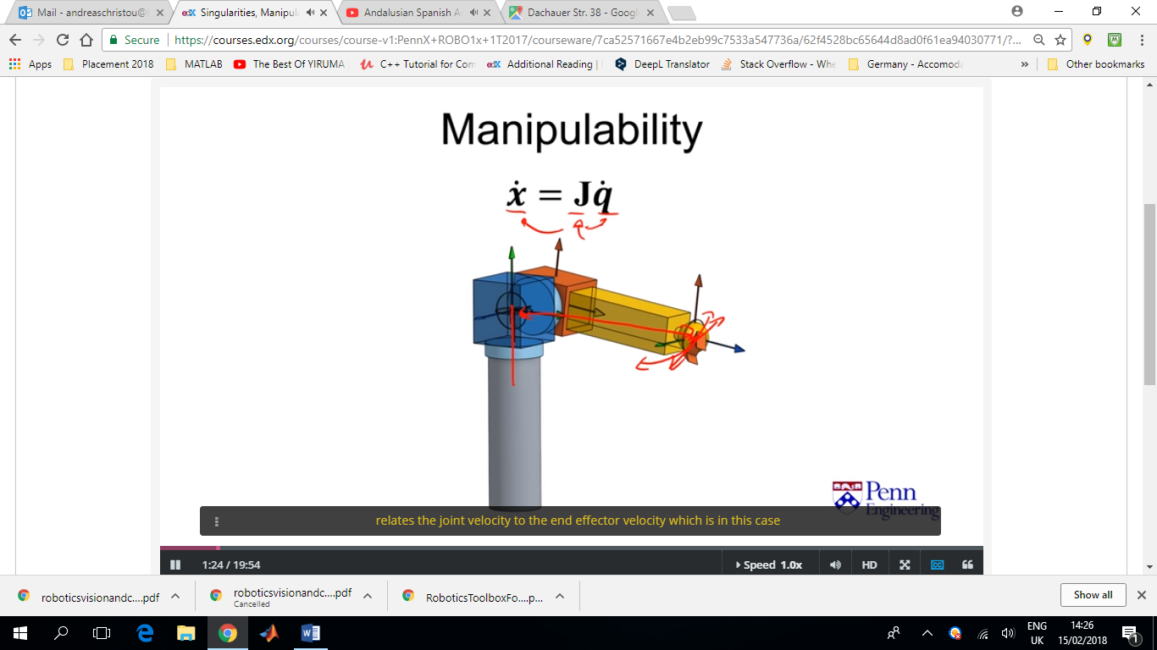

When dealing with **multiple** inputs at the same time, like our case, one way to do this is to think about the inputs as the unit norm. So in this case, any individual input can be a 100% if all the other inputs are at 0%. Or we can combine the different inputs as long as the sum of the square of those has a magnitude of 1, then we have that limit norm as an input. If we 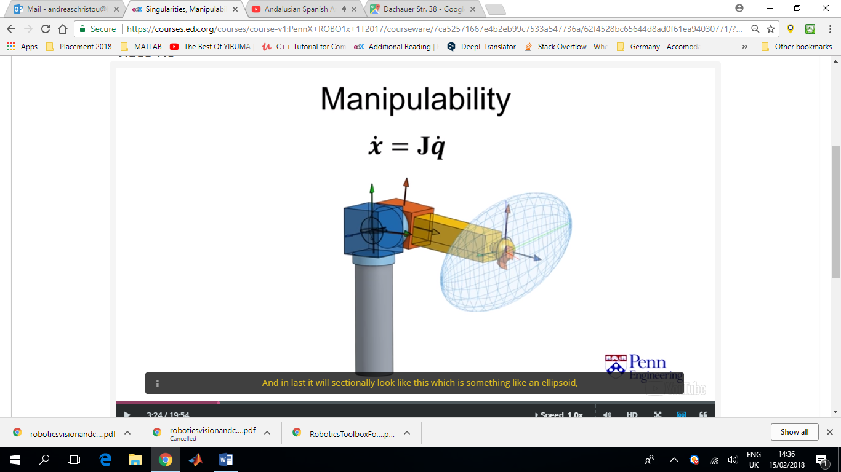look at the boundary of what the input is, so if we at the unit sphere form input, we can map that onto the output velocities, (the velocities of the end effector). (figure)

We would normally know what the maximum direction of this ellipsoid is going to be for the direction that has the maximum joint according to the Jacobian transformation.

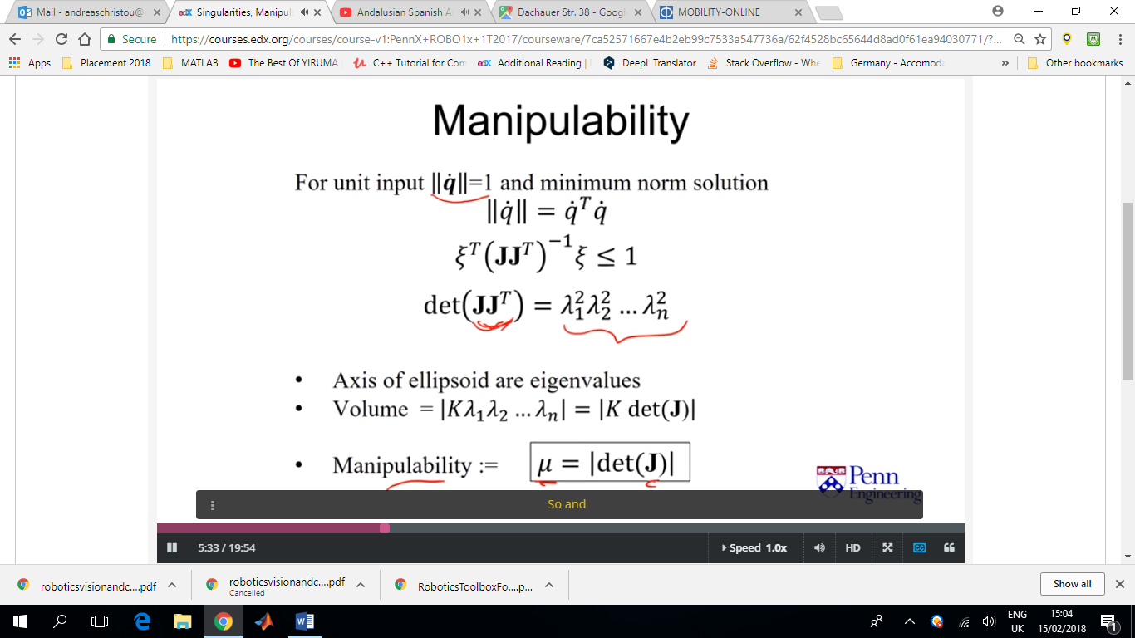Since the Jacobian is a linear mapping between these two spaces we can show that the mapping of this unit input boundary becomes an ellipsoid a little bit more precisely.

It turns out that the axis of the ellipsoid are the eigenvalues obtained from the determinant of the Jacobian times the transpose of the Jacobian, with the direction of each axis being eigenvectors.

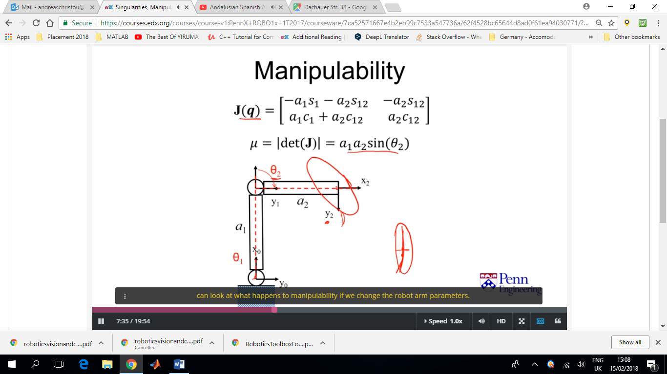Essentially what we want to have in this system is that the size of this ellipsoid allows us to think about what the velocities are at that end effector for the given inputs. And if we consider a unit norm input we have a kind of a normalised way to look at that output. A characteristic metric that we will use, is what people call manipulability.

In this case we can see that manipulability is greater when theta2 is closer to π/2 and when a1 and a2 are bigger. This essentially means that the (capability of having the) velocity at the same point will increase.

At theta2=0 (singularity) the manipulability ellipse becomes a straight line. The volume or in this case the area of this ellipse is zero.

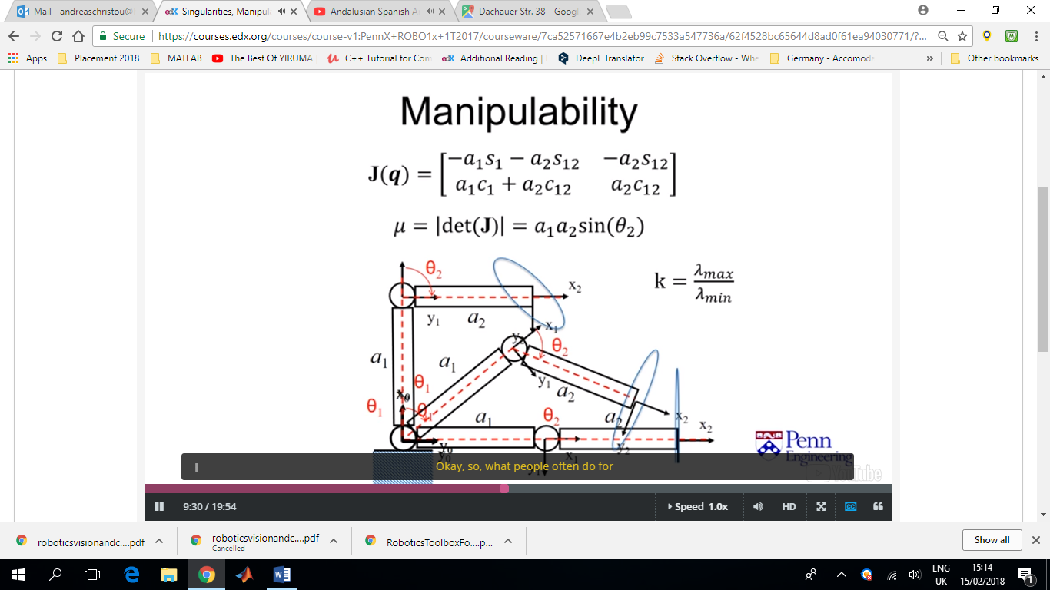People commonly use this value k, called the condition number. The ideal condition number is 1 (which corresponds to a spherical case). The largest k is, the worse the manipulability.

The Robot would be able to resist larger forces if they were applied along the shorter axis of the ellipsoid. So theoretically, at the singularity, the robot can resist a huge force if its directed along x2. (zero force/torque is required by the link ‘motors’ to resist this force)

What is the Unit Norm Input and does it actually make sense? ||**q_dot**||=1

How do we compare a prismatic joint’s velocity to a revolute joint’s velocity? (the units are different)

So, what we want to achieve is to scale things up to a maximum capability. So, if the motors had a maximum velocity, then we would know that there was a maximum motor action. If the motor is attached to a revolute joint there would be a maximum rotation velocity and if the motor is attached to a prismatic joint, then it would have a maximum translational velocity. We can scale and normalise those values to the maximum velocities that is capable of the actuators (the actuator authority).

If we are thinking about each individual dimension separately, then the unit norm in this context makes sense. But when we combine them, the unit norm assumes that it’s the square root of the sum of the squares and that assumes that there is a coupling between those dimensions in that way. Very likely it’s not going to be exactly that way. But there probably will be some kind of coupling, as in this particular case, if the arm is moving out or has a certain velocity, that might reflect on the motors when it moves. They might not be able to move as fast, maybe because power is being used or other issues. So there might be some type of coupling in that. And that kind of represents a gross collection of this type of coupling and gives us a rough idea for what the manipulability space looks like and at least the major axes where we have these maximum velocities does actually make sense.

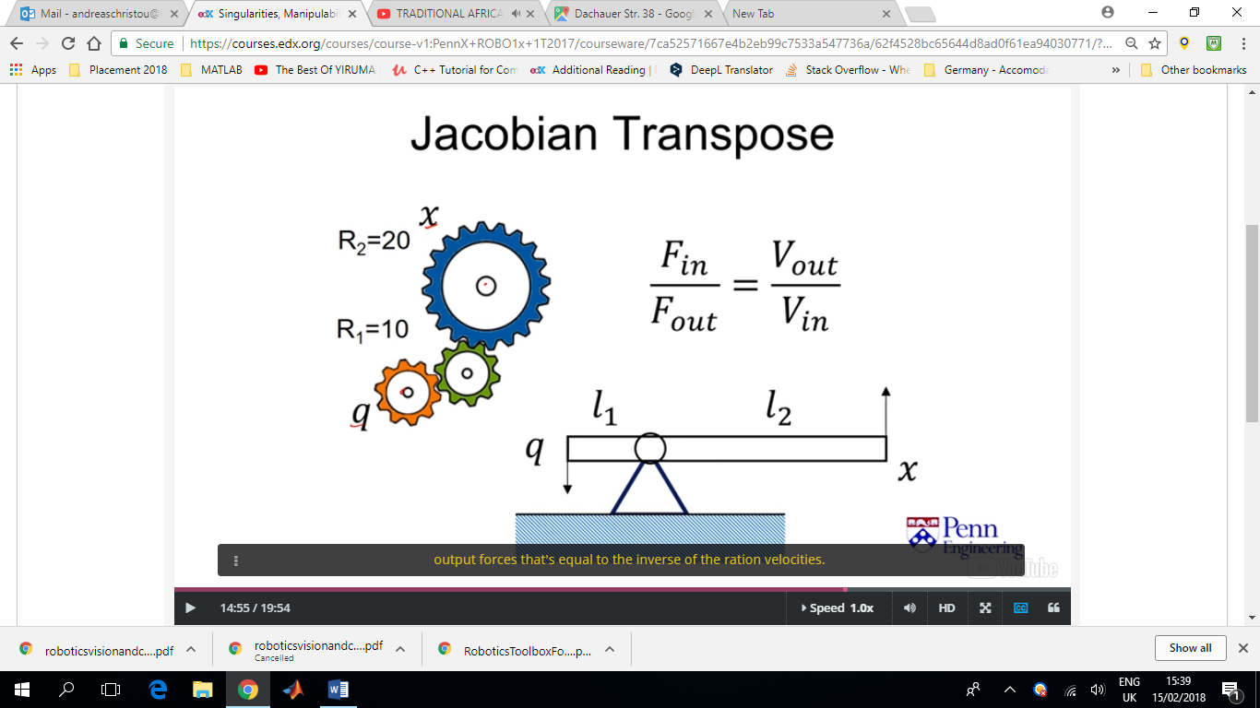This ratio of velocities can also be thought of as a gear ratio. (q=input, x=output) Trade off between speed and torque. The ratio of the input and output forces is the inverse of the ratio of the velocities.

We can do the same thing with the Jacobian by applying the principle of virtual work.

Using the static model (since the Jacobian cannot take into account the dynamic inertias of the arm) we can calculate the torques and forces required by the motors to counteract a mass placed at the end effector. 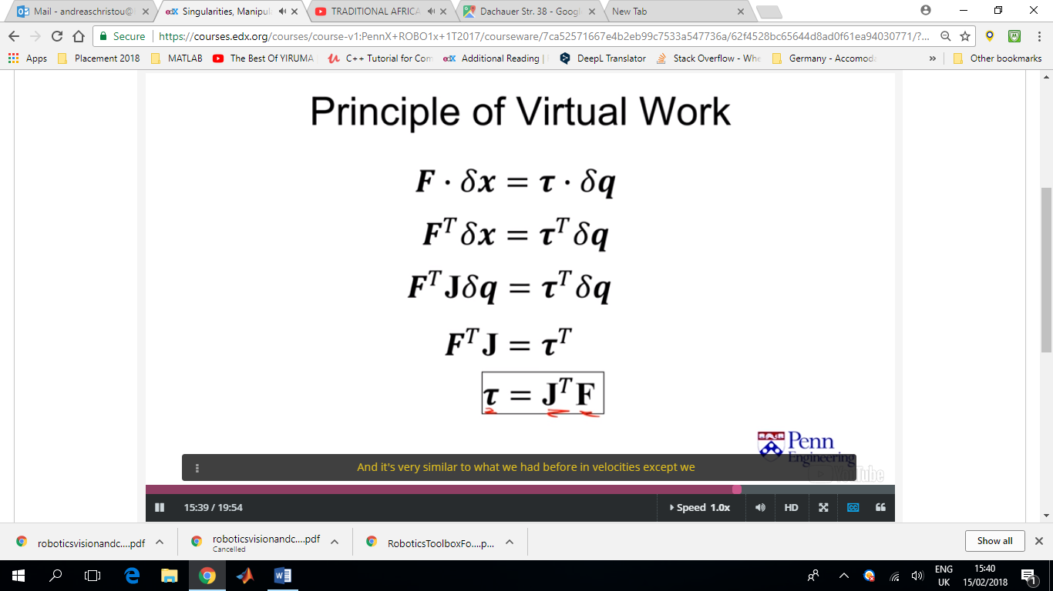

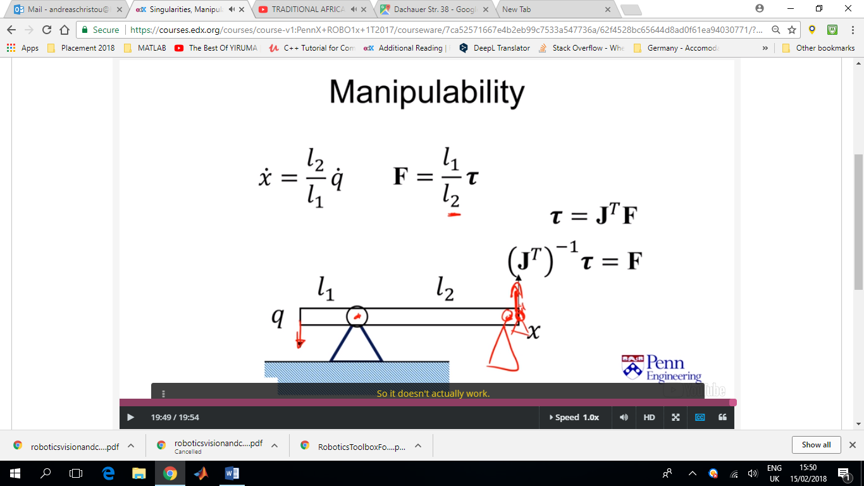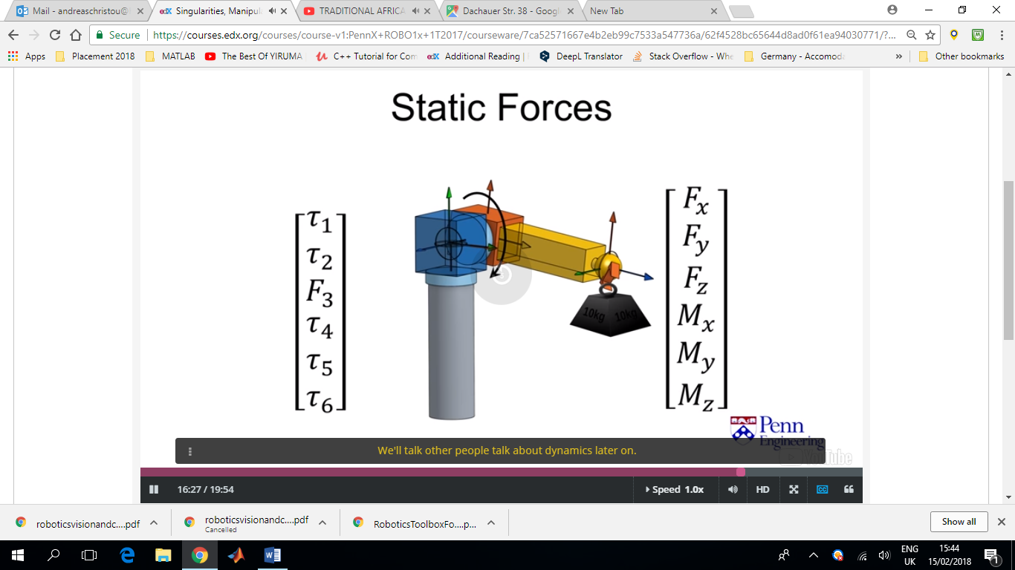

**Finish Project 2 Week 8 to Make sure it’s ALWAYS correct and spend time on project 3!!**

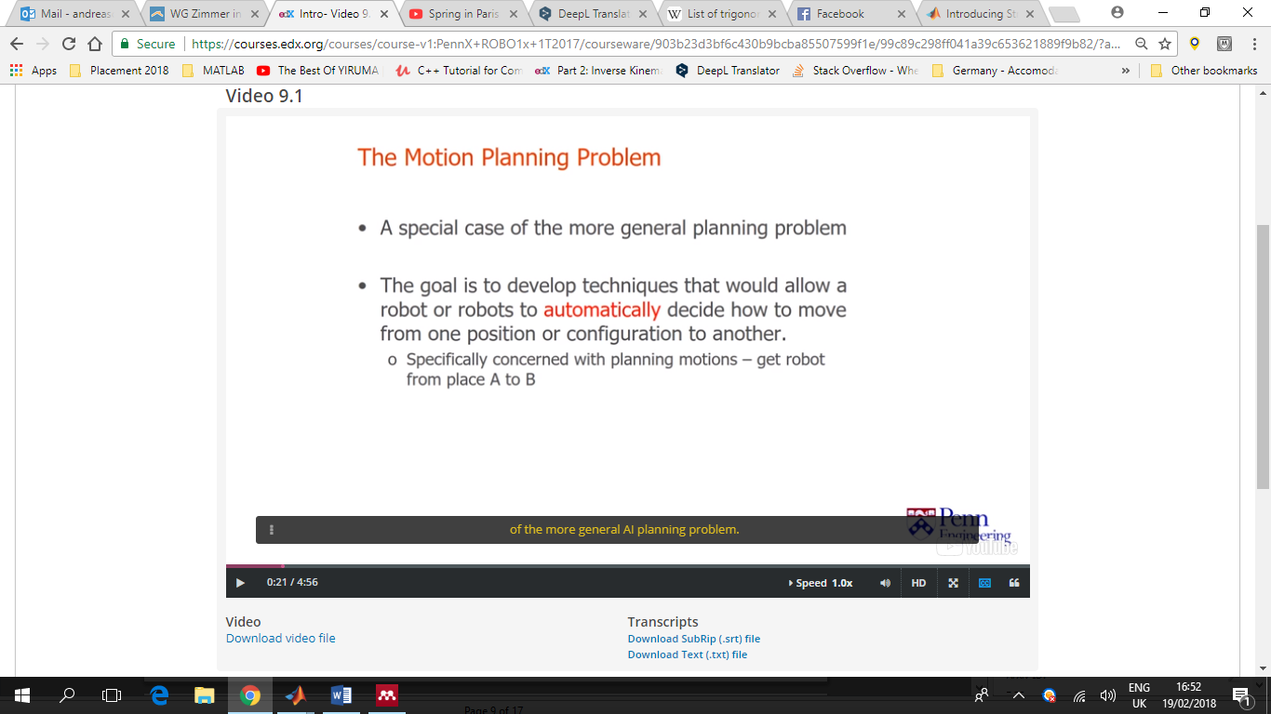Motion planning is a more generalised version of the more general AI planning problem.

Goal is to come up with a sequence of actions to accomplish a given goal safely and efficiently (in this case moving from one place to another).

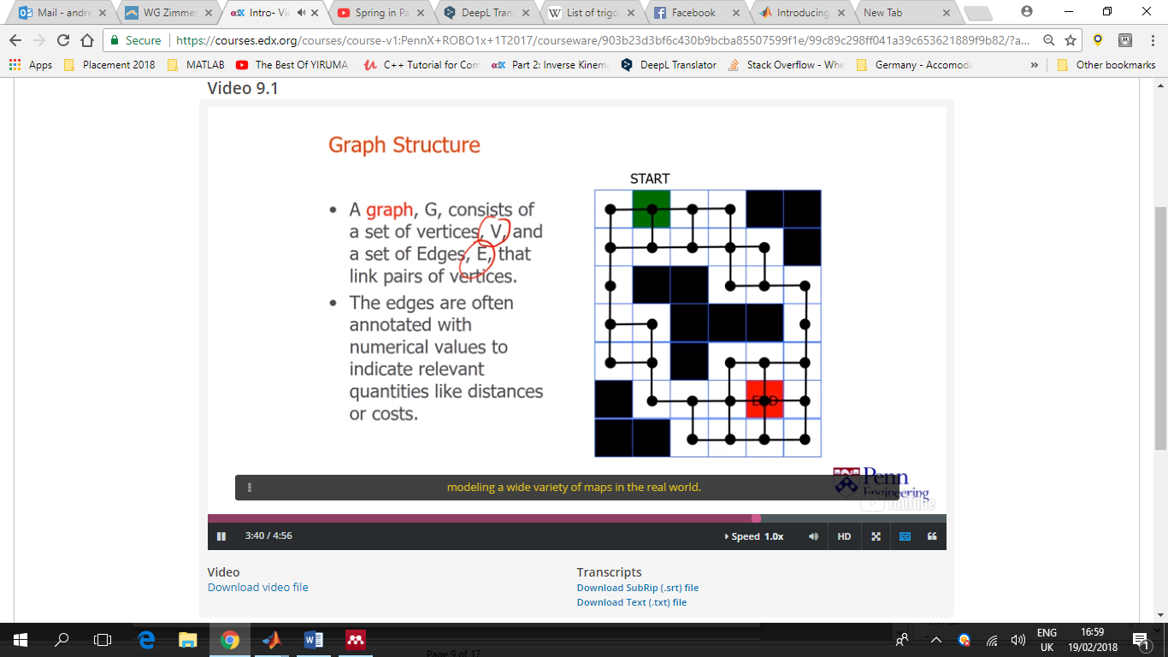G=graph

V=nodes

E=sides,edges

With each edge we can associate an edge weight or cost (in this case we can associate a unit distance with each of the edges between associate nodes)

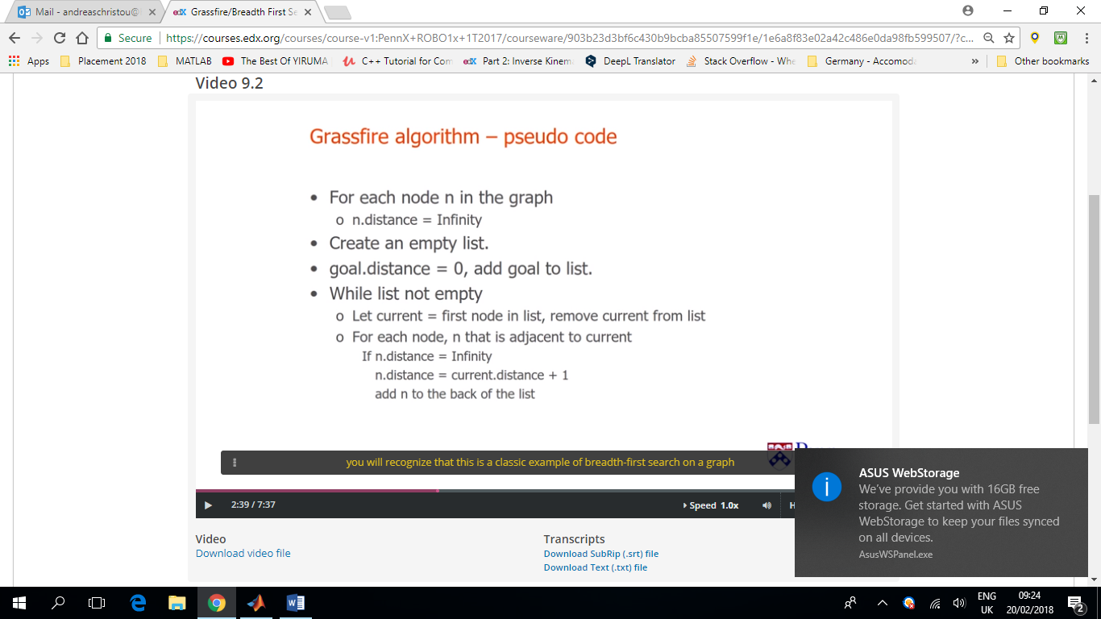

Figure Breadth-first search Algorithm

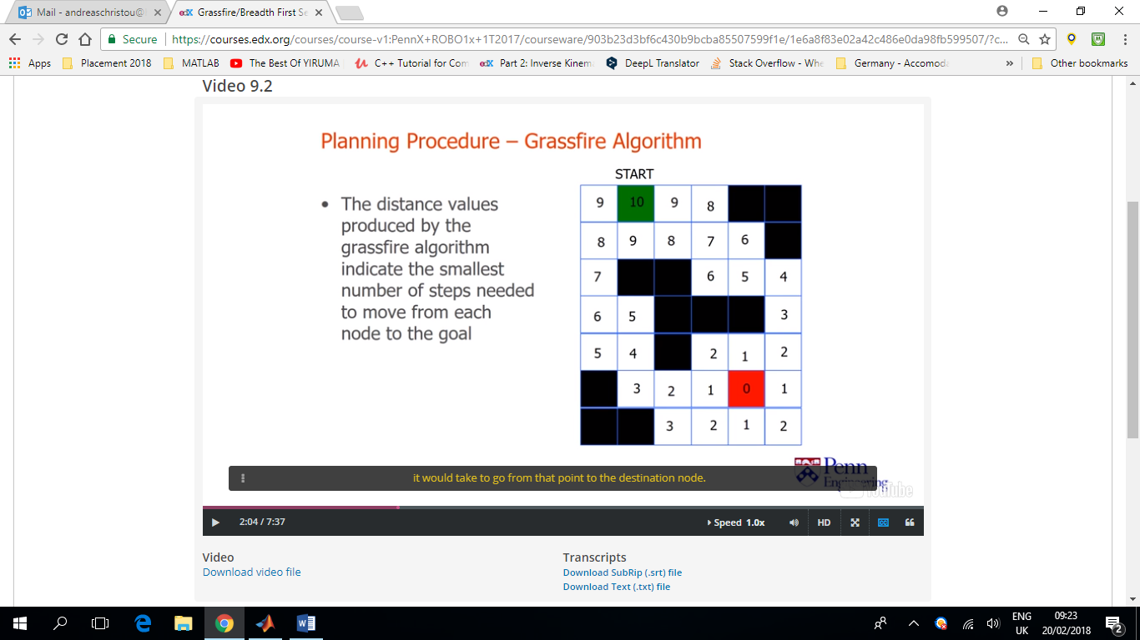

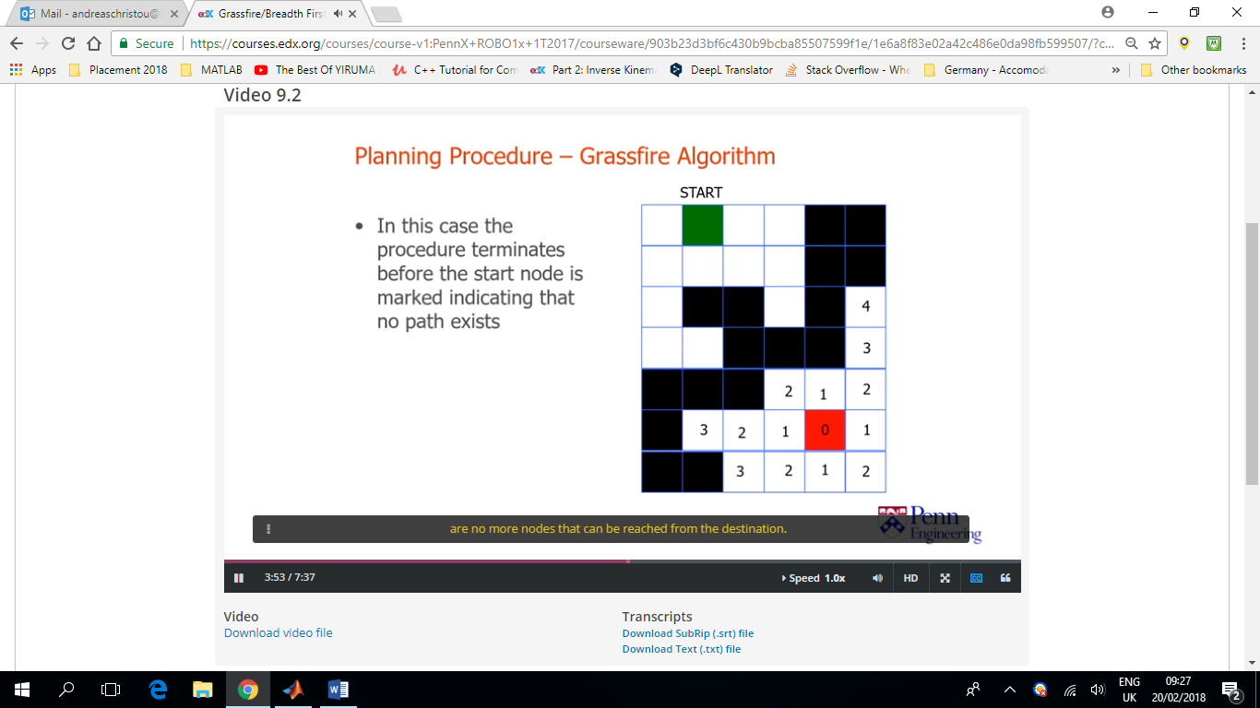Since the start node has not been marked we can conclude that there is no path between the start point and the destination.

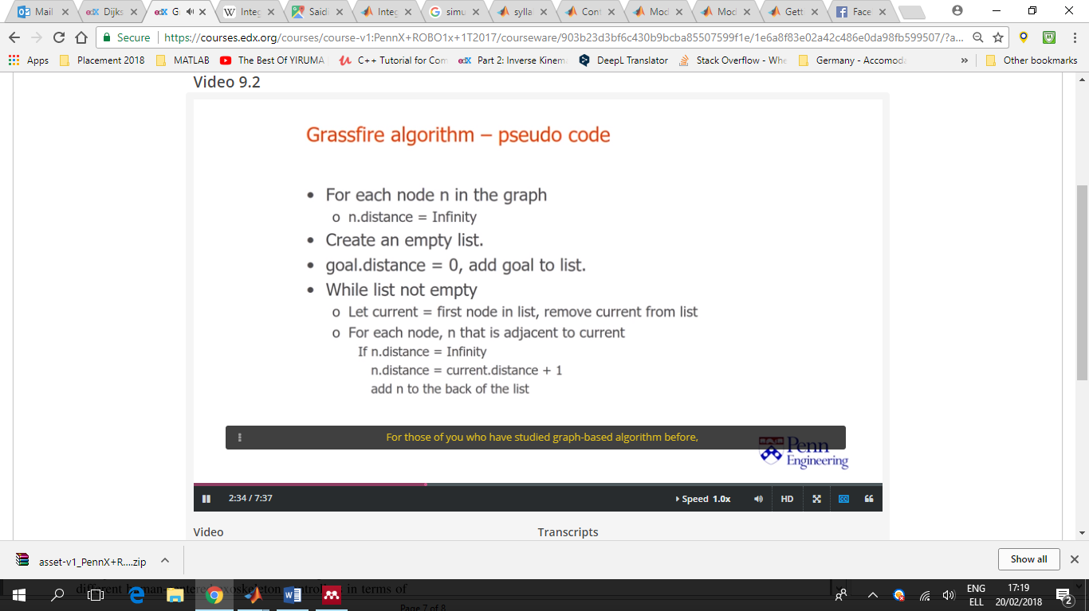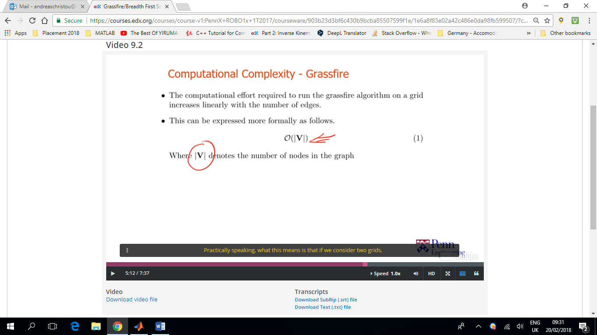Equation (1) denotes that the computational effort grows **linearly** as the number of nodes increases.

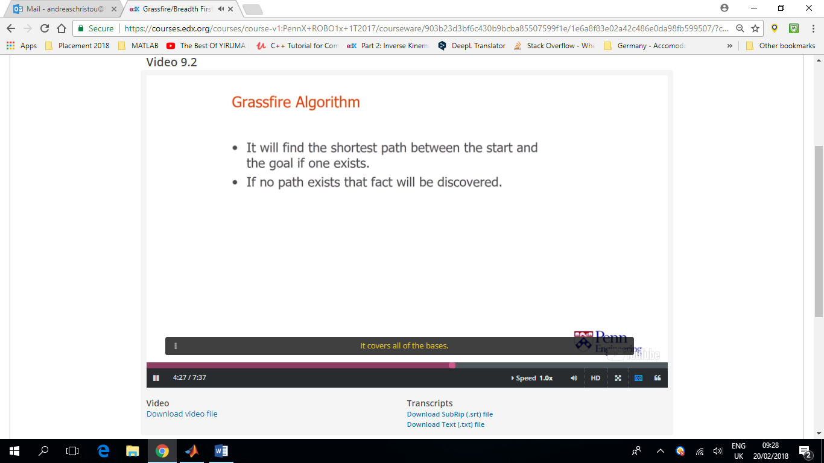

Figure . Grassfire Algorithm Desired Characteristics

In motion planning problems, the amount of computational effort required to solve a problem grows **exponentially** as we increase the number of dimensions.

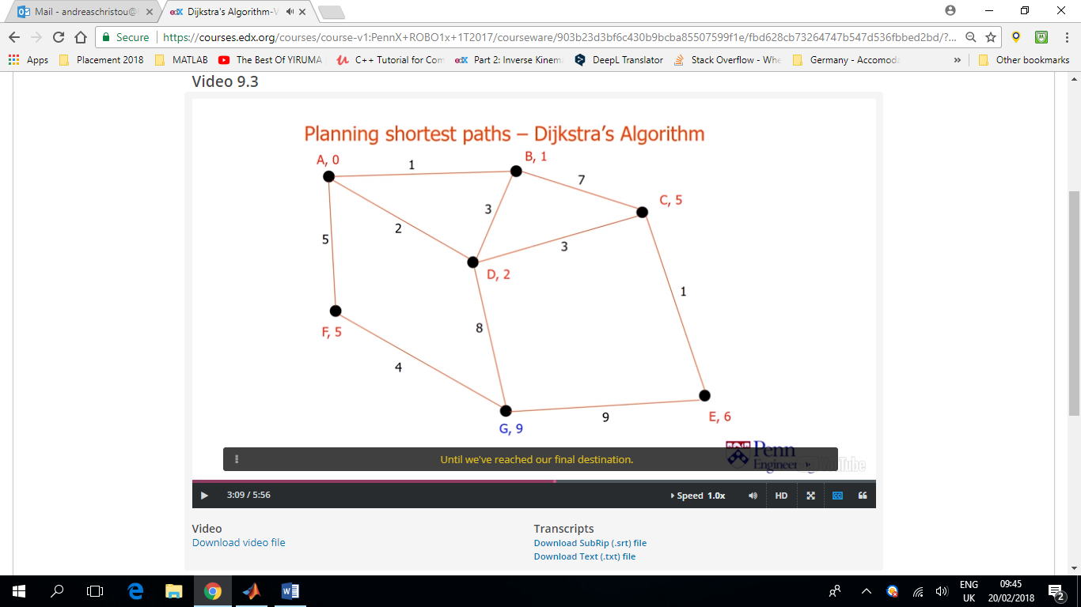Another method for finding the shortest path through arbitrary graphs with non-negative edgeways

We use red to indicate that the node has been removed from the list.

Blue is used to indicate that the nodes have been added to the list of nodes that we are considering.

So we proceed by removing the lowest cost node from the list and updating its neighbours one at a time until we reach our final destination.

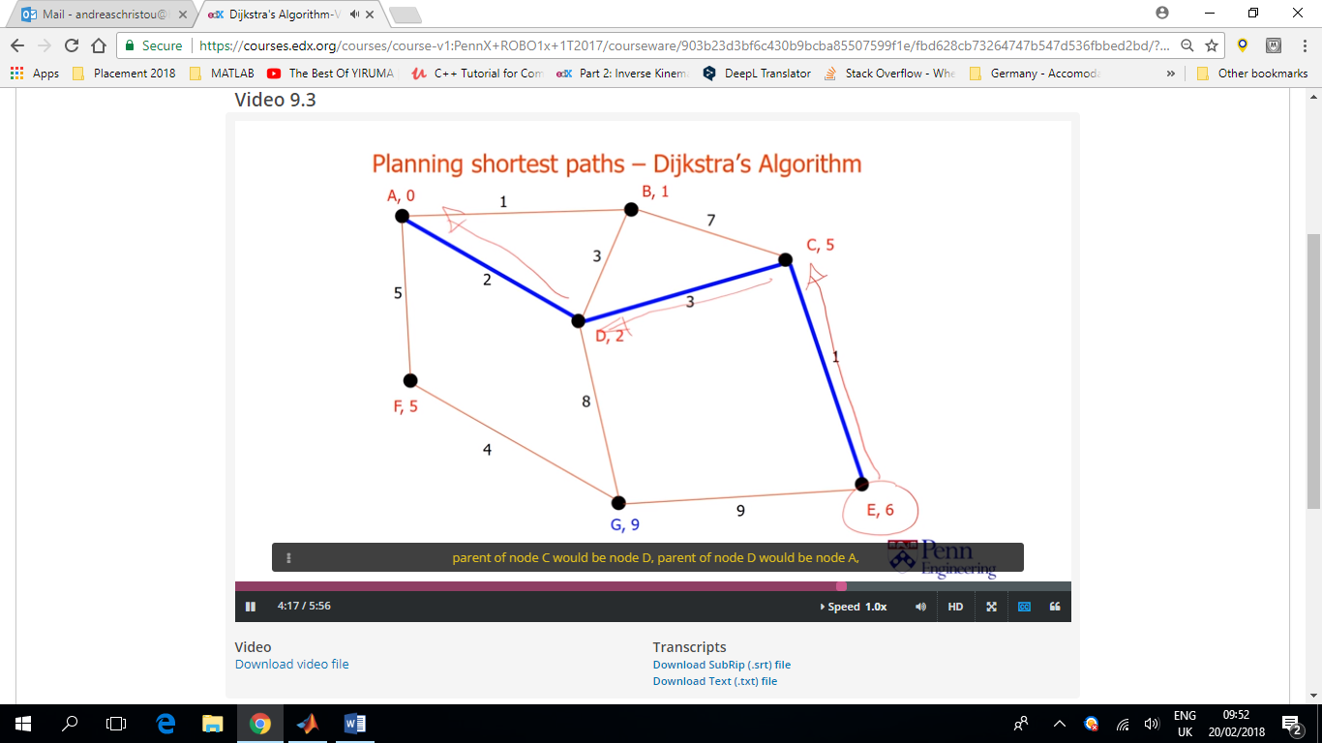As the algorithm proceeds we continually update these distance values to reflect the current best known path from the start node to that node and we continually update the parent node to point to the next node along that best node path. Once the Dijkstra’s Algorithm encounters the end node (in the case node E) we can use these parent fields to reconstruct the shortest path between the end node and the start node.

In this case the parent of node E will be node C, the parent of node C will be node D etc.

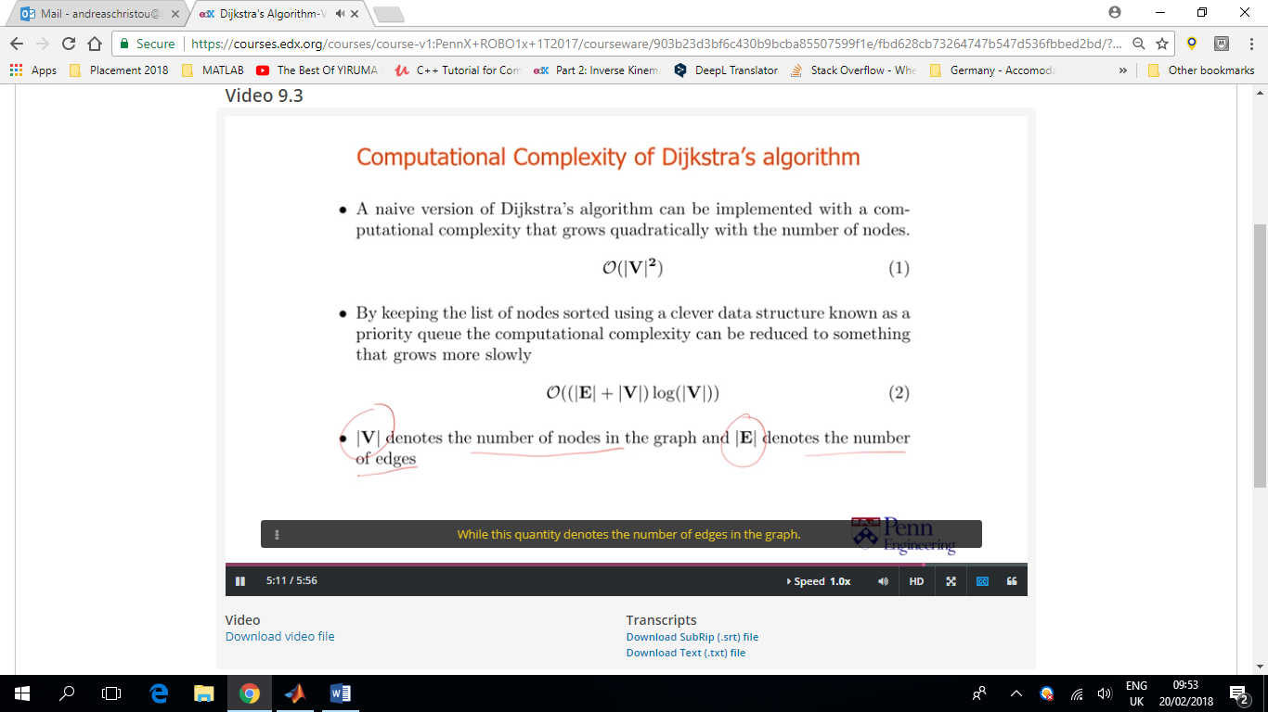It seems that the computational effort involved in the Dijkstra’s Algorithm grows faster compared to the Grassfire Algorithm. The reason it works, it’s that it end up marking nodes in the order of their distance from the start node. By keeping the nodes sorted by distance, and marking them in that order, we are guaranteed that whenever we mark a node we can be sure that there is no shorter path to the node via another unmarked node. Since we are assuming that all edge weights are non-negative.

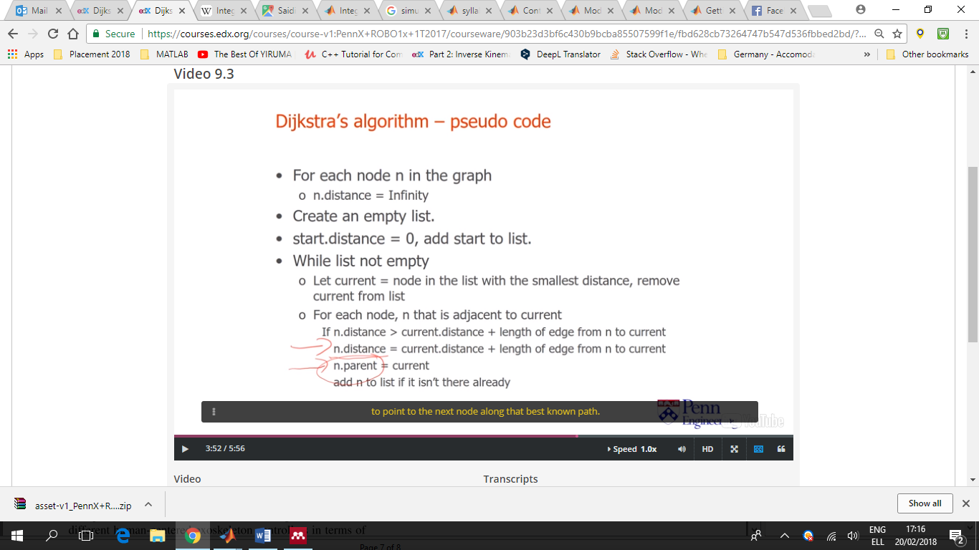

Both Dijkstra’s and Grassfire Algorithms may end up visiting all or most of the nodes in the graph for solving the problem. For many motion planning problems, we can exploit the structure of the problem to come up with procedures that arrive to good solutions more quickly. A good example is the A* Algorithm, belongs to a 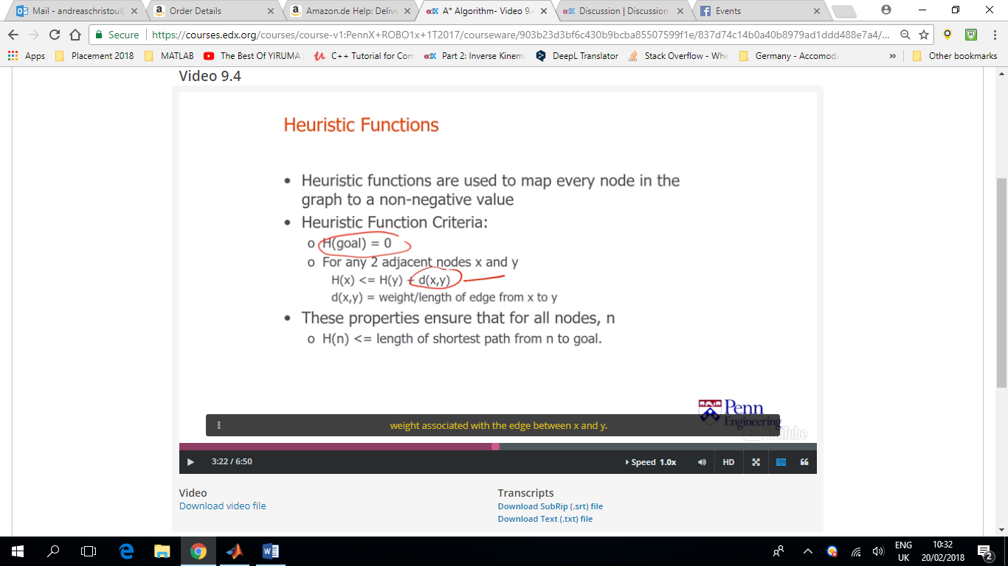broader class of procedures called Best First search algorithms. They explore a set of possibilities by using an approximate or heuristic cost function to sort the various alternatives and then expect the options in that order.

Sometimes, we have some idea in which direction we need to move to make computational cost lower (instead of checking out all/or most of the possibilities).

The A* Algorithm uses what’s known as a heuristic distance and explores the most promising avenues first. The heuristic may be wrong and there definitely situations where the best way to get to the goal is to start off in the opposite direction.

Heuristic distance = an estimate of the distance from any given node to the goal node.

d(x,y) is the length or weight associated with the edge between x and y.

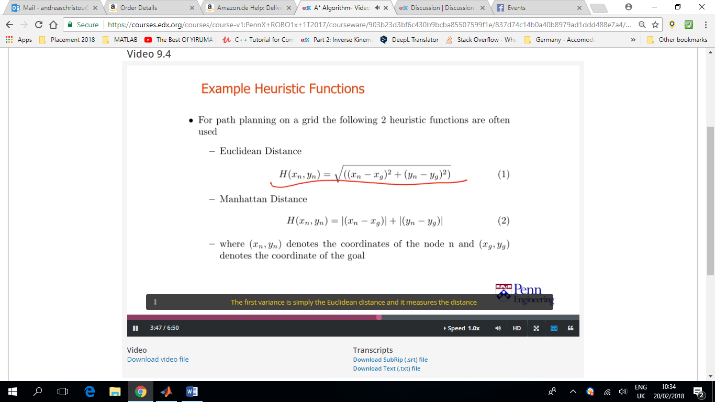

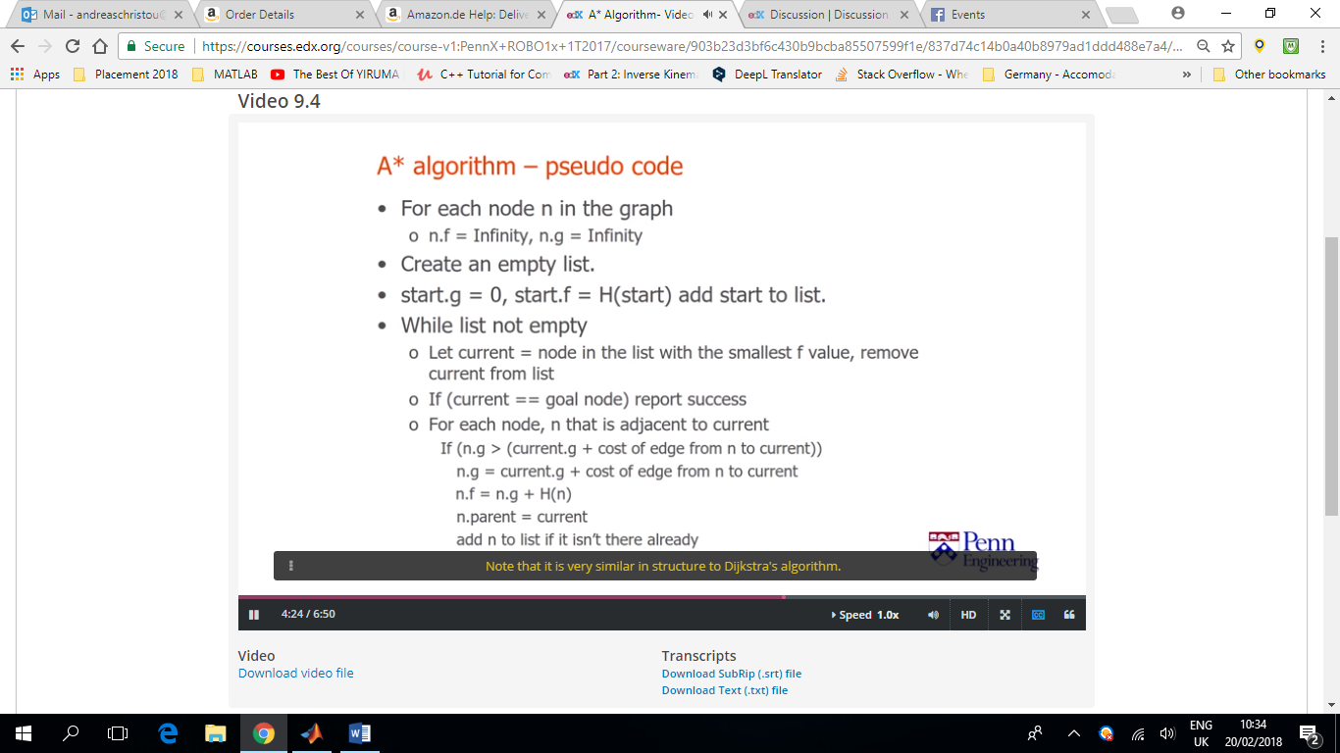

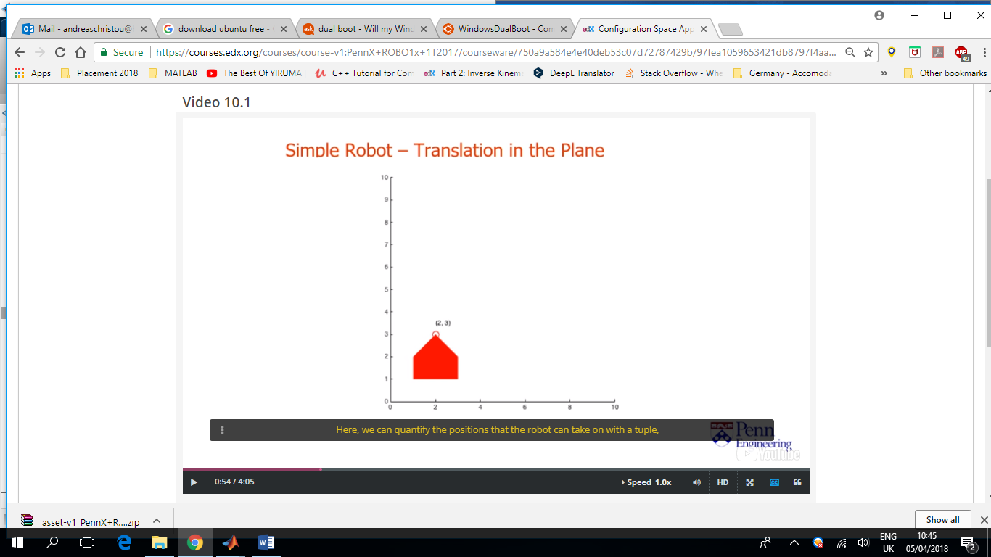In practise most robots can move continuously through space. Configuration space is a handy mathematical and conceptual tool which helps us think about these kind of problems in a unified framework.

Configuration space of a robot = Set of all possible configurations and/or positions that the robot can attain.

In this example we can quantify the positions that the robot can take with a tuple, txty (a set of two coordinates – in 2D space -). This tuple denotes the coordinates of a particular reference point on the robot with respect to a fixed coordinate frame of reference. In this case, our robot has 2DoF.

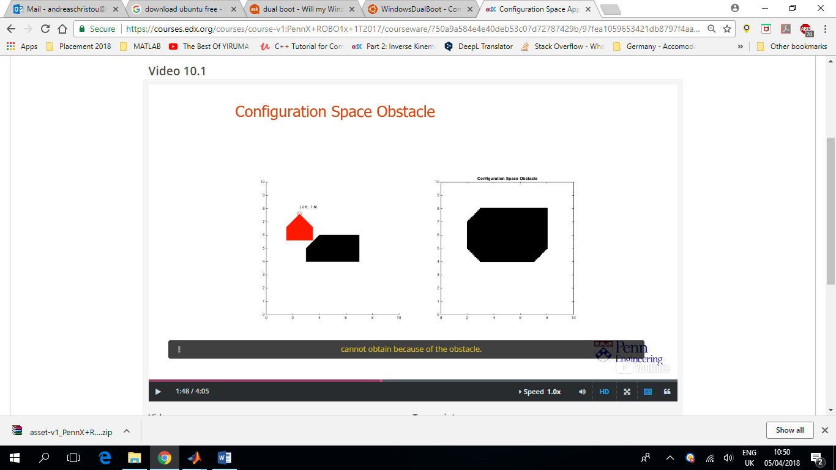Configuration Space Obstacle = The txty configurations that the robot CANNOT take because of the obstacle.

On the left hand side we can see the geometric obstacle.

Free space is anything outside the configuration space obstacle.

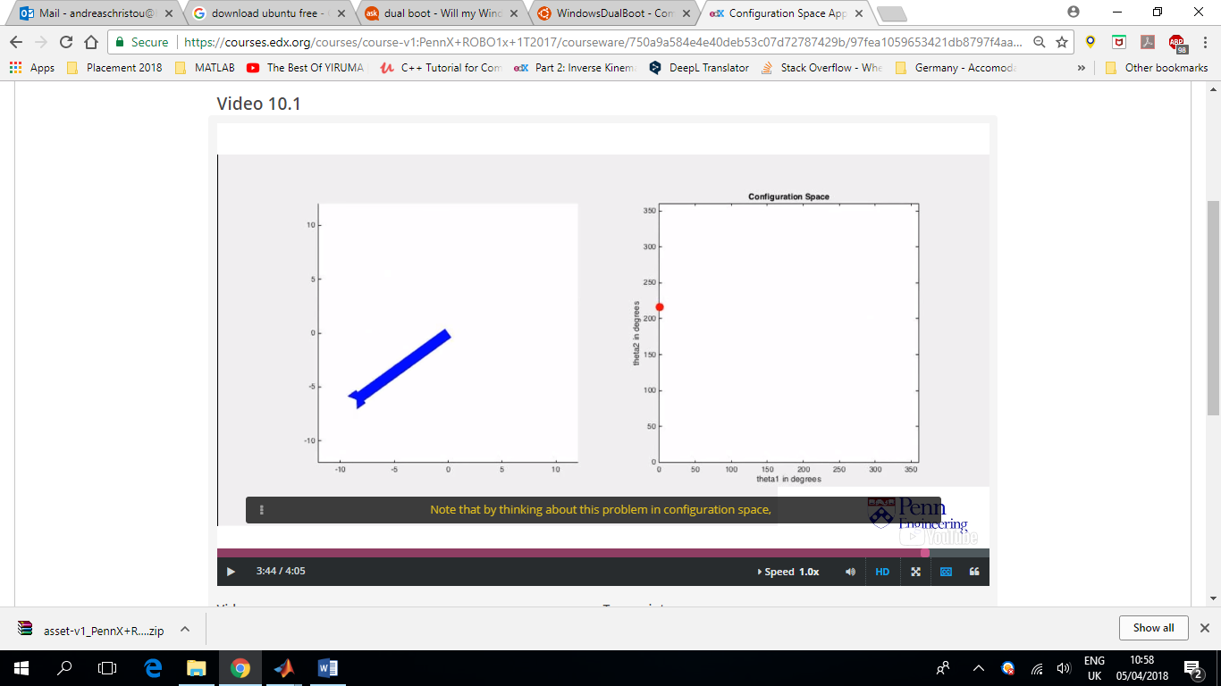The shape of the configuration space obstacle depends both on the shape of the obstacle and the shape of the robot. More formally we refer to this as the Minkowski sum of the obstacle and the robot shape.

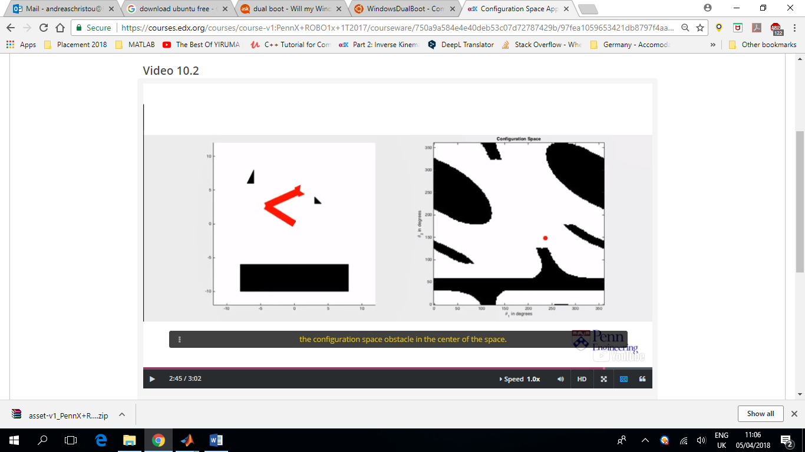We can define the coordinates that describe the robots motion by a single point using a configuration space.

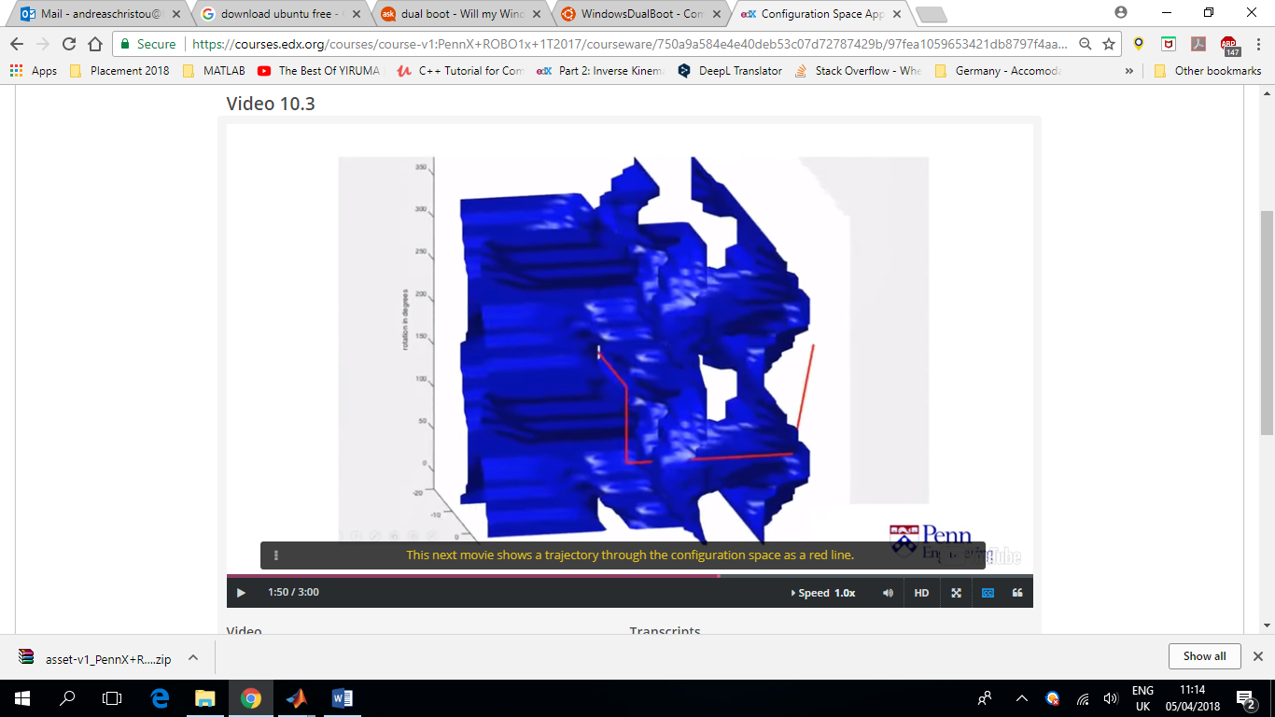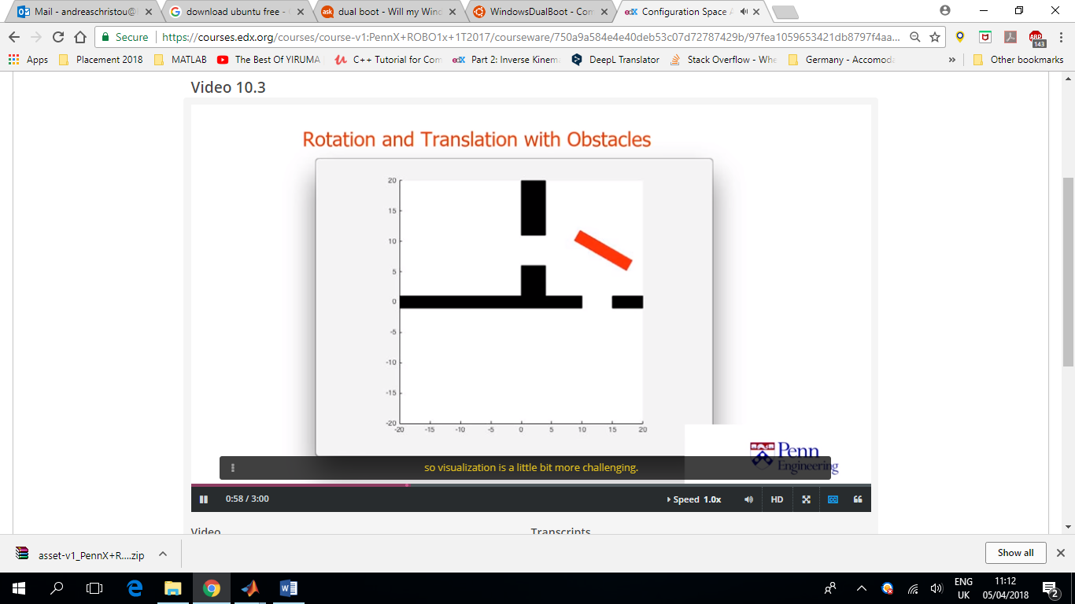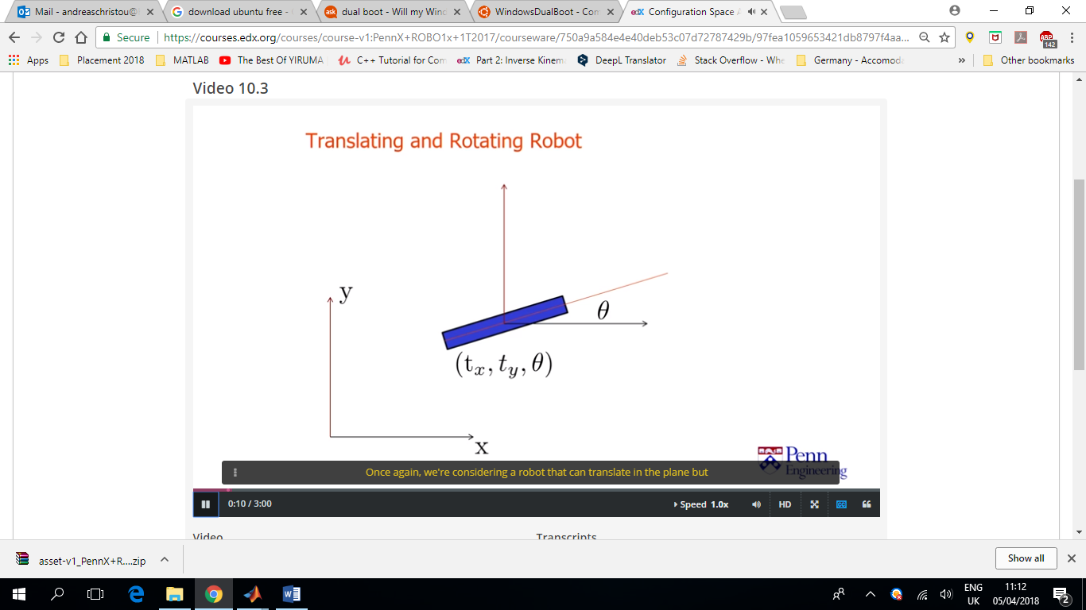

A more complicated example with a robot consisting of 3DoF. The configuration space is 3D and harder to visualise. The red line shows the trajectory that the robot can follow to avoid obstacles

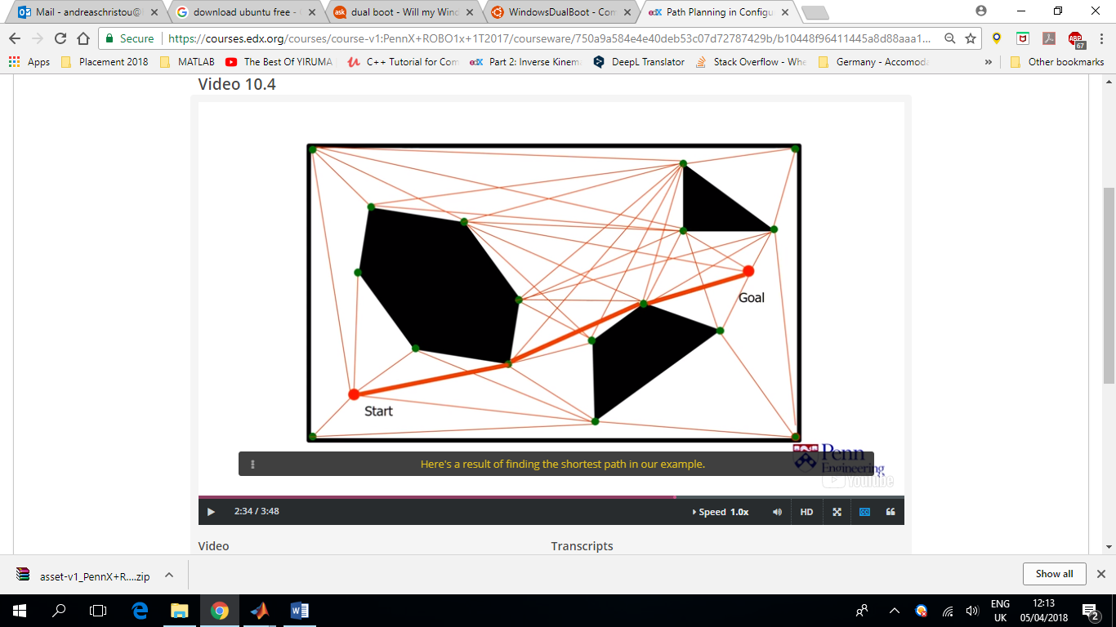In this example where the obstacles are modelled as polygons, we discretise the map by associating each configuration space vertex (corner of polygon) to a node. Then we compute a visibility graph and draw edge between any two vertices that can be connected by a straight line that lies entirely in free space (including any pair of neighbouring vertices on the same configuration space obstacle).

In order to be able to run this algorithm, we need to be able to know whether a line segment between any two points, intersects a configuration space obstacle. In this case where the configuration space obstacle are polygons, this is straight forward. Start and goal locations are included as nodes in our graphs.

Then we can find the shortest distance using Dijkstra’s Algorithm.

In practise, we may pretend that the robot is a bit bigger than it is, to inflate the configuration space obstacles by a safety margin and allow for a smoother and safer trajectory.

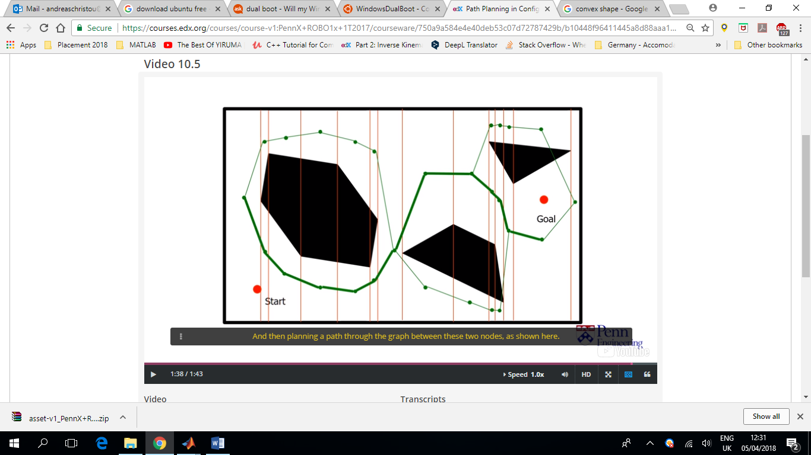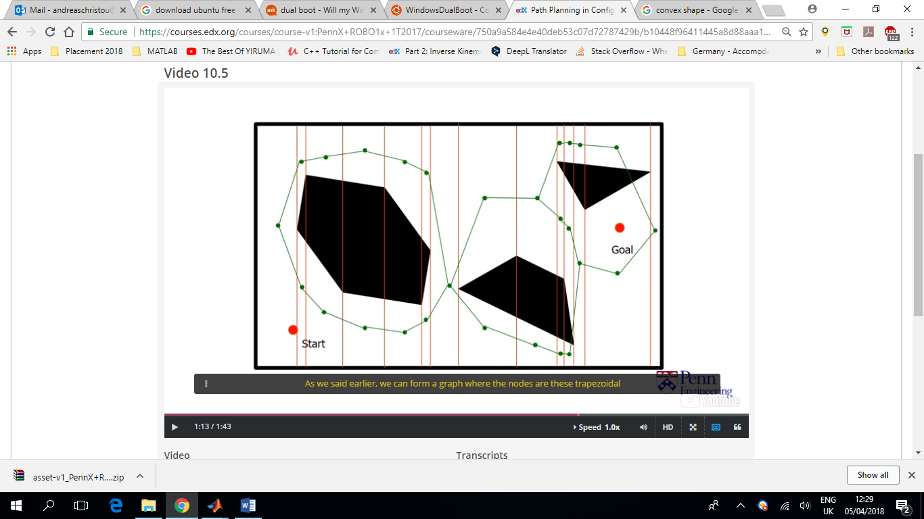Another approach that is particularly effective in situation where the configuration space obstacles can be modelled as polygons, is **cell decomposition**. The goal is to divide the robot’s free space into a set of simpler regions (red lines), and then form a graph where the nodes of the regions and edges indicate which regions are adjacent to one another (green lines). In this case, we sort the obstacle vertices (corners/nodes) based on their x-coordinate and then proceed from left to right, dividing the free space up into regions as we go up. This procedure divides the two-dimensional configuration space into a collection of trapezoidal and triangular regions. These shapes are convex (interior angles < 180o), which means that robot can safely move in a straight line between any two points in each cell.

We form a graph (green lines), where the nodes are these trapezoidal regions and the edges indicate which regions are adjacent to one another. Path planning can then be carried out by finding which cell contains the start location and which cell contains the goal location, and then planning a path through the graph, between these two nodes.

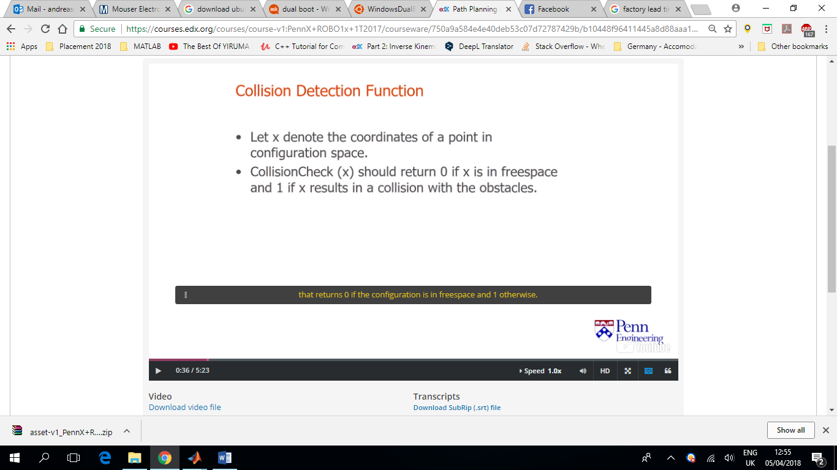Polygonal obstacles are convenient to work with because they provide an explicit description of the configuration space obstacles. Sometimes we don’t have this luxury and obstacles are instead defined implicitly by a collision function.

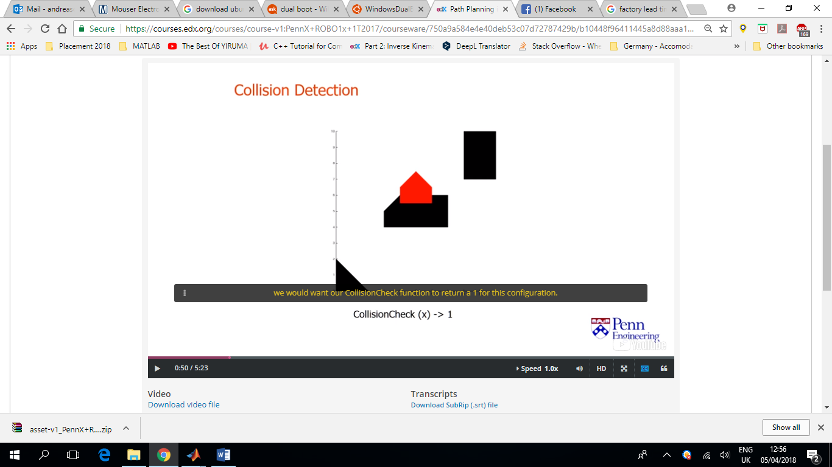We first represent both our robot and obstacles as collections of triangles (or any other convex shape?). To detect collisions, we need determine whether any of the robot triangles overlap any of the obstacle triangles.

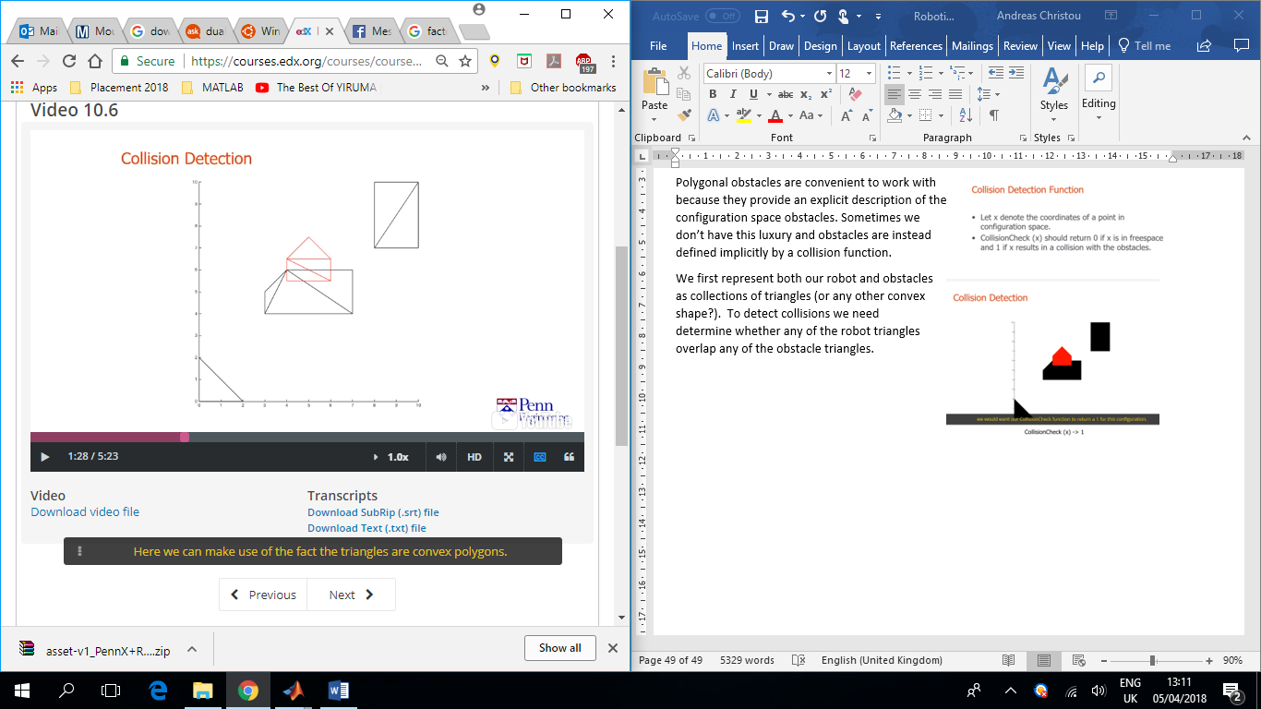

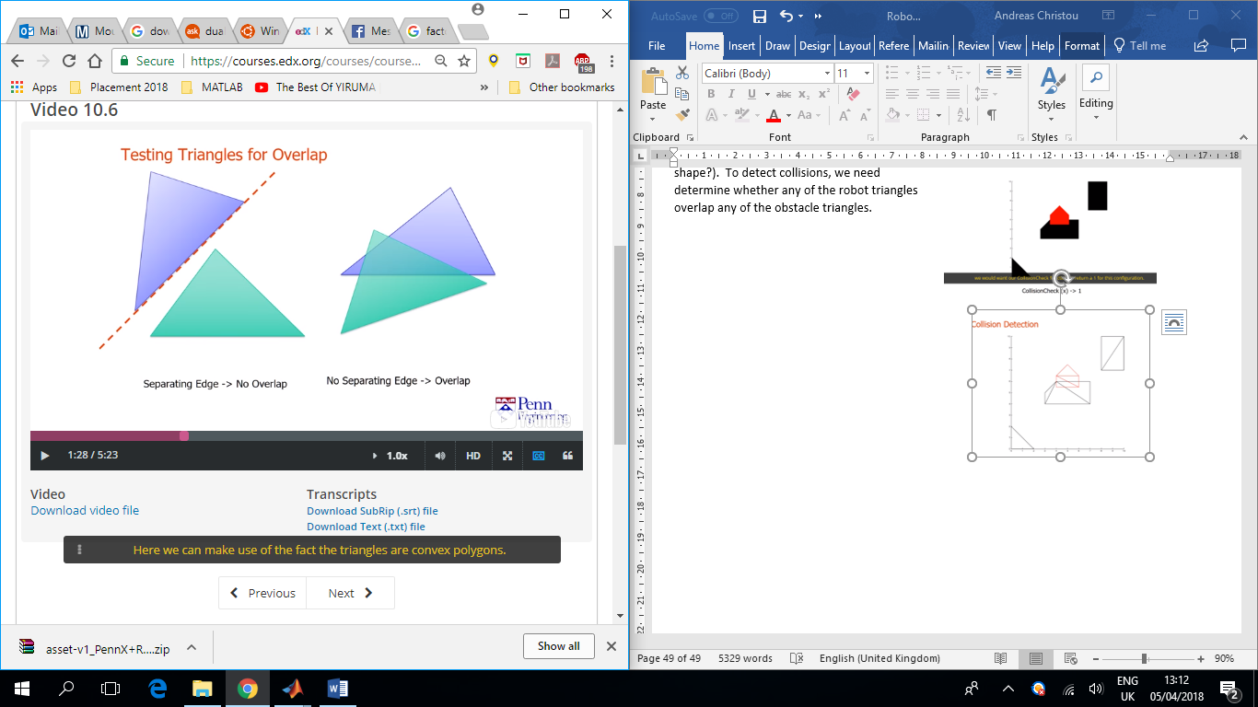

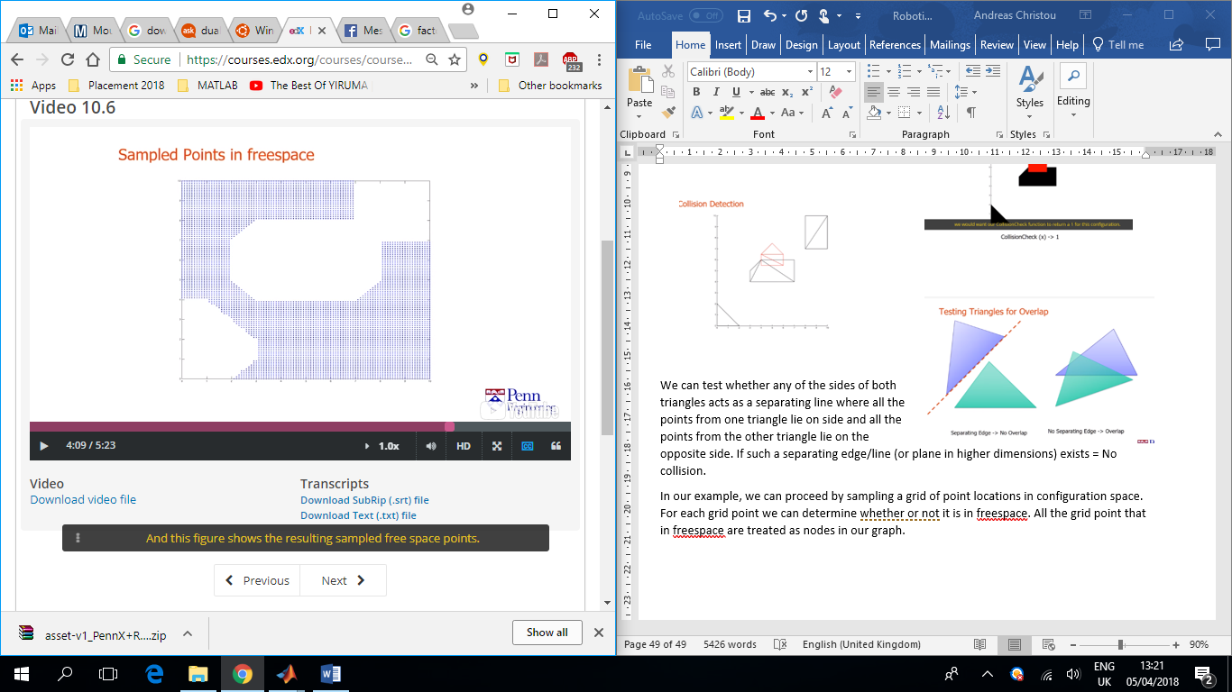We can test whether any of the sides of both triangles acts as a separating line where all the points from one triangle lie on side and all the points from the other triangle lie on the opposite side. If such a separating edge/line (or plane in higher dimensions) exists = No collision.

In our example, we can proceed by sampling a grid of point locations in configuration space. For each grid point we can determine whether or not it is in free space. All the grid point that in free space are treated as nodes in our graph.

In this example, we are going to assume that if two adjacent grid points are both in free space, then all the point between them are also in free space and we can connect them (via edges of unit length as we did before). Then we define our start and goal point and apply our suite of 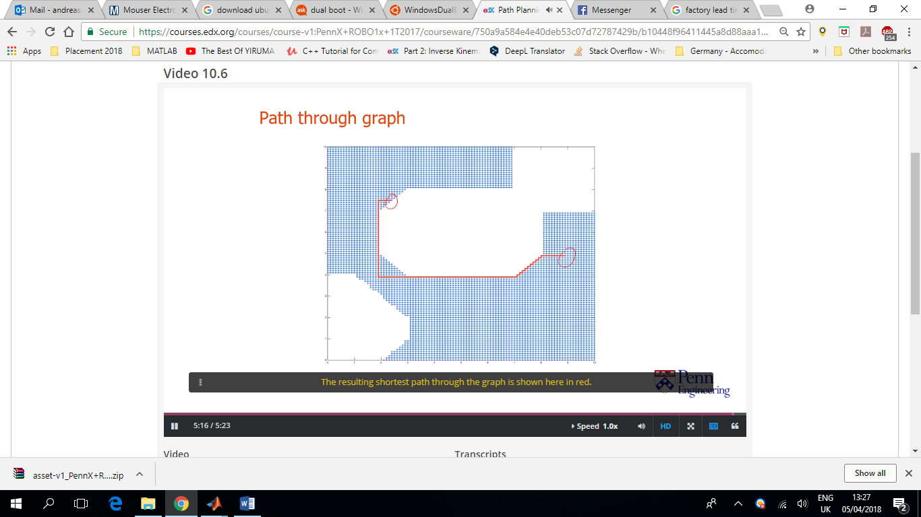graph-based path planning tools to search for a path between the two nodes. The resulting shortest path here can be seen in red.

Chapter 11

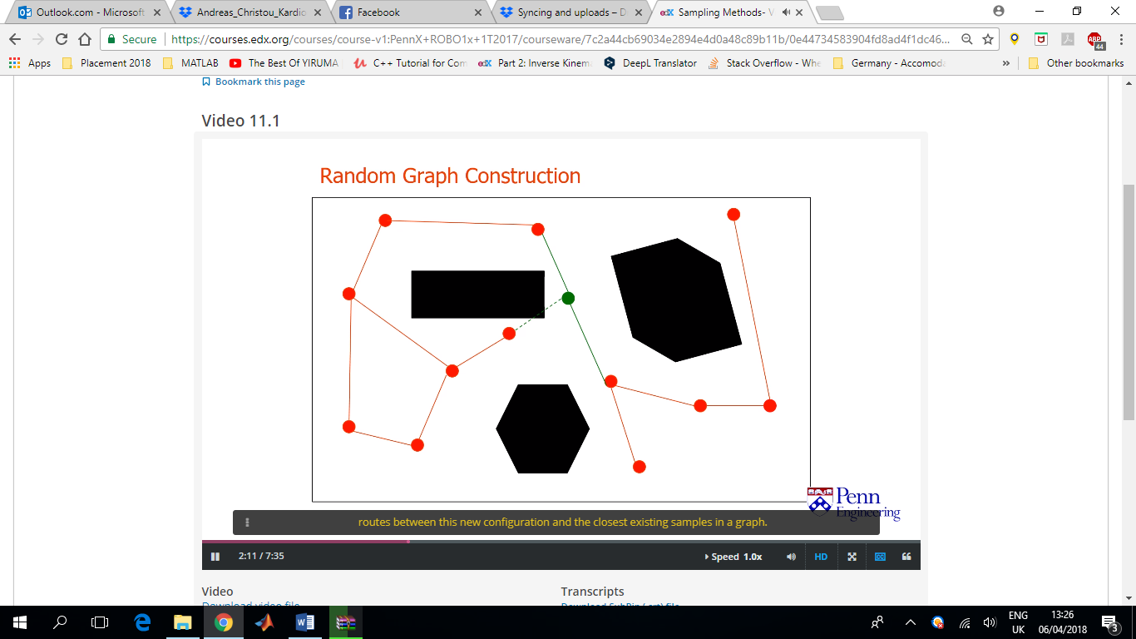The approach of discretising the configuration space evenly on a grid can work well when the dimensions of configuration space is low, say two or three. But the number of samples required can grow to be a huge number as we increase the dimensions of the configuration space. An alternative idea is to choose the points in the configuration space randomly instead of uniformly. In the hope that we will choose a set of configurations that capture the underlying structure of the free space.

The green dot in this 2D example, shows the new configuration. If it is in free space, it tries to see if it can form routes between the closest existing samples in the graph. Every path is recorded as a new edge.

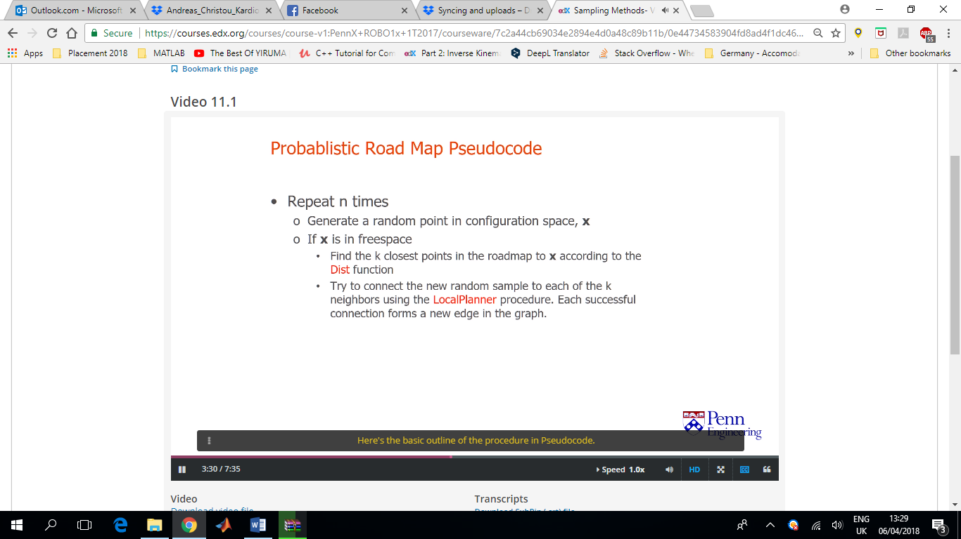The goal is to construct a graph of configuration space points and edges that capture the underlying topology of the free space. This is known as the probabilistic roadmap method or PRM for short.

Distance Function = Considers the configuration space coordinates of two points and returns a real number which is reflective of the distance between those two configurations.

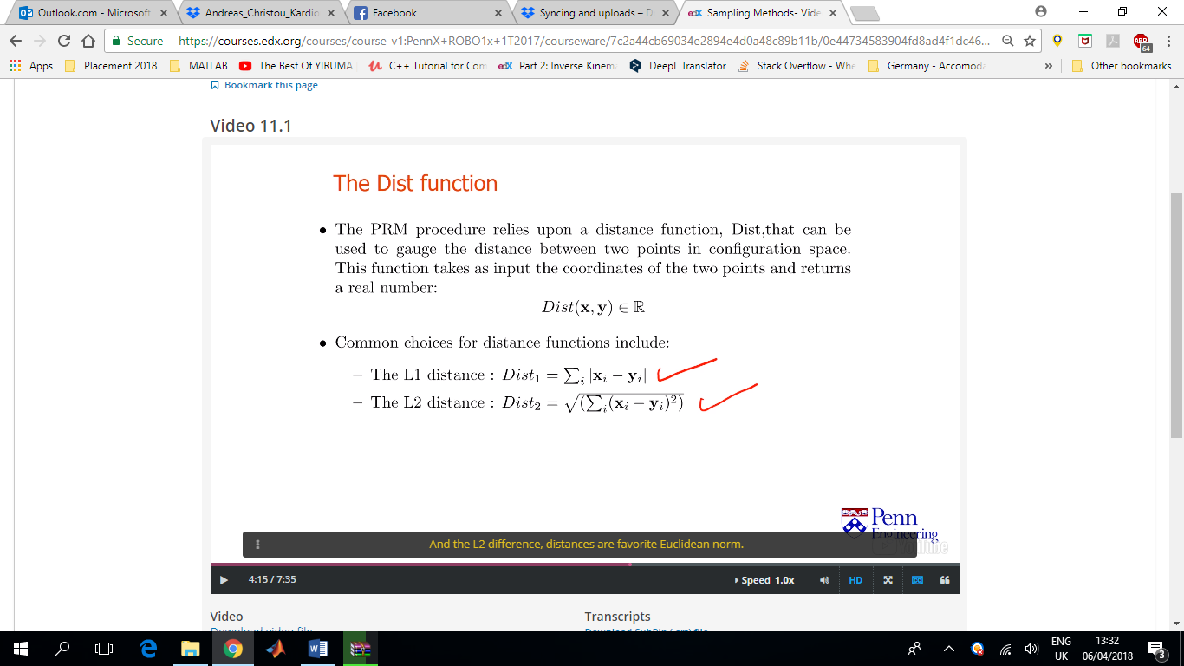

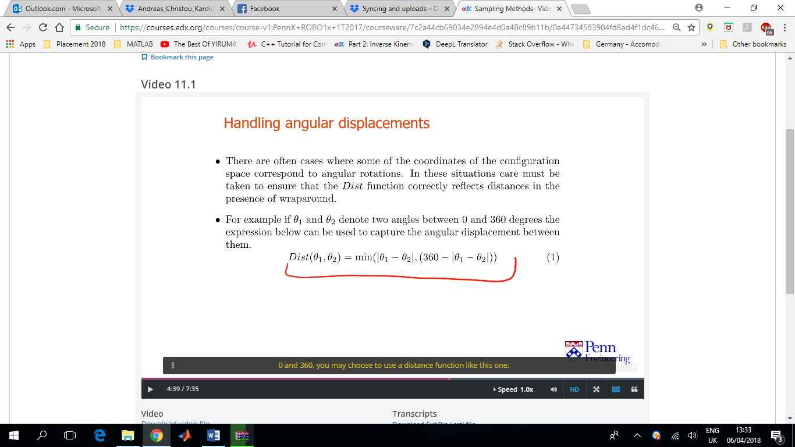This actually captures the fact that 0 and 360 point in the same orientation.

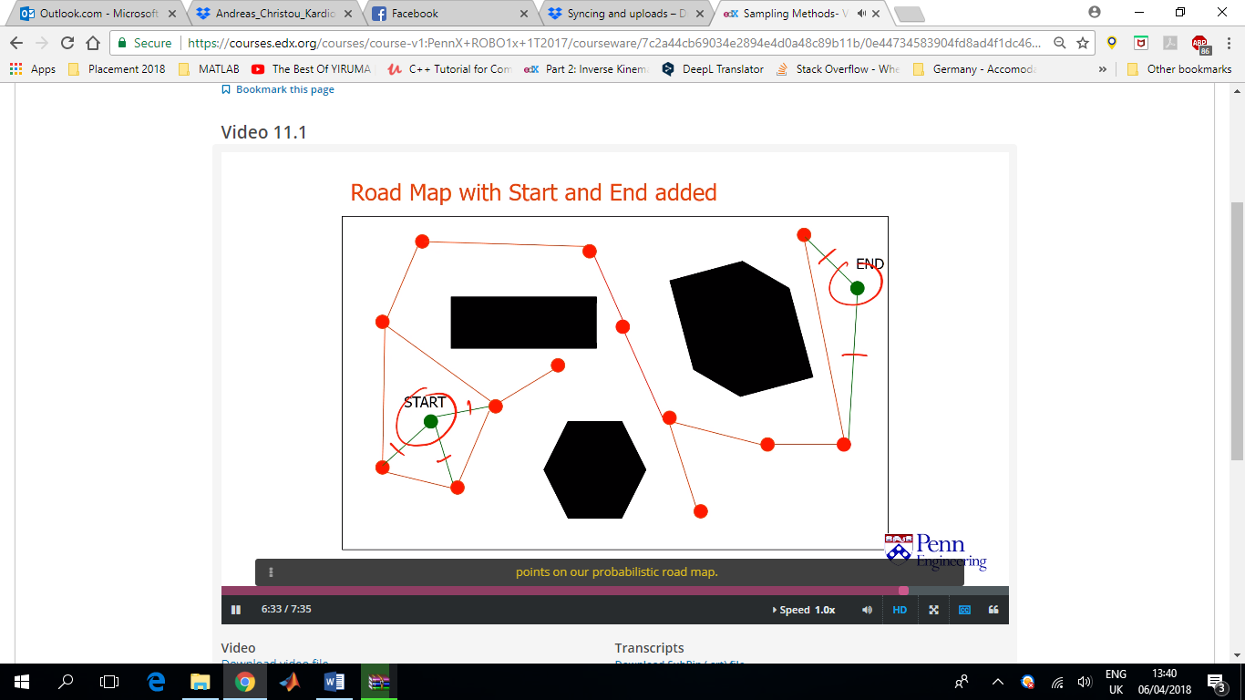LocalPlanner decides whether there is a path between points X1 and X2. A common way to handle this is to construct a set of evenly spaced samples on a straight line between the two configurations and to use the CollisionCheck function to check that all these intermediate configurations are collision free.

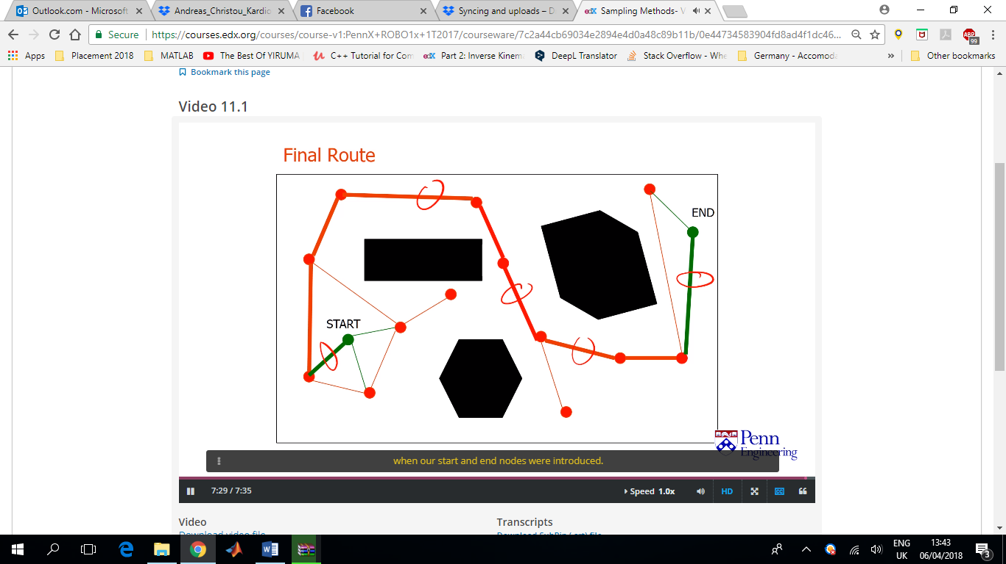Once we’ve generated what we believe to be a sufficient sampling of the configuration space, we try to generate paths between a designated start and end configuration. We start off by attempting to connect the start and goal configurations to nearby nodes on the roadmap. If this step succeeds and we find these connecting edges, then we try to find a path between the start and goal nodes via the roadmap using our usual suited graph-based path planning Algorithms like Dijkstra’s Algorithm or A* (query phase).

Red edges=edges that correspond to edges in our original probabilistic roadmap

Green edges=augmented edges that we added when the start and end nodes were introduced

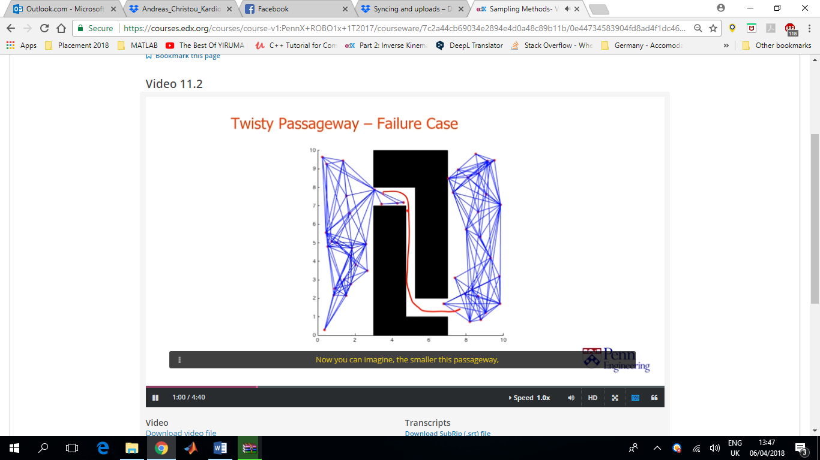PRM is not complete (even though it works well in practise). It is possible to fail to find a path even if one exists. They are so called probabilistically complete. However, it’s hard to know if there is in fact, no path, or whether you would be able to find one if you just kept trying long enough.

In order to deal with this problem, a number of approaches have been proposed to bias the sampling algorithm so as to increase the chance of finding routes in these challenging cases.

One idea is to try and sample more points closer to the boundaries of the configuration space obstacles.

However, there is still no sampling strategy that is guaranteed to work well in all cases.

Resulting paths may also be jerky and unnatural. Path-smoothing procedures are often times used.

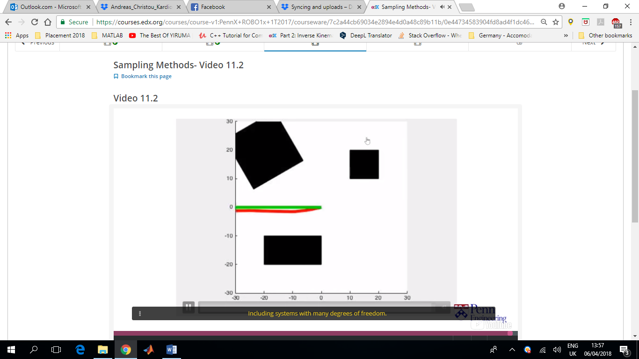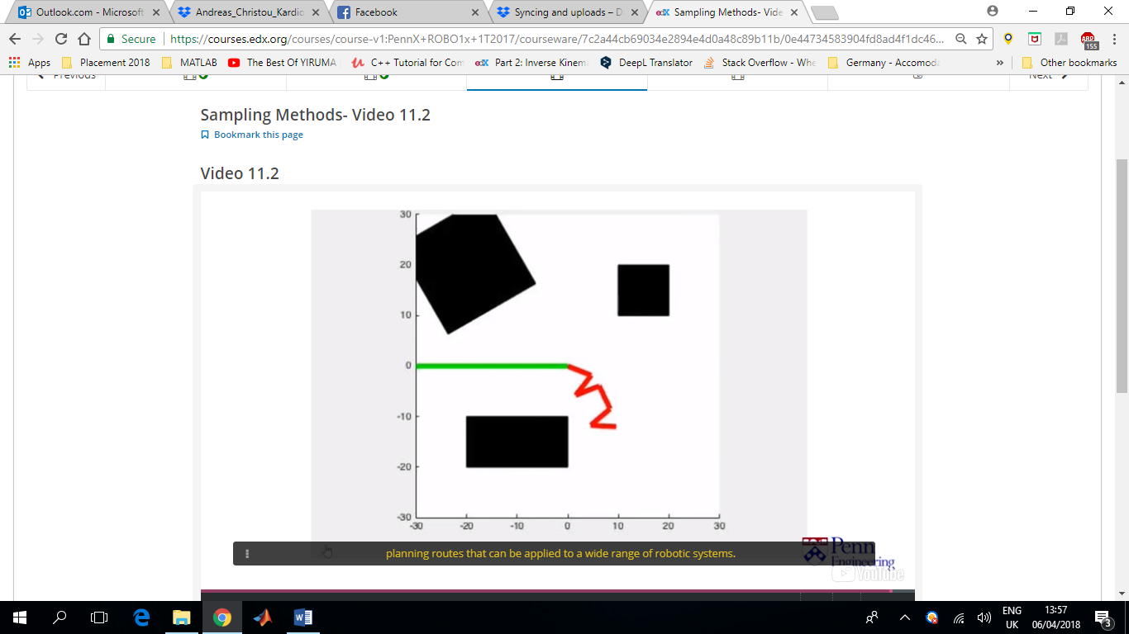

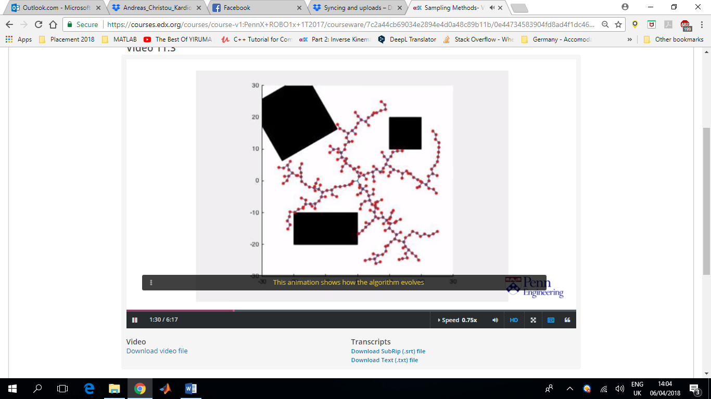In cases where we are interested in answering only one path planning problem, it can be wasteful to construct road maps that span the entire free space. In these situations, it may be better to use procedures that explicitly consider the start and end locations in the sampling procedure.

One such approach is the rapidly exploring random tree, RRT, method. Similarly to PRM, it generates random samples and connects them together to form a graph. But the sampling scheme is a bit different. The RRT procedure proceeds by the construction of a special kind of graph called a tree. The graph grows from the start of seed location at the centre of the 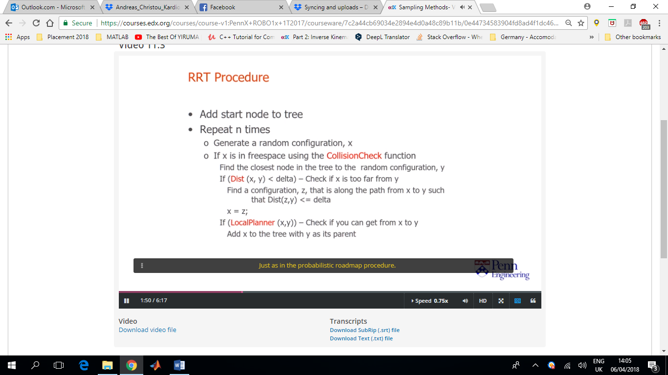figure.

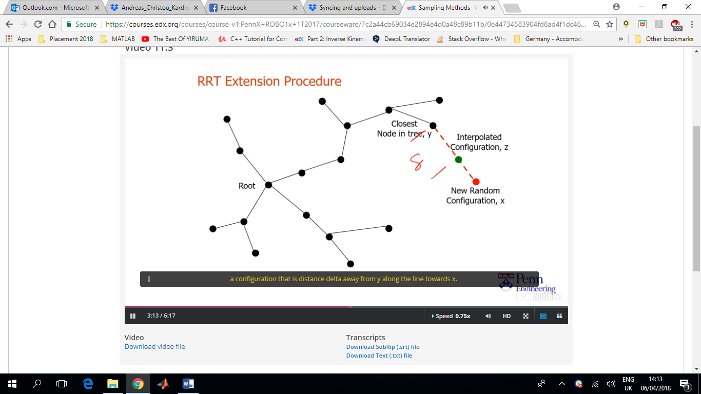

In practise we actually construct two trees. One rooted at the start node and one rooted at the end node. The procedure then tries to grow both trees until they meet.

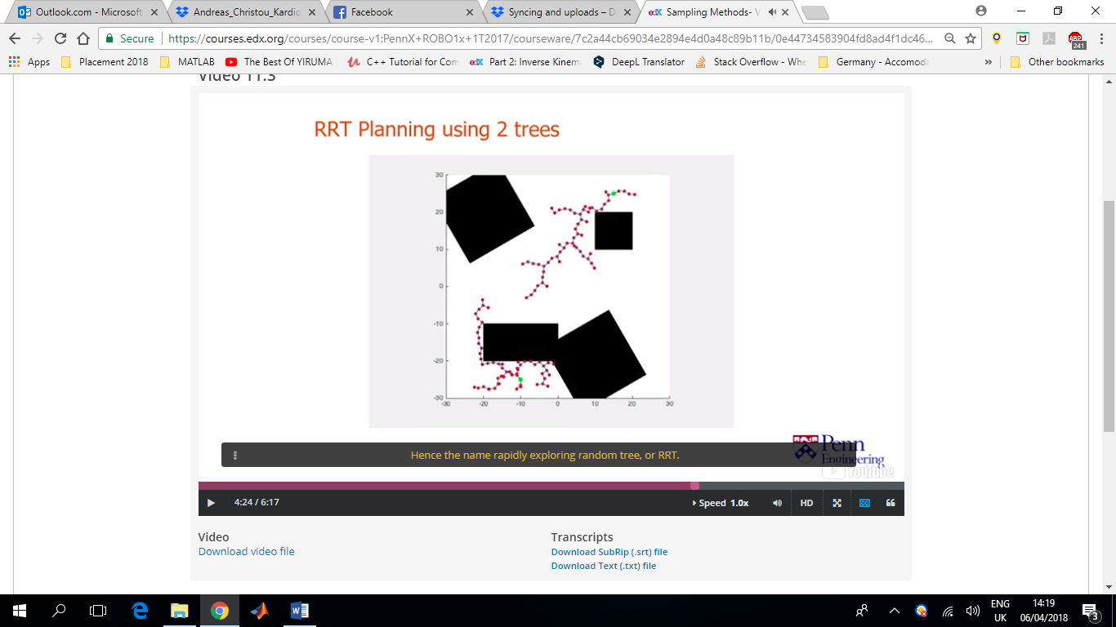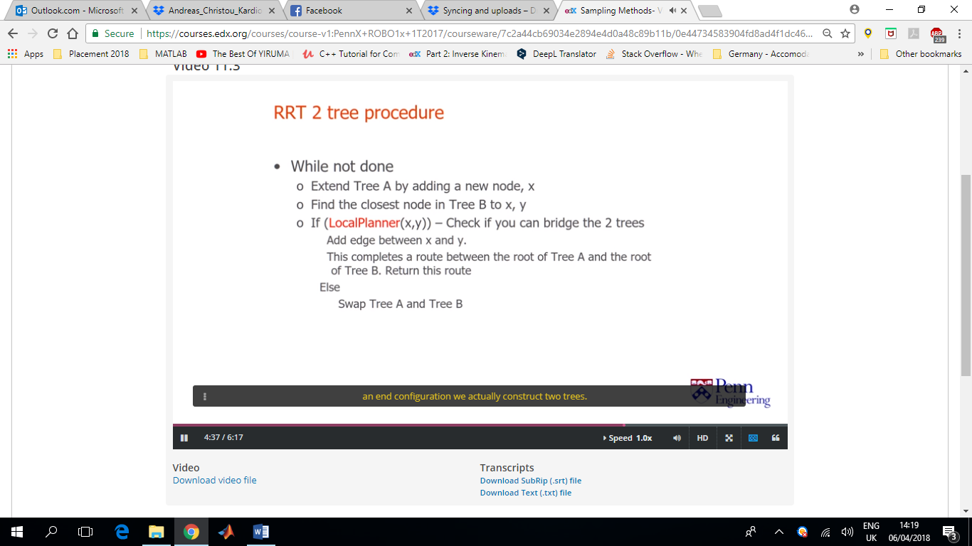

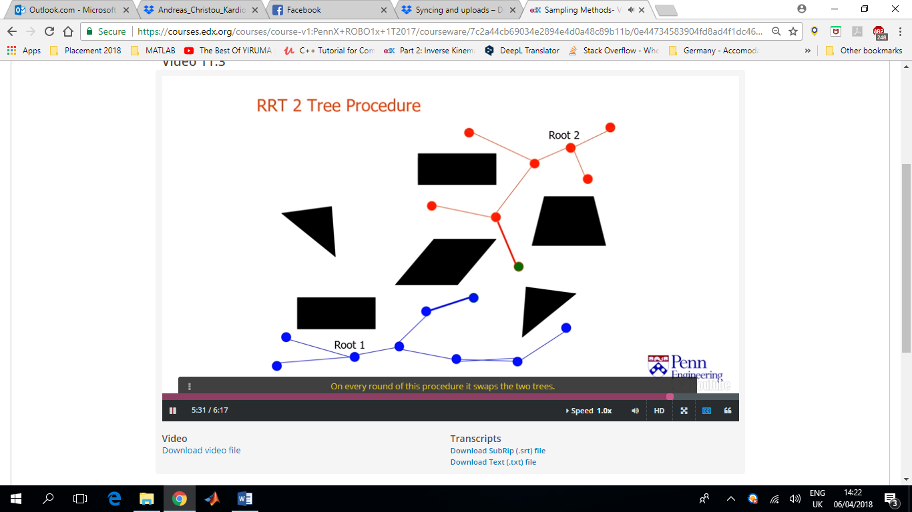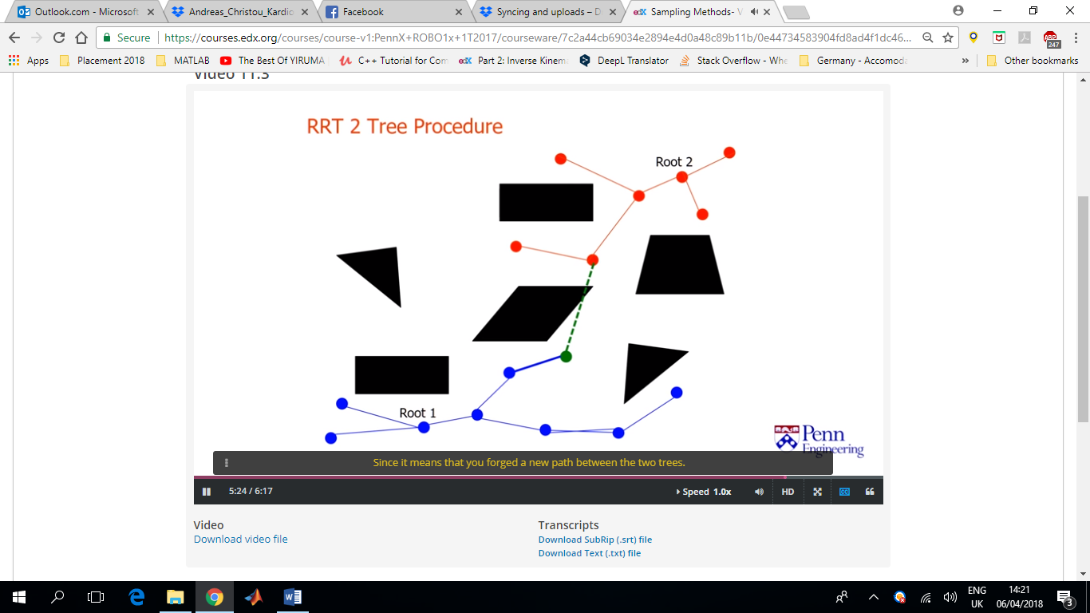

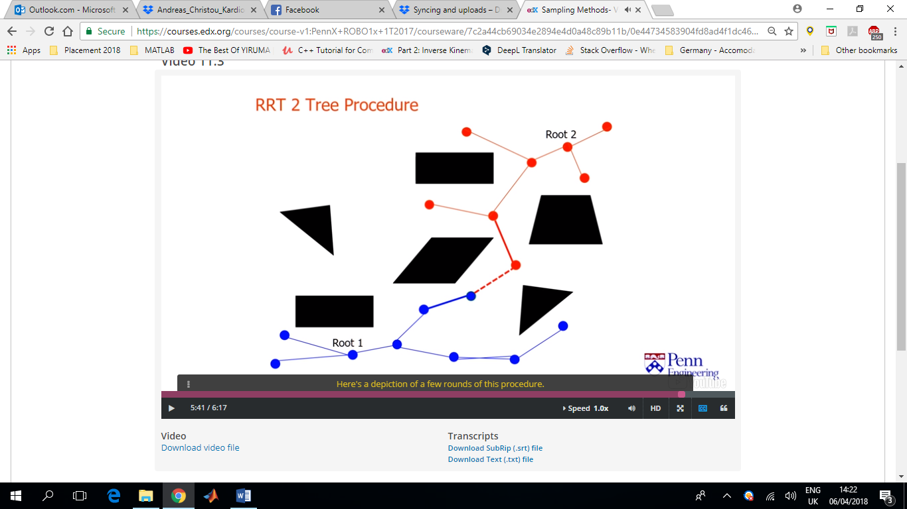

This is a very effective method, and can also be used on systems that have dynamic constraints that limit how they can move. For example a car like robot where limits on the turning radius imply that it cannot translate sideways or turn in place around its centre.

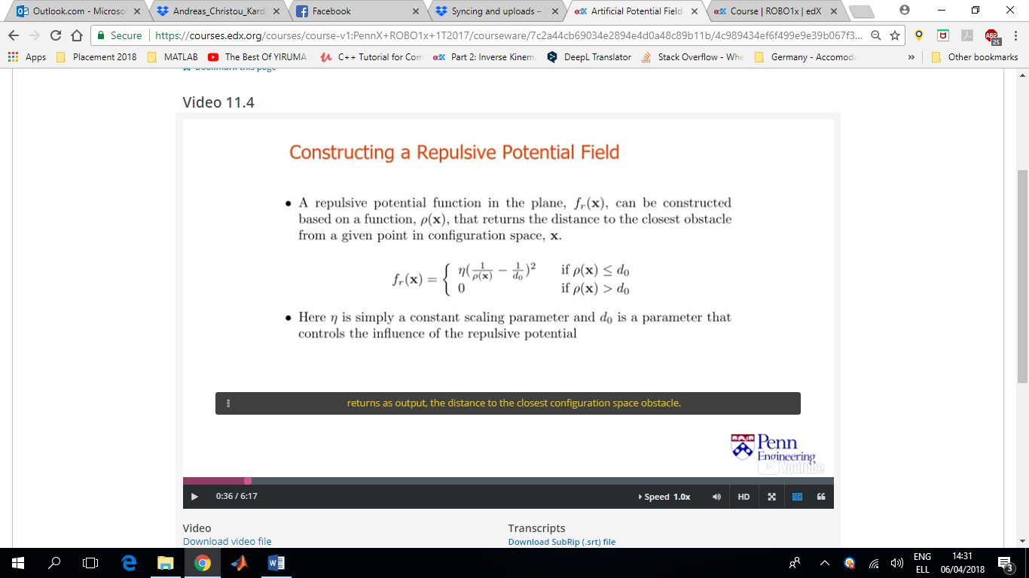To avoid the obstacles we construct a function fr, to repel the robot from the obstacles.

For polygons, ρ(x) can be constructed analytically. Alternatively if we are willing to discretise our workspace into a grid, we can imply an operation from image processing called a distance transformation, to approximate this distance at every grid location.

A function can be constructed from the sum of a function that attracts the robot to the desired location and a function that repels the robot away from the obstacles.

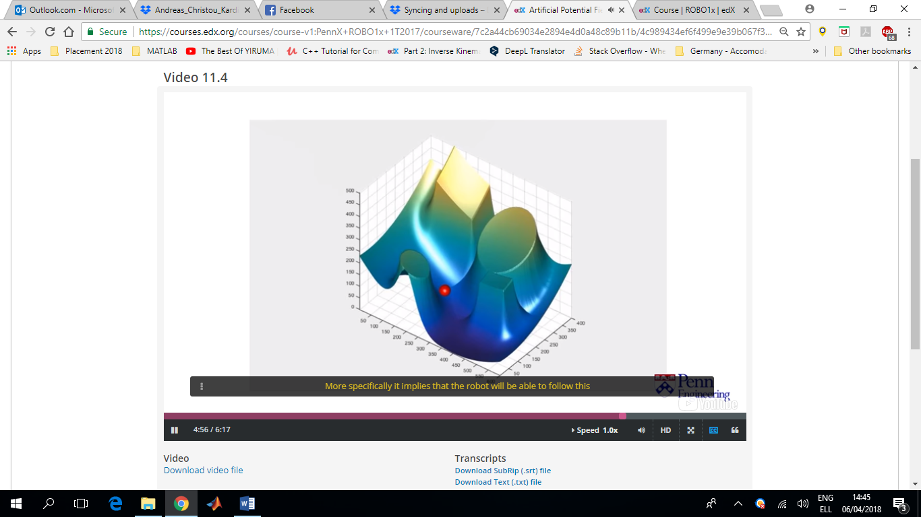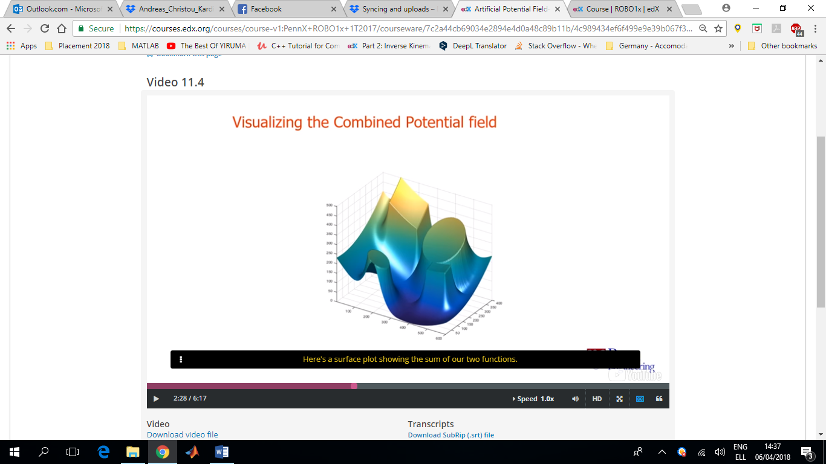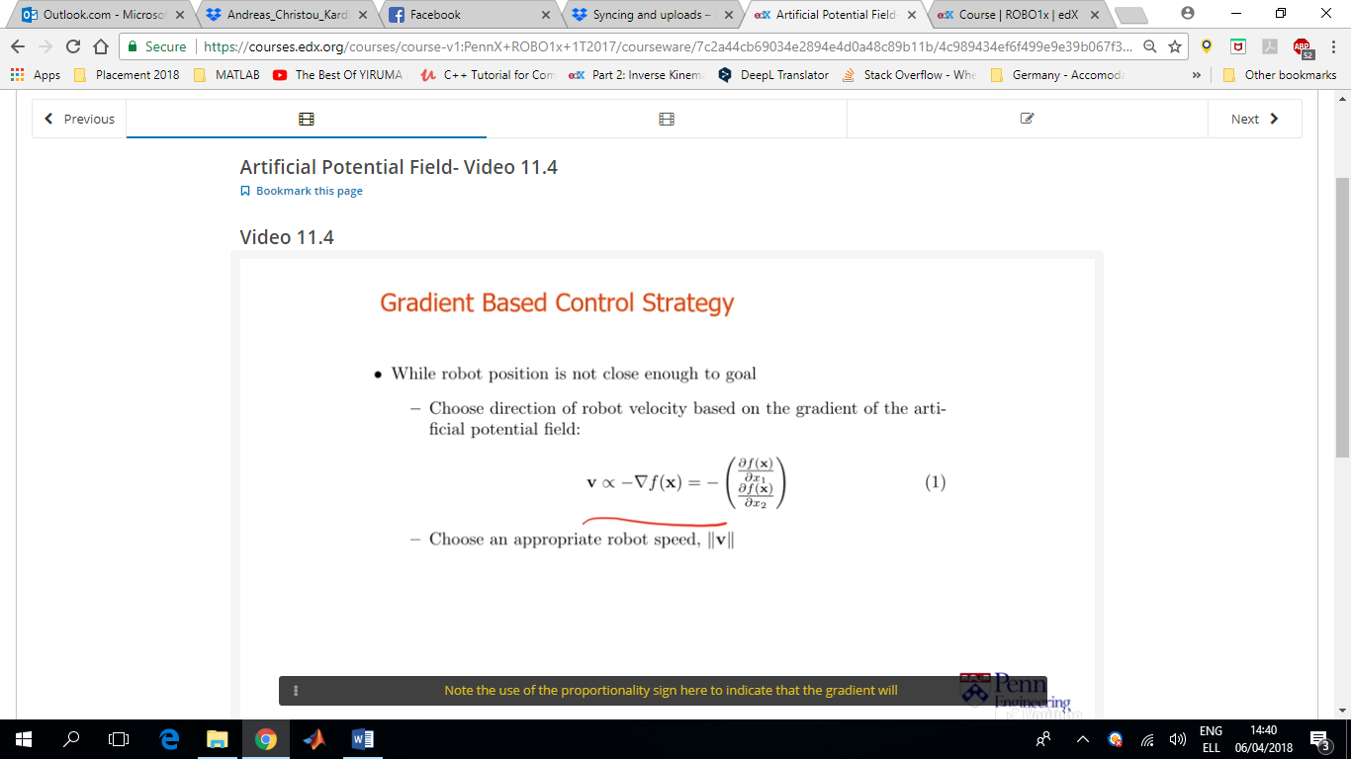

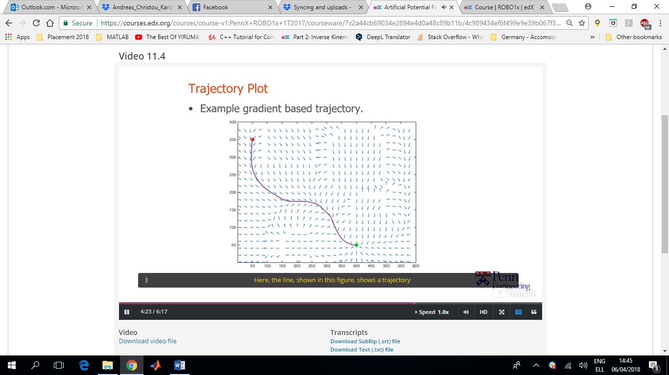Using calculus and the gradient of the potential function, we guide our robot to the end configuration. We choose the velocity of the robot, v, based on the gradient of the potential function. Note the use of the proportionality sign. The gradient will be used to decide on the direction of the motion but the speed of the robot is up to the programmer. Constant speed can be chosen, or a proportional speed to avoid overshoot and slow down as you approach the goal.

An attractive feature of this procedure, is that it only requires a robot to be able to evaluate the gradient of this potential function F. The robot will be able to follow this procedure using ONLY knowledge of its positions and local sensor data. A robot that knew its position in space can easily evaluate the attractive component of the potential function and a robot that can measure the range to all the obstacles within a distance d0, of its current position will be able to evaluate the repulsive component of the artificial potential field. The required gradient could then be approximated by evaluating the potential function at a few locations in the vicinity of the robot’s current position and then applying simple finite difference methods (sensor-based planning).

Another attractive feature is that they are relatively simple to implement. In fact, they can be incorporated into real time control schemes running at tens of hertz, using local sensor data.

A downside of these methods, is that it can be very difficult to ensure that they will always work. Ideally, our potential function will only have a single global minimum located at the desired configuration. However, in practise the robot might be trapped in local minima, which are very hard to eliminate.

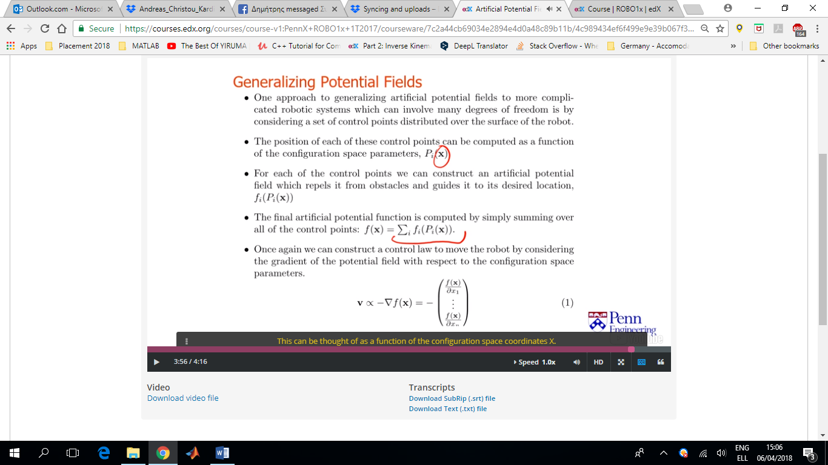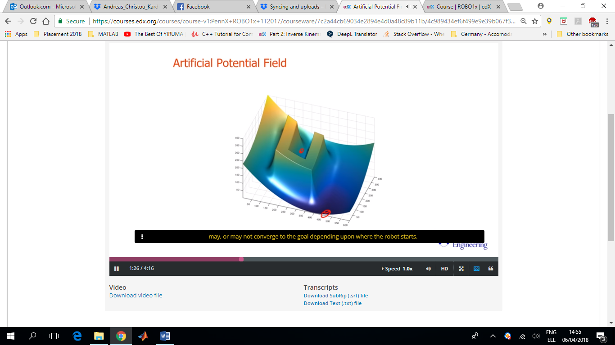Obtaining potential functions for configuration spaces with more degrees of freedom can be hard. One approach to generalise this idea of potential fields to robots with multiple degrees of freedom is to think in terms of control points that are distributed over the surface of the robot. For each of these control points we can construct a potential field which guides is away from objects in the workspace and towards its final goal. We can do this by considering the distance between the point and the workspace obstacle as we discussed earlier. We can also compute the positions of each of these control points as a function of the configuration space coordinates, denoted by the vector **x**. We can then construct an aggregate potential function by computing the sum of these individual potential functions as shown in the figure (bullet point 4). This can be thought of as a function of the configuration space coordinates x. We can then apply the control scheme by computing the gradients of these function with respect to this configuration space coordinates. This gradient then provides information on how to move the robot towards the goal and away from obstacles.

